|  |
| --- |
|  |

|  |
| --- |
| **Point of Sale** |
| Heaven Skincare |
|  |
| User manual for Point of Sale application. |
|  |
| **Simon Carter** |
| **10/26/2016** |
|  |

# Revision History

|  |  |  |
| --- | --- | --- |
| Version | Date | Status and Description |
| 0.01 | 08/05/2016 | Initially created. |
| 0.02 | 16/05/2016 | Add section for Coupon codes |
| 0.02 | 02/06/2016 | Add section for Diary New Appointment Wizard and Diary Waiting List. |
| 0.03 | 03/06/2016 | Finished user settings section.  Add section for changing languages within the POS. |
| 0.03 | 15/06/2016 | Add section for SMS alerts  Start of Diary section. |
| 0.04 | 04/08/2016 | Add section for Country options.  Add trouble shooting section. |
| 0.05 | 09/08/2016 | Add section for cancel Invoice. |
| 0.06 | 14/09/2016 | Update for invoices, staff notes and order dispatch with staff notes. |
| 0.07 | 28/09/2016 | Add notes for Staff Members |
| 0.08 | 04/10/2016 | Add product section  Add section on Member level  Add stock control section |
| 0.09 | 05/10/2016 | Add product group section  Complete section on Salon Diary.  Add section for replication.  Add section for Customer data accuracy.  Add section for Installation. |
| 0.10 | 06/10/2016 | Completed all sections. |
| 0.11 | 20/10/2016 | Staff Section Completed. |
| 0.12 | 26/10/2016 | Customer Export section completed. |
| 0.13 | 05/12/2016 | Include section on Commission Pools. |
| 0.14 | 08/12/2016 | Include section on Bonus and Client commission.  Update manage staff section. |
| 0.15 | 13/12/2016 | Include section on Auto Updates |
| 0.16 | 21/12/2016 | Include section on Affiliate Commission |
| 0.17 | 23/02/2017 | Update on discount section. |
| 0.18 | 22/03/2017 | Include section on Price Calculator |
| 0.19 | 27/03/2017 | Include section on default icons |
| 0.20 | 21/04/2017 | Include section on Top Selling Products |

[Revision History 1](#_Toc486590019)

[Definitions, acronyms and abbreviations. 8](#_Toc486590020)

[Shortcut Keys 9](#_Toc486590021)

[Fonts 9](#_Toc486590022)

[Point of Sale 10](#_Toc486590023)

[Features 10](#_Toc486590024)

[Installation 11](#_Toc486590025)

[Install Type 11](#_Toc486590026)

[Destination Location 11](#_Toc486590027)

[Distributor Details 12](#_Toc486590028)

[Server 12](#_Toc486590029)

[Select Start Menu 13](#_Toc486590030)

[Additional Tasks 13](#_Toc486590031)

[Ready to Install 13](#_Toc486590032)

[Finish 13](#_Toc486590033)

[POS User Interface 14](#_Toc486590034)

[Home Button and Status Bar Items 14](#_Toc486590035)

[Home Buttons 15](#_Toc486590036)

[Status Bar 16](#_Toc486590037)

[Lists Views 17](#_Toc486590038)

[Discounts 18](#_Toc486590039)

[Product Discount 18](#_Toc486590040)

[User Discount 18](#_Toc486590041)

[Sale Discount 18](#_Toc486590042)

[Display Language 19](#_Toc486590043)

[Settings 19](#_Toc486590044)

[Standard Settings. 19](#_Toc486590045)

[Standard Icons 20](#_Toc486590046)

[Administration Settings 21](#_Toc486590047)

[User settings 28](#_Toc486590048)

[Plugin Modules 33](#_Toc486590049)

[Administration 33](#_Toc486590050)

[Settings 33](#_Toc486590051)

[The administration plugin module introduces one new setting screen shown in Standard Icons 33](#_Toc486590052)

[Products 35](#_Toc486590053)

[Product Edit 36](#_Toc486590054)

[Details 36](#_Toc486590055)

[Settings 37](#_Toc486590056)

[Product Items 38](#_Toc486590057)

[Top Selling Products 41](#_Toc486590058)

[Product Groups 42](#_Toc486590059)

[Product Groups 43](#_Toc486590060)

[Edit Product Group 44](#_Toc486590061)

[Discount Coupons 46](#_Toc486590062)

[Step 1 47](#_Toc486590063)

[Step 2 48](#_Toc486590064)

[Step 3 49](#_Toc486590065)

[Step 4 50](#_Toc486590066)

[Summary 51](#_Toc486590067)

[System Emails 52](#_Toc486590068)

[Customers 53](#_Toc486590069)

[Create New Customer 54](#_Toc486590070)

[View Customer Details 55](#_Toc486590071)

[View Customer Orders 56](#_Toc486590072)

[View Customer Invoices 57](#_Toc486590073)

[View Customer Support Tickets 58](#_Toc486590074)

[View Customer Marketing Preferences 59](#_Toc486590075)

[View Customer Delivery Addresses 60](#_Toc486590076)

[View Customer Notes 61](#_Toc486590077)

[View Customer Appointments 62](#_Toc486590078)

[Export Customers 63](#_Toc486590079)

[Staff 67](#_Toc486590080)

[Settings 67](#_Toc486590081)

[Leave 67](#_Toc486590082)

[Manage Staff 68](#_Toc486590083)

[Toolbar Icons 68](#_Toc486590084)

[Staff Members 69](#_Toc486590085)

[Create Staff Member 69](#_Toc486590086)

[Remove Staff member 73](#_Toc486590087)

[Details 74](#_Toc486590088)

[Contact 75](#_Toc486590089)

[Employment 76](#_Toc486590090)

[Personal 77](#_Toc486590091)

[Leave 78](#_Toc486590092)

[Sickness 79](#_Toc486590093)

[New 80](#_Toc486590094)

[View 84](#_Toc486590095)

[Return To Work 85](#_Toc486590096)

[Sickness Statistics 86](#_Toc486590097)

[Emergency Contact 87](#_Toc486590098)

[Driving Licence 88](#_Toc486590099)

[Diary 89](#_Toc486590100)

[Working Hours 90](#_Toc486590101)

[Treatments 91](#_Toc486590102)

[Permissions 92](#_Toc486590103)

[Commission 93](#_Toc486590104)

[Staff Commission 94](#_Toc486590105)

[Settings 95](#_Toc486590106)

[Commission Pools 96](#_Toc486590107)

[Settings 96](#_Toc486590108)

[Pools 97](#_Toc486590109)

[Generate Data 98](#_Toc486590110)

[Pool Commission Data 99](#_Toc486590111)

[Pay Commission/Pay Pool Commission 100](#_Toc486590112)

[Account Commission 104](#_Toc486590113)

[Settings 105](#_Toc486590114)

[Generate Data 106](#_Toc486590115)

[Account Commission Data 107](#_Toc486590116)

[Bonus Payment 108](#_Toc486590117)

[Step 1 108](#_Toc486590118)

[Step 2 109](#_Toc486590119)

[Step 3 110](#_Toc486590120)

[Step 4 111](#_Toc486590121)

[Step 5 112](#_Toc486590122)

[Affiliate Marketing and Commission 113](#_Toc486590123)

[Commission on Sales 113](#_Toc486590124)

[SEO Links 113](#_Toc486590125)

[Affiliate Settings 114](#_Toc486590126)

[The customer plugin module introduces one new setting screen shown in Standard Icons 114](#_Toc486590127)

[Setting Up Affiliates 116](#_Toc486590128)

[Affiliate Settings. 117](#_Toc486590129)

[True Link URL 117](#_Toc486590130)

[Affiliate Commission Data 118](#_Toc486590131)

[Pay Commission 119](#_Toc486590132)

[Cash Drawer 122](#_Toc486590133)

[Settings 125](#_Toc486590134)

[The Cash Drawer plugin module introduces one page in the Standard Icons 125](#_Toc486590135)

[Till 127](#_Toc486590136)

[Till - Check Type 128](#_Toc486590137)

[Verify Till 128](#_Toc486590138)

[Safe 129](#_Toc486590139)

[Safe - Check Type 130](#_Toc486590140)

[Verify Safe 130](#_Toc486590141)

[Petty Cash 131](#_Toc486590142)

[Petty Cash - Check Type 132](#_Toc486590143)

[Verify Petty Cash 132](#_Toc486590144)

[Currency Watch 134](#_Toc486590145)

[Currency Watch Options 135](#_Toc486590146)

[Database Backup 136](#_Toc486590147)

[Diary 137](#_Toc486590148)

[Settings 138](#_Toc486590149)

[Text Magic Integration 138](#_Toc486590150)

[Text magic integration can be found in the Standard Icons 138](#_Toc486590151)

[User – Diary Settings 140](#_Toc486590152)

[Staff Selection 141](#_Toc486590153)

[Salon Utilisation 141](#_Toc486590154)

[Toolbar 141](#_Toc486590155)

[Date Selector 142](#_Toc486590156)

[Team View 142](#_Toc486590157)

[Week View 142](#_Toc486590158)

[Colour Scheme 142](#_Toc486590159)

[Ignore Working Hours 142](#_Toc486590160)

[Image Overlays 143](#_Toc486590161)

[Salon Treatments 143](#_Toc486590162)

[Advanced Settings 146](#_Toc486590163)

[General 146](#_Toc486590164)

[Colours 147](#_Toc486590165)

[Image Overlays 148](#_Toc486590166)

[Auto Hide 149](#_Toc486590167)

[Settings 150](#_Toc486590168)

[Text Magic Integration 150](#_Toc486590169)

[Text magic integration can be found in the Standard Icons 150](#_Toc486590170)

[User – Diary Settings 152](#_Toc486590171)

[Times 154](#_Toc486590172)

[Advanced 155](#_Toc486590173)

[Appointment Menu 156](#_Toc486590174)

[Appointment Statuses 157](#_Toc486590175)

[Create or Edit Appointment 158](#_Toc486590176)

[Add Treatments 162](#_Toc486590177)

[Previous Treatments 163](#_Toc486590178)

[Appointment History 164](#_Toc486590179)

[Appointment Changes 165](#_Toc486590180)

[Reports 166](#_Toc486590181)

[New Appointment Wizard 167](#_Toc486590182)

[Step 1 167](#_Toc486590183)

[Step 2 168](#_Toc486590184)

[Step 3 169](#_Toc486590185)

[Waiting List 170](#_Toc486590186)

[Availability 170](#_Toc486590187)

[Step 1 171](#_Toc486590188)

[Step 2 172](#_Toc486590189)

[Step 3 173](#_Toc486590190)

[Step 4 174](#_Toc486590191)

[SMS Alerts 175](#_Toc486590192)

[Step 1 175](#_Toc486590193)

[Step 2 176](#_Toc486590194)

[Step 3 177](#_Toc486590195)

[Export 178](#_Toc486590196)

[Sage 178](#_Toc486590197)

[Help Desk 179](#_Toc486590198)

[View Ticket 180](#_Toc486590199)

[Invoices 182](#_Toc486590200)

[Settings 182](#_Toc486590201)

[The Invoice plugin module introduces 3 setting options and can be found in the Standard Icons 182](#_Toc486590202)

[Invoice Settings 183](#_Toc486590203)

[Invoice Header Settings 183](#_Toc486590204)

[Invoice Footer Settings 185](#_Toc486590205)

[Invoice Manager 186](#_Toc486590206)

[View Invoice 187](#_Toc486590207)

[Invoice Actions 188](#_Toc486590208)

[Change Sales Person 189](#_Toc486590209)

[Cancel Invoice 190](#_Toc486590210)

[Issue Refund 191](#_Toc486590211)

[Marketing 192](#_Toc486590212)

[Settings 192](#_Toc486590213)

[The marketing plugin module introduces two new page to the Standard Icons 192](#_Toc486590214)

[Marketing File Settings 193](#_Toc486590215)

[Mail Chimp Integration 194](#_Toc486590216)

[Create Marketing Email 195](#_Toc486590217)

[Campaign Name 195](#_Toc486590218)

[Select Template 196](#_Toc486590219)

[Landing Page 197](#_Toc486590220)

[Social Media 198](#_Toc486590221)

[Menu Items 199](#_Toc486590222)

[Preview 200](#_Toc486590223)

[Campaign 201](#_Toc486590224)

[Repeat Options 202](#_Toc486590225)

[Update Marketing Files 202](#_Toc486590226)

[Orders 203](#_Toc486590227)

[Settings 203](#_Toc486590228)

[The orders plugin module introduces three new pages to the Standard Icons 203](#_Toc486590229)

[Order Manager Settings 204](#_Toc486590230)

[Recorded Delivery Settings 204](#_Toc486590231)

[Label Printer Settings 206](#_Toc486590232)

[Create Order 207](#_Toc486590233)

[Save - Save’s the order so it can be re-opened at a later date. See Popup Menu 208](#_Toc486590234)

[Popup Menu 209](#_Toc486590235)

[Open Saved Order 210](#_Toc486590236)

[Find Order 211](#_Toc486590237)

[View Orders Received 211](#_Toc486590238)

[View Unpaid Orders 212](#_Toc486590239)

[Dispatch Orders 213](#_Toc486590240)

[Tracking Reference 214](#_Toc486590241)

[Stock Control 215](#_Toc486590242)

[Settings 215](#_Toc486590243)

[The stock control plugin introduces two new pages to the Standard Icons 215](#_Toc486590244)

[Stock Control Settings 216](#_Toc486590245)

[Automatic Stock Reordering 217](#_Toc486590246)

[Stock Control 218](#_Toc486590247)

[Stock In 220](#_Toc486590248)

[Stock Out 221](#_Toc486590249)

[Stock Audit 221](#_Toc486590250)

[Create Stock 223](#_Toc486590251)

[Stock History 223](#_Toc486590252)

[Auto Stock Re-Order 224](#_Toc486590253)

[Till 225](#_Toc486590254)

[Appointments 225](#_Toc486590255)

[Adding Products/Treatments 226](#_Toc486590256)

[Current Sale 226](#_Toc486590257)

[Apply Discount 227](#_Toc486590258)

[Apply Discount 229](#_Toc486590259)

[Completing a Sale 229](#_Toc486590260)

[Entering Payment 230](#_Toc486590261)

[Redeeming a Voucher 230](#_Toc486590262)

[Cash Payment 230](#_Toc486590263)

[Split Payment 231](#_Toc486590264)

[Update All Images 232](#_Toc486590265)

[Updater 232](#_Toc486590266)

[Training Schedule 232](#_Toc486590267)

[New Training Course Wizard – Step 1 233](#_Toc486590268)

[New Training Course Wizard – Step 2 234](#_Toc486590269)

[New Training Course Wizard – Final Step 234](#_Toc486590270)

[Edit Training Course 235](#_Toc486590271)

[Edit Training Course – Add Attendees 236](#_Toc486590272)

[Voucher Management 237](#_Toc486590273)

[Create Vouchers 238](#_Toc486590274)

[Website Administration 239](#_Toc486590275)

[Settings 239](#_Toc486590276)

[The website administration plugin module introduces one page to the Standard Icons 239](#_Toc486590277)

[Countries 241](#_Toc486590278)

[Address Options 242](#_Toc486590279)

[Customer Comments 243](#_Toc486590280)

[Treatments 244](#_Toc486590281)

[Treatments Edit 245](#_Toc486590282)

[Treatment Groups 246](#_Toc486590283)

[Treatment Group Edit 247](#_Toc486590284)

[Distributors 248](#_Toc486590285)

[Salon Owners 248](#_Toc486590286)

[Salon Owner Details 250](#_Toc486590287)

[Salon Owner Permissions 251](#_Toc486590288)

[Salons 252](#_Toc486590289)

[Salons Edit 253](#_Toc486590290)

[Salon Edit – General 253](#_Toc486590291)

[Salon Edit – Settings 254](#_Toc486590292)

[Salon Edit – Type 255](#_Toc486590293)

[Salon Edit – Opening Hours 256](#_Toc486590294)

[Salon to Salon Owner 257](#_Toc486590295)

[Salon Updates 258](#_Toc486590296)

[Salon Update Approval Process 258](#_Toc486590297)

[Missing Links 259](#_Toc486590298)

[Missing Link Edit 259](#_Toc486590299)

[Celebrities 260](#_Toc486590300)

[Tips and Tricks 261](#_Toc486590301)

[Tips and Tricks Edit 262](#_Toc486590302)

[Videos Administration 263](#_Toc486590303)

[Automatic Rule Updates 264](#_Toc486590304)

[Create Automatic Rule Wizard – Step 1 265](#_Toc486590305)

[Create Automatic Rule Wizard – Step 2 266](#_Toc486590306)

[Create Automatic Rule Wizard – Step 3 267](#_Toc486590307)

[Create Automatic Rule Wizard – Step 4 268](#_Toc486590308)

[Create Automatic Rule Wizard – Step 5 269](#_Toc486590309)

[Member Level 270](#_Toc486590310)

[Replication 271](#_Toc486590311)

[Parameters 272](#_Toc486590312)

[Administration 272](#_Toc486590313)

[IgnoreRole 272](#_Toc486590314)

[ic 272](#_Toc486590315)

[MultiInstance 272](#_Toc486590316)

[Troubleshooting 273](#_Toc486590317)

[Wrong Currency showing in Invoices/Stock control 273](#_Toc486590318)

[Make sure you set the correct currency in the User settings 273](#_Toc486590319)

[I cannot see a product but a co-worker can 274](#_Toc486590320)

[Foot Notes 274](#_Toc486590321)

# Definitions, acronyms and abbreviations.

The following list represents the definitions, acronyms and abbreviations used within this manual:

|  |  |
| --- | --- |
| POS | Point of Sale |
| Plugin | A module designed to be included in the POS which adds specific functionality. |
| Case Sensitive | If a word is case sensitive then the system will differentiate between the letter A and a, each letter must be typed correctly. HousE is different from house. |
| Wizard Interface | A wizard interface provides the user with a number of steps to complete, typically you would click Next until the end, where you would then click Finish to commit the changes. |
| Double Click | To use the mouse to double click an object. For touch screen devices you can use your finger to double click the item. |
| SMS | Simple Message Service, also known as a “Text Message” which is sent to a mobile phone. |
| JPEG | A type of image, usually has a file extension of .jpg or .jpeg |
| CSV | CSV is a simple file format used to store tabular data, such as a spreadsheet or database. Files in the CSV format can be imported to and exported from programs that store data in tables, such as Microsoft Excel or OpenOffice Calc. CSV stands for "comma-separated values" |
| Sage | Accounting package. |

# Shortcut Keys

The following key combinations can be used as a short cut to perform certain actions within the POS.

|  |  |
| --- | --- |
| Ctrl + C | Copies the selected text. |
| Ctrl + X | Cut’s the selected text. |
| Ctrl + V | Paste’s previously cut or copied text. |
| Ctrl + O | View orders received. |
| F1 | Display help for current window, if available. |
| F8 | Show user settings. |
| F9 | Locks the POS, requiring the user to logon again |
| F11 | Reconnects the POS to the Replication engine. |
| F12 | Force the replication engine to replicate. |

# Fonts

This manual uses several fonts to represent different areas

IF you see text using this font, this represents an option within the POS

# Point of Sale

The POS is designed to manage front of house sales, as well as back office functions.

The POS uses a plugin design which allows administrators to include or exclude the functionality required for each location and job role. The plugin modules can be managed through the Administration options.

## Features

The POS has the following features

* Till – The till allows for direct sales at the store front.
* Stock Control – Stock management.
* Invoice Management.
* Order Management.
* Salon Diary.
* Customer Management.
* Cash flow management.
* Help desk management for online support tickets.
* Training schedule – manage internal training events.
* Website administration.

## Installation

Installation of the POS is completed via an installation wizard with several options.

### Install Type

There are three types of installs:

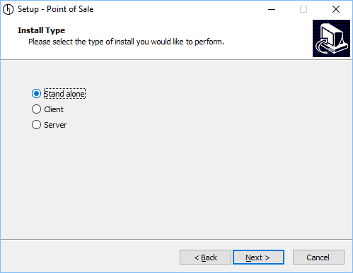

Stand Alone - The installation is to be used on a single computer in a location.

Client - When the POS is installed on multiple computers, within a single location, each install is called a “client”, they will connect to a single database (Server) within the site.

Server - Used in conjunction with Client, the server is the main computer which services the database.

### Destination Location

Where the POS will be installed on the specified computer.

Depending on the Install Type, several folders will be created within this location.

### Distributor Details

In order to install the POS you need to enter your email address and password that is used on our website.

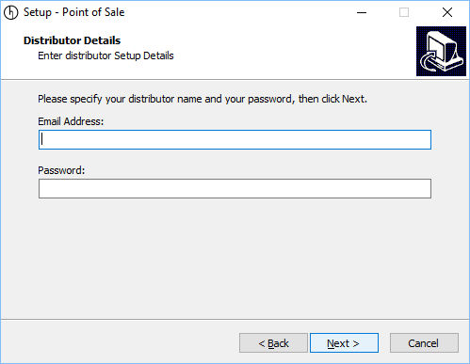

### Server

If you have selected client, you can select which Server you wish to attach to.

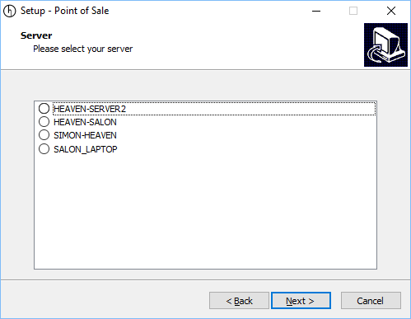

### Select Start Menu

Select the name of the Start Menu item, this will be available when you click Start in Windows.

### Additional Tasks

Select any additional tasks that should be completed during install.

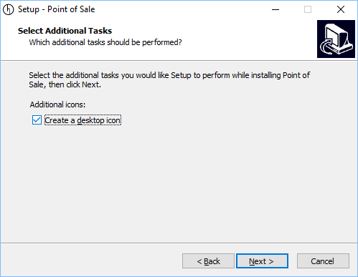

### Ready to Install

Confirms the options you have selected, click next to install.

### Finish

When installation is complete you may have to restart your computer for the changes to take effect.

Your POS is now ready to use.

# POS User Interface[[1]](#footnote-1)

The user interface is the home of the POS, it is highly configurable and allows users to complete all tasks.

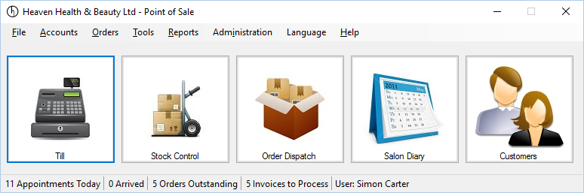

## Home Button and Status Bar Items

You can customise what items you want to display within the POS, you can have:

* Up to 5 home buttons.
* Choice of status bar items.

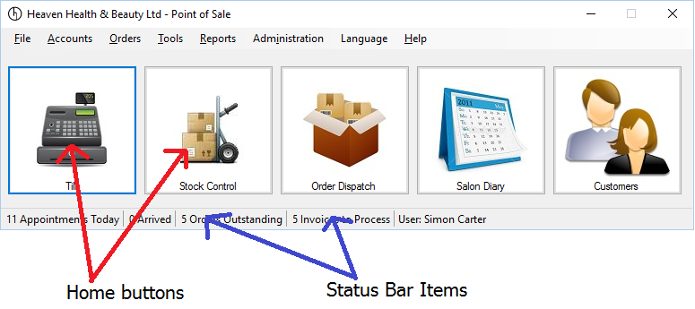

To configure your POS, right click on a status bar item, or right click on a home button. This will display a menu, select the Edit menu.

### Home Buttons

The home button settings are available when you edit the Home Button items. The available home button items will depend on which plugin modules you have loaded.

You can drag and drop the available items from the Available items, down to the Selected items. You can also re-order the Selected items by selecting them and dragging them left or right.

Changes will occur straight after you click the Save button.

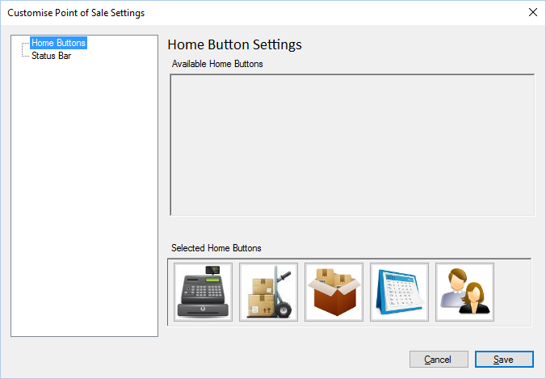

### Status Bar

The status bar settings are available when you edit the status bar items. The available status bar items will depend on which plugin modules you have loaded.

You can drag and drop the available items from the Available items, down to the Selected items. You can also re-order the Selected items by selecting them and dragging them left or right.

Changes will occur straight after you click the Save button.

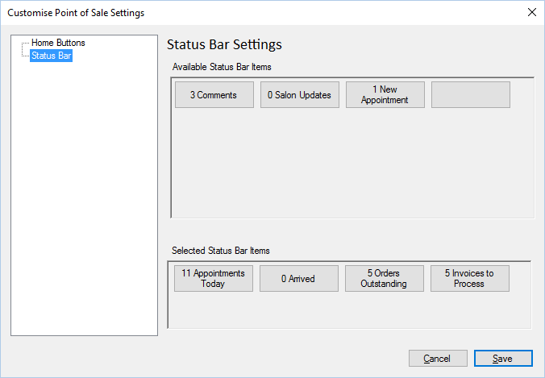

### Lists Views

Where ever you see lists within the POS you can change the order of the columns, resize the columns and sort ascending/descending on any column. All settings will be remembered.

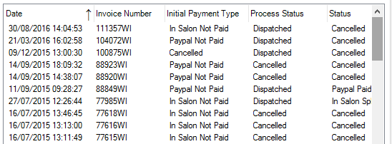

Sort Columns - Click the column header, the first click will sort the column ascending, subsequent clicks will alternate the sorting between descending and ascending.

Resize Lists - Move the mouse between the column headers, the cursor will change to a line with an arrow pointing both left and right. Hold the left mouse button down and drag the column to the desired size.

Auto Resize Column - Move the cursor between the column headers until it changes (as above) and double click, the column will be resized to the most appropriate size for the content.

Change Column Order - To change the column order, place your mouse anywhere in the column, hold down the left mouse button and move your mouse left or right. When the column is in the desired position, release the left mouse button.

## Discounts

When creating orders or using the till, you can specify user defined discounts



The discount is an individual product or treatment discount, using the Till only the default method of assigning discounts is available, when creating an order you can specify the Deafault method or Mimic the Sage method of discounts.

Default - When the default method is used, the discount given is product discount, then user discount plus sale discount.

Sage - The Sage method of providing discount is to give the product discount, then remove the sale discount and then to remove the user discount.

### Product Discount

Each product can be provided an individual discount, this is based on percentage. See Product Item Edit for details on how to set a product level discount.

### User Discount

The user discount is given on a product by product basis and is a percentage that is provided in the Discount box (see above).

### Sale Discount

The sale discount is a further discount that can be applied to the whole sale, this can be a percentage or fixed monetary value.

## Display Language

The POS can be localized into many different languages, language selection can be changed by selecting the Language menu item

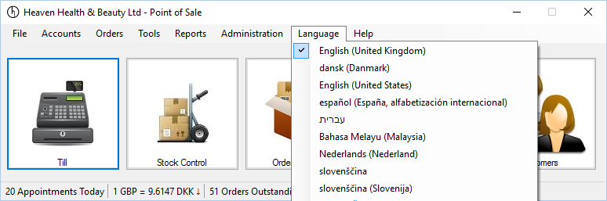

Please view User - Language Settings section for information on how to show or hide the Language menu.

## Settings

Settings are split into two parts, these are:

* Administration settings – settings which affect the entire POS.
* User settings – settings which affect the active user.

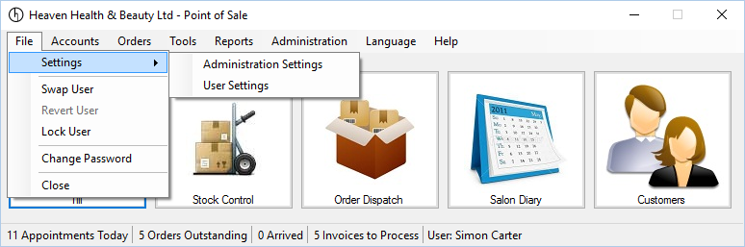

Both of these settings are accessible by selecting the File menu, selecting the Settings menu and then the appropriate menu.

### Standard Settings.

Standard settings are those that affect the POS, Plugin Modules may or may not have other Administration or User settings, if so these will be discussed within the appropriate section for that plugin module.

Settings are broken down into two sub sections, they are Administration settings, only available to POS administrators and User settings which can be used by all system users.

#### Standard Icons

Throughout the POS, there are a number of standard buttons displayed on many of the forms shown, these are designed to indicate actions available across a number of areas. The buttons are always displayed on the top of each form.



If the button appears “greyed out” it is disabled and cannot be used. When the mouse is hovered over each button a hint will appear indicating what action the button will perform.

|  |  |
| --- | --- |
|  | Add or insert. |
| C:\Users\Simon\AppData\Local\Microsoft\Windows\INetCache\Content.Word\action_Cancel_16xLG.PNG | Delete or cancel. |
| C:\Users\Simon\AppData\Local\Microsoft\Windows\INetCache\Content.Word\icon_edit_16.png | Edit |
|  | Save |
|  | Refresh or reload. |
|  | Mark as paid. |
| C:\Users\Simon\AppData\Local\Microsoft\Windows\INetCache\Content.Word\user_16xLG.PNG | View user or view customer. |
| C:\Users\Simon\AppData\Local\Microsoft\Windows\INetCache\Content.Word\column_16xLG.PNG | Print label. |
|  | Print or print invoice. |
| C:\Users\Simon\AppData\Local\Microsoft\Windows\INetCache\Content.Word\notebook_16xLG.PNG | Notes or staff notes. |
|  | Customer notes. |
| C:\Users\Simon\AppData\Local\Microsoft\Windows\INetCache\Content.Word\Team_16xLG.PNG | Change sales person for invoice. |
|  | Issue refund to customer. |
|  | Enter or view tracking details. |
| C:\Users\Simon\AppData\Local\Microsoft\Windows\INetCache\Content.Word\calendar_16xLG.PNG | Select date, select number of days or update invoice date. |
| C:\Users\Simon\AppData\Local\Microsoft\Windows\INetCache\Content.Word\Close_16xLG.PNG | Close the current form. |
| C:\Users\Simon\AppData\Local\Microsoft\Windows\INetCache\Content.Word\lightningBolt_16xLG.PNG | Search or Execute. |
|  | Select count or Number 5 |

#### Administration Settings

Administration settings can only be accessed by users with Admin Member Level. These settings affect the entire POS system.

##### Administration - Login Settings

Login/Logout settings allow administrators to automatically log a user out after a pre-determined number of minutes, of inactivity.

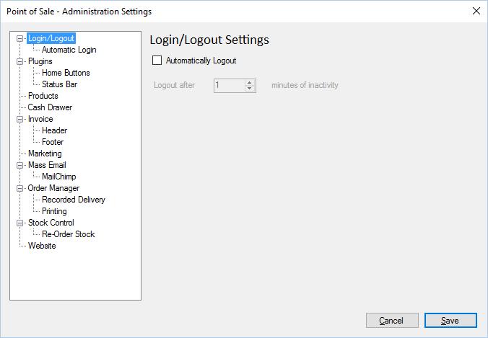

##### Administration - Automatic Login[[2]](#footnote-2)

Automatic login allows administrators to login to the POS automatically using a pre-configured user account.

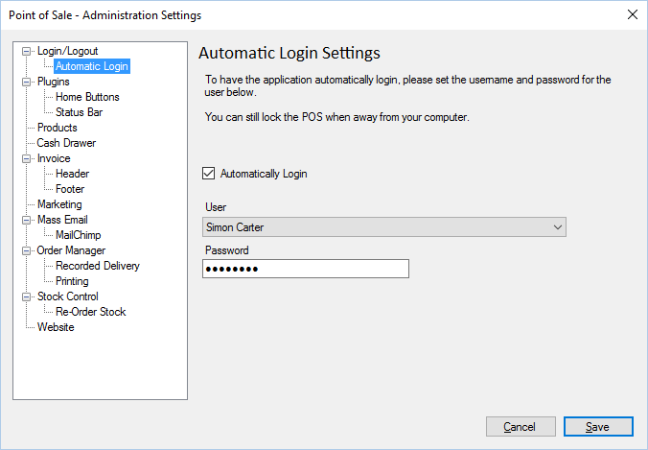

Automatically Login. If set, the POS will attempt to automatically login when initially loading.

User. The user account that is used to login automatically.

Password. The password for the user.

##### Administration - Plugin Settings

Plugin settings will allow administrators to configure which plugin modules are loaded, and what happens when new plugins are automatically downloaded.

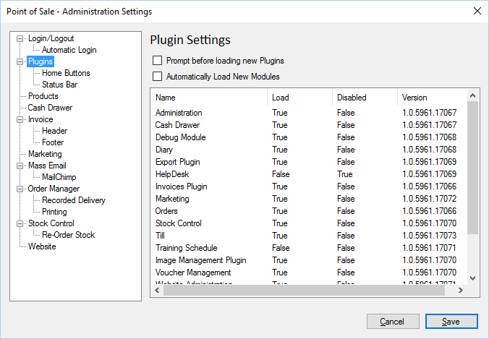

The POS will update and obtain new plugins automatically, as long as there is internet access.

Prompt before loading new Plugins. If new plugin modules are downloaded automatically, you can change this option which will prompt users that it has found new plugins and do they wish to load them.

Automatically load New Modules. If set, this option will automatically load new plugin modules and activate them for use but the current user.

##### Administration - SMS Reminder Alerts

SMS Reminder alert allow staff to send SMS messages to customers as a reminder of an upcoming appointment.

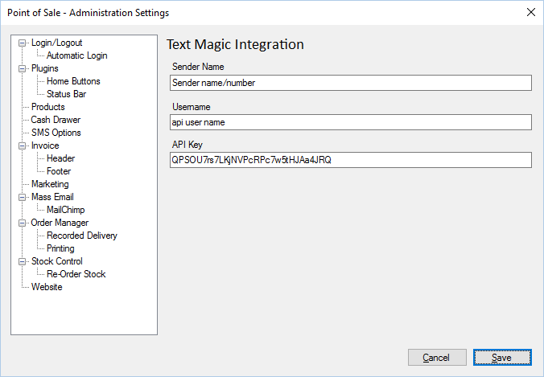

You can create an account with Text Magic (<https://www.textmagic.com/>) a 3rd party sender of SMS messages.

Sender Name. The sender name as created on the text magic website (https://my.textmagic.com/online/reply-options/senderids).

Username. The username for the account (https://my.textmagic.com/online/api/rest-api/keys)

API Key. The integration API key (see above link).

##### Administration – Invoice

Invoice settings determine how invoices are viewed

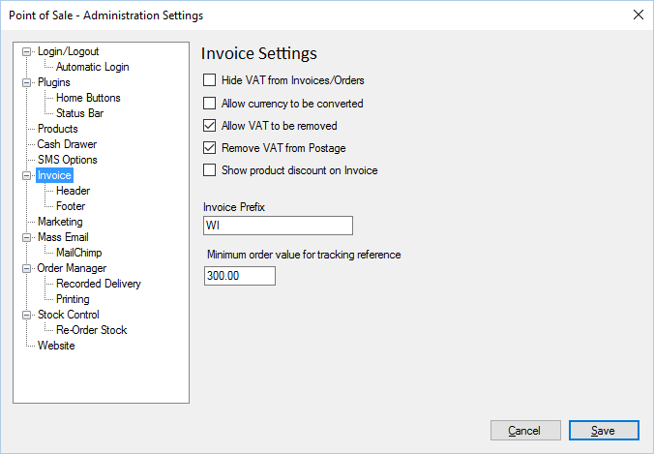

Hide VAT from Invoices/Orders. Does not show VAT on invoices

Allow currency to be converted. Allows currencies to be converted into other currencies.

Allow VAT to be removed. Allows VAT to be removed from invoices/orders.

Remove VAT from postage. VAT is removed from postage.

Show product discount on invoice. Shows the discount if there is one.

Invoice Prefix. Letters/Numbers to prefix any invoice

Minimum order value for tracking reference. Invoices being Dispatch Orders will not require a tracking reference if the order is below this value.

##### Administration - Invoice Header

You can change the image displayed at the top of an invoice

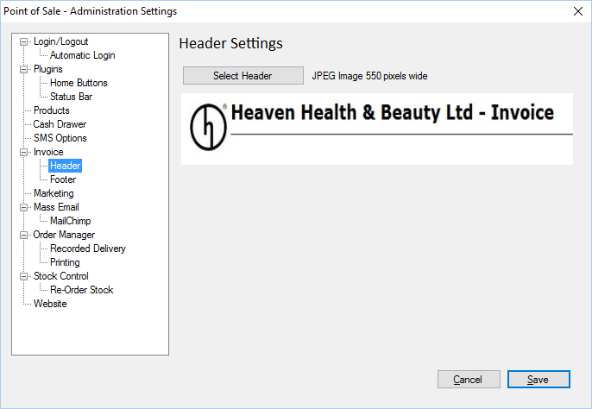

Select Header: Click select header to select a new header image. The image must be a JPEG image which is 550 pixels wide.

##### Administration - Invoice Footer

You can change the text displayed at the bottom of an invoice

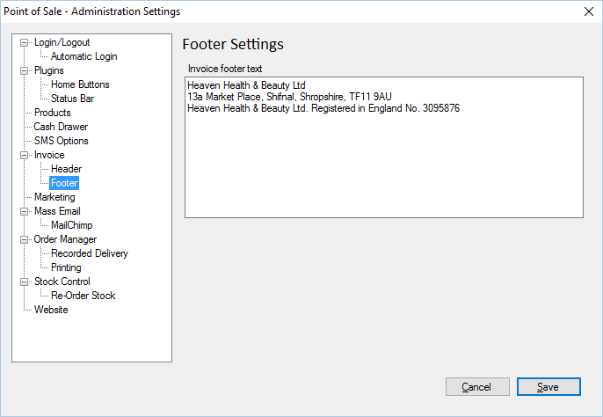

Invoice Footer Text: Text displayed on the bottom of an invoice.

#### User settings

User settings can be accessed by all POS users.

##### User – General

General settings for the POS.

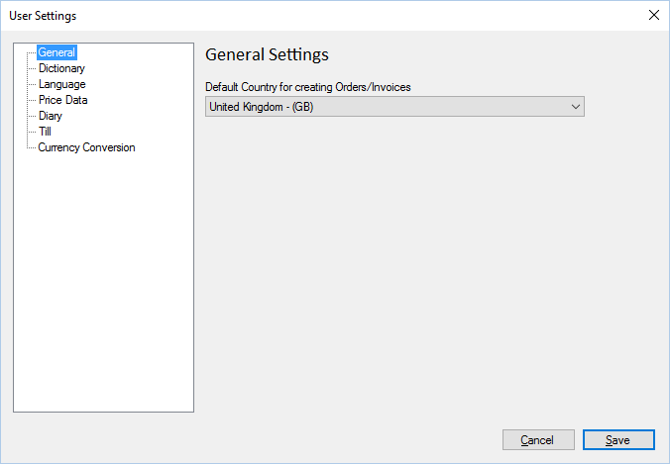

Default Country for creating Orders/Invoices. This is the default country used for creating invoices and orders, users can still change to a separate country on order creation.

##### User - Dictionary Options

User dictionary options allows users to select the default dictionary to be used when spell checking.

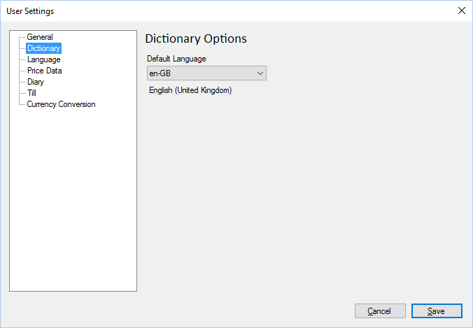

Please note that when spell checking, you can select other dictionaries.

##### User - Language Settings

The language options allow users to change the default currency used.

If the show language menu is checked, then the POS will have a further menu allowing users to select translated options.

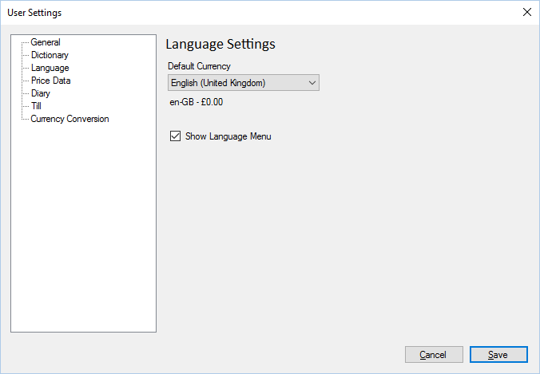

##### User - Price Data

Each product can have up to 3 different standard prices, the Price Data tab allows users to change the description of the price column to something that is easier to remember.

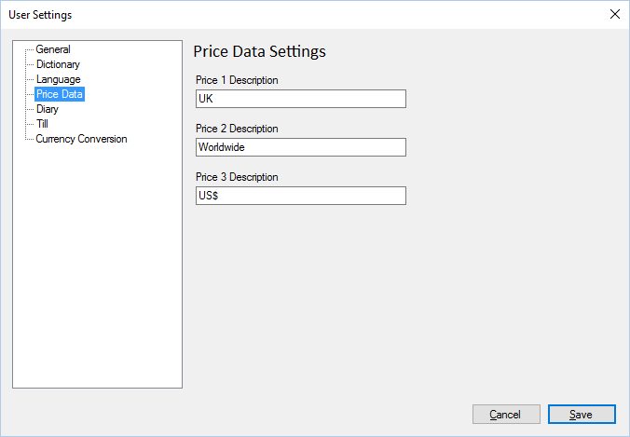

##### User - Till Settings

Till settings provide users different options when viewing the Till

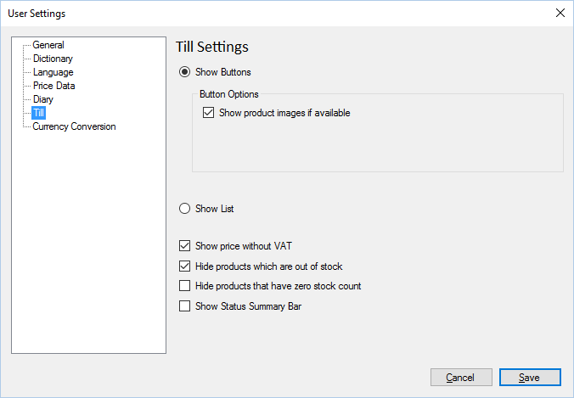

If Show Buttons selected then buttons will be shown within the till.

Show product images if available shows images of products on the buttons within the till. Images are automatically downloaded from the website.

If Show List is selected then product items in the till will be shown in a simple list format.

If Show Prices without VAT is selected then prices will be shown in the Till without VAT applied.

If Hide Products which are out of stock**[[3]](#footnote-3)** is selected then products which are out of stock will not be loaded into the till. This can increase the load speed of the POS.

If Hide products that have zero stock count is selected, any product which has no stock will not be loaded. This can increase the load speed of the POS.

If Show Status Summary Bar is selected then a status bar will be shown along the bottom edge of the Till screen with a summary of the transaction.

Please note that the Till will need to be re-opened for changes to take effect.

# Plugin Modules

Plugin modules enclose functionality for specific tasks, grouped by

## Administration

The administration plugin module includes base administration settings for the POS.

### Settings

#### The administration plugin module introduces one new setting screen shown in Standard Icons

Throughout the POS, there are a number of standard buttons displayed on many of the forms shown, these are designed to indicate actions available across a number of areas. The buttons are always displayed on the top of each form.



If the button appears “greyed out” it is disabled and cannot be used. When the mouse is hovered over each button a hint will appear indicating what action the button will perform.

|  |  |
| --- | --- |
|  | Add or insert. |
| C:\Users\Simon\AppData\Local\Microsoft\Windows\INetCache\Content.Word\action_Cancel_16xLG.PNG | Delete or cancel. |
| C:\Users\Simon\AppData\Local\Microsoft\Windows\INetCache\Content.Word\icon_edit_16.png | Edit |
|  | Save |
|  | Refresh or reload. |
|  | Mark as paid. |
| C:\Users\Simon\AppData\Local\Microsoft\Windows\INetCache\Content.Word\user_16xLG.PNG | View user or view customer. |
| C:\Users\Simon\AppData\Local\Microsoft\Windows\INetCache\Content.Word\column_16xLG.PNG | Print label. |
|  | Print or print invoice. |
| C:\Users\Simon\AppData\Local\Microsoft\Windows\INetCache\Content.Word\notebook_16xLG.PNG | Notes or staff notes. |
|  | Customer notes. |
| C:\Users\Simon\AppData\Local\Microsoft\Windows\INetCache\Content.Word\Team_16xLG.PNG | Change sales person for invoice. |
|  | Issue refund to customer. |
|  | Enter or view tracking details. |
| C:\Users\Simon\AppData\Local\Microsoft\Windows\INetCache\Content.Word\calendar_16xLG.PNG | Select date, select number of days or update invoice date. |
| C:\Users\Simon\AppData\Local\Microsoft\Windows\INetCache\Content.Word\Close_16xLG.PNG | Close the current form. |
| C:\Users\Simon\AppData\Local\Microsoft\Windows\INetCache\Content.Word\lightningBolt_16xLG.PNG | Search or Execute. |
|  | Select count or Number 5 |

Administration Settings.

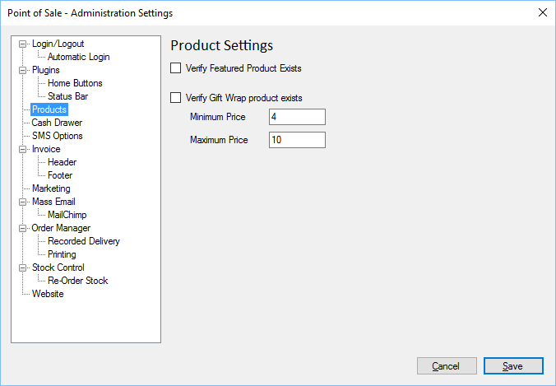

Verify Featured Product - If ticked, verifies that a featured product exists, the featured product is shown on the website and must be set.

Verify Gift wrap - If gift wrapping is available as an option in your online shopping cart, this option will verify it exists and that its value is between a minimum and maximum price.

Minimum Price - Minimum price of the gift wrap.

Maximum Price - Maximum price of the gift wrap.

### Products

You can view and edit all products within the POS.

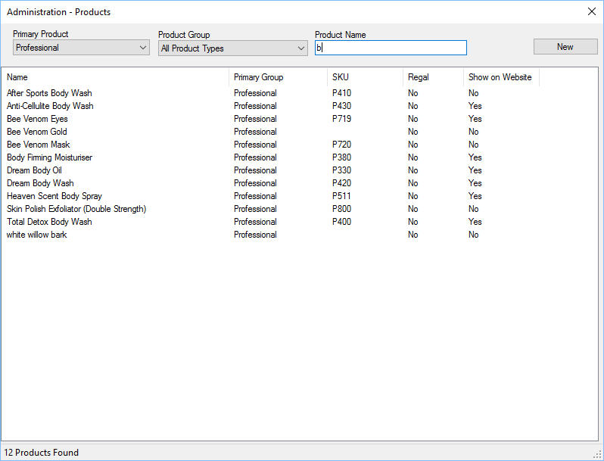

When viewing products you can filter on primary product type, product group or enter the name, or part of the name to filter down to specific products.

Clicking the New button will create a new product.

### Product Edit

There are several different options when editing a product. Each product should have a unique name, a valid product code (also known as SKU) and be assigned to a primary group type.

#### Details

The product details include a description, how to use, ingredients and features section, if used these details will be shown within the website.

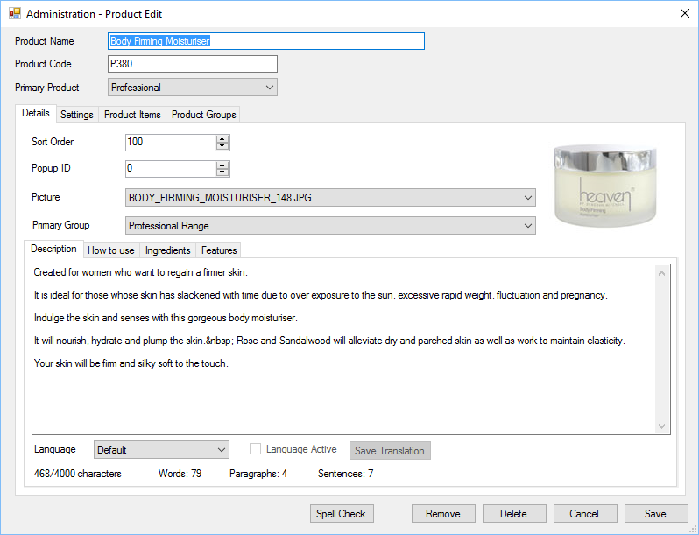

If you have multiple languages setup for your website you can translate the different sections, select the language, once the translation is complete click the “Language Active” tick box and then click “Save Translation”, if the translation is incomplete do not click the “Language Active” tick box.

It is important that you click “Save Translation” when you have made changes, as this is not done when you click the normal save button.

The save button will save all other settings other than tranlations.

You can delete a product if it has not been used within an invoice or order and as long as there is no stock available. If it has been used within an invoice or order you can “Remove” the product, this will permanently remove it, without deleting it.

#### Settings

The settings tab changes how the product is used within the POS and on the website.

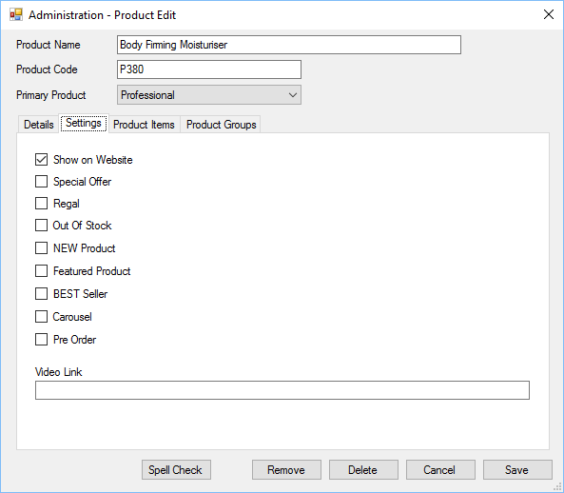

Show on Website - If selected the product will be visible on the website.

Special Offer - If selected the product will be shown as a special offer.

Regal - If selected the product will be flagged as “Regal” within your website.

Out of Stock - If selected, then the product will be shown as out of stock on the website.

New Product - If selected the product will be flagged as “New” within the website.

Featured Product - If selected the product will appear be the featured product on the website. There can only be one featured product at a time.

Best Seller - If selected the product will be flagged as a “Best Seller” within the website.

Carousel - If selected the product will appear in a carousel within the website.

Pre Order - If a product is out of stock but available for pre order, a pre order notification will be given to the customer.

Video Link - If the product has an associated youtube video, you can specify the unique youtube reference and it will be displayed on the website.

#### Product Items

Each product can have multiple product items, these represent the saleable or stock items.

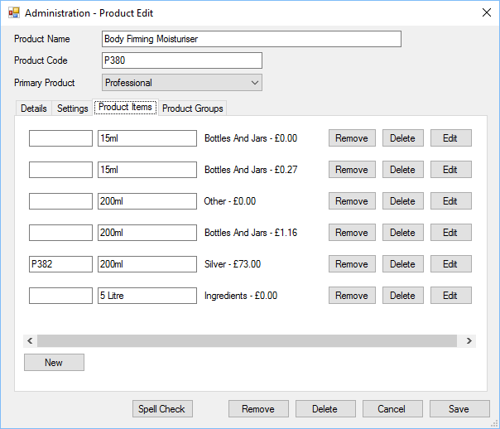

You can change the product code and product size directly or for more options click Edit.

Remove - This will permanently remove the product from the system, without deleting it.

Delete - This will allow you to delete the product item, as long as there is no stock and that it hasn’t been used within an order or invoice. If it has been used within an invoice or order then use the Remove option.

New - Creates a new product item.

##### Product Item Edit

You can edit a product item for more options.

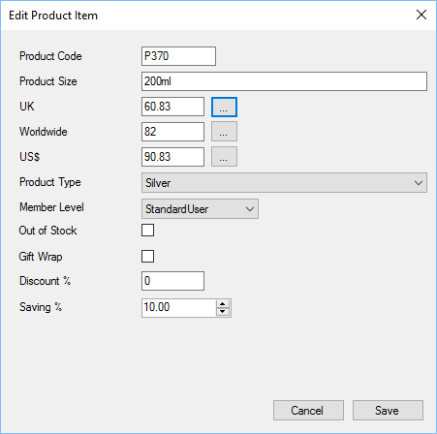

Product Code - Also known as SKU, is a unique product identifier.

Product Size - Description of the product size or product colour.

Prices - Please see User - Price Data section for the available price options.

Product Type - This represents the product item primary type.

Member Level - The product will only be visible to members with this member level and above. Please see the section on Member Level for more information.

Out of Stock - Product item will be marked as out of stock on the website, and will not be available for sale within the POS.

Gift Wrap - If the product item represents the product item for gift wrapping then this tick box should be set. Only one product item within the system can be Gift Wrap.

Discount - If the product item is to be temporarily discounted, the discount amount should be entered here. This will affect sales on the website and within the POS.

Saving - If the product offers a saving (for instance if it’s a kit) you can put the saving here to be shown on the website.

The buttons next to the prices will load the product Price Calculator which allows staff to calculate the cost of an item with VAT added.

##### Price Calculator

The price calculator allows staff to accurately price an item depending on VAT rates and calculate the price based on the final retail price.

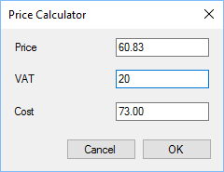

Price - The net amount for the product.

VAT - The current VAT Rate set as default for the POS.

COST - The final price if VAT is charged to a customer.

Changing and of the value’s will recalculate the values, if you press OK then the net price will be updated for the product item.

#### Top Selling Products

You can view the top selling products for the selected number of days and optionally set the “Best Seller” status for those products selected.

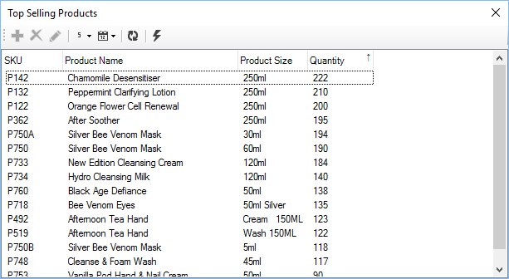

The above form shows the top selling products based on sales for the selected number of days and items.

View Product Reports for other options.

#### Product Groups

Each product can belong to multiple Product Groups, which will show within the website.

To show the product within a certain product group, put a tick in the box next to the product group name.

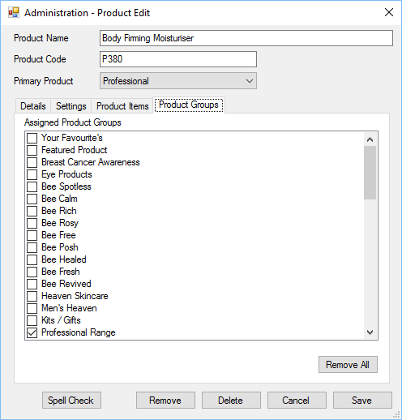

### Product Groups

Product groups allow products to be grouped by type, both within the POS and on websites.

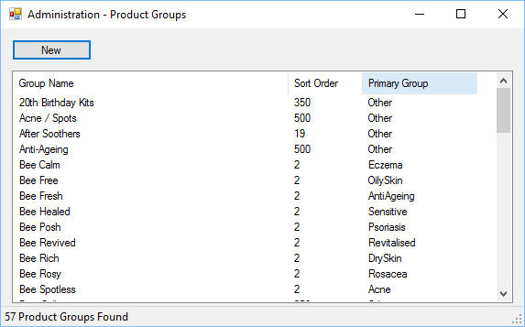

To edit a product group double click from within the list.

#### Edit Product Group

Product groups are split into two types with either a named product group[[4]](#footnote-4), or other. Named product groups behave and display differently within the website.

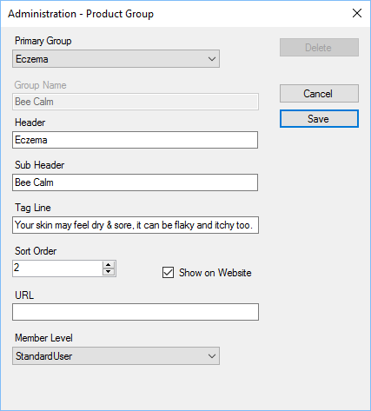

Primary Group - Primary group type; you should only have 1 group for each type listed, unless the type is other.

Group Name - Only used with Other, allows users to specify the name of the group.

Header - For named group types only this is the Group Header name.

Sub Header - For named group types only, specifies the sub header for the group.

Tag Line - Used on the website only, the header displayed at the top of the page when the group is selected.

Sort Order - Specifies the sort order for the group, lower numbers appear before higher numbers. If groups have the same sort order then they will be sorted by name as well.

Show on Website - If ticked the group will be shown on the website.

URL - You can add a URL (website address), if one is specified then when a user clicks the group on the website, it will jump to the URL specified. If no URL is specified then the standard website group page will be displayed.

### Discount Coupons

Discount coupons can be used by the Till module and on the website. There is no limit to the number of active coupons.

The name of the coupon must be unique and is not case sensitive.

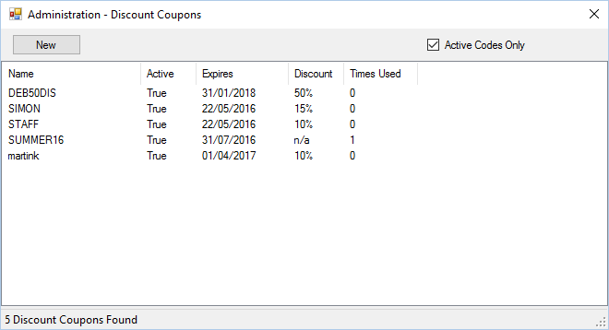

You can choose to view active coupon codes or all codes within the database.

Double click an existing coupon to edit, or click “New” to create a new coupon.

When you edit or create a coupon you will be shown a Wizard interface to guide you through the steps of setting up your coupon.

See the Apply Discount section to see how the coupon can be redeemed in the Till.

#### Step 1

Step 1 allows you to define the name, start and expiry date/time.

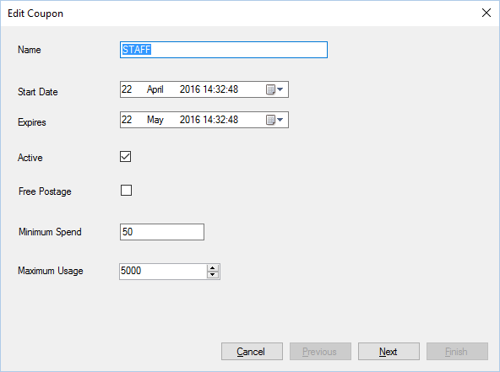

* Name: Unique coupon name
* Start Date: Date/time the coupon can be used.
* Expires: Date/time the coupon ceases to be usable.
* Active: Weather the coupon is active (can be used) or inactive (cannot be used).
* Free Postage: If set then the user who uses the coupon can have free postage.
* Minimum Spend: Minimum amount of products the user must have in their shopping cart to use the voucher.
* Maximum usage: The maximum number of times the coupon can be used.

#### Step 2

Step 2 allows you to define the type of voucher and it’s settings.

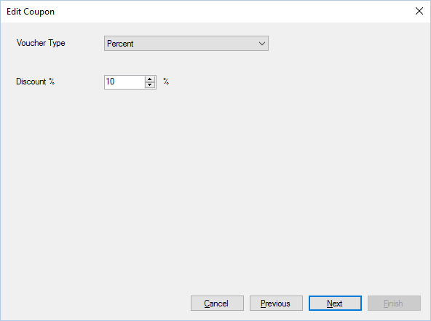

Currently there are 5 voucher types they are:

**Percent**: The user is given a discount percent from their shopping cart.

**Value**: The user is given a specific monetary value off their shopping cart.

**Footprint**: This code does not provide the user with any money off but provides a way of tracking sales.

**Special Offer**: Provides the user with a special offer, other than money off. I.e. enter the code “code” to receive a free gift of our choice.

**Free Product**: The user can have a specific free product if they buy a specific product. I.e. but a hand cream and get an eye cream free.

#### Step 3

Step 3 allows you to define what products the user must have in their basket to activate the coupon.

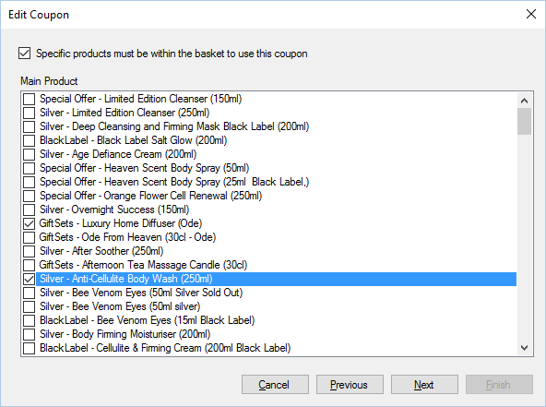

The main product is one that the user must have in their basket to activate the coupon, you can choose multiple products here. The user only has to have one of the products within their basket to activate the coupon code.

Tick each one that applies.

#### Step 4

Step 4 allows you to specify a free product that the user can have, providing all previous step’s have been fulfilled.

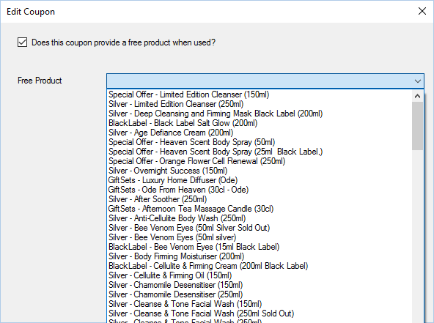

#### Summary

The summary window allows you to have an overview of the coupon.

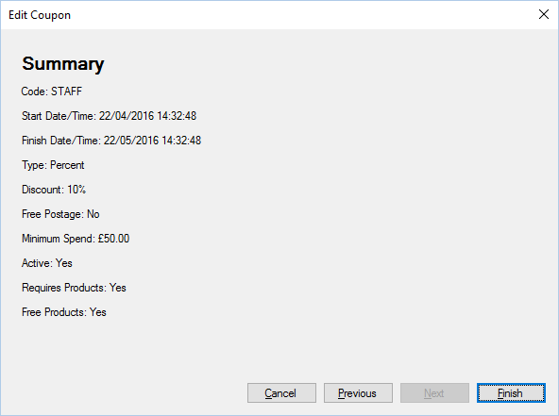

Click finish to save the coupon settings or click cancel to forget the changes you have made.

### System Emails

You can configure and change the emails which are sent by the POS and website.

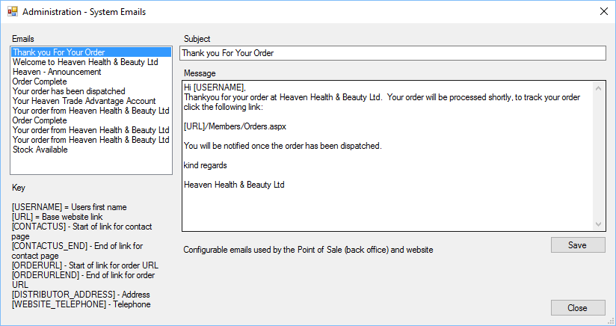

The system is designed to send emails at different times when triggered. You can update how an email appears, or the language used.

Emails - Type of Email.

Key - Configurable options within an email, these items will be replaced with the actual value stored in settings.

Subject - The subject/title of the email.

Message - The message within the email.

Save - Saves user changes.

### Customers

You can search for and edit customers within the POS.

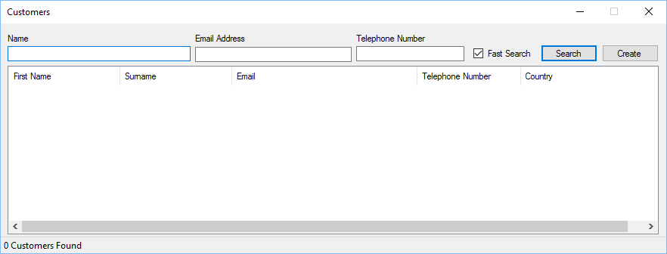

Name - Full or partial name of customer, you can enter part names for first and surname, for example, if you wanted to search for “Tracey Toddlington” you could enter: tra tod.

Email - Enter full or partial email address.

Telephone Number - Enter full or partial telephone number.

Fast Search - Limits the search to the first 200 matching records.

Search - Searches the customer database.

Create - Creates a new customer record, see Create New Customer section for more information.

You can double click a customer to edit/view the customer details.

#### Create New Customer

Users can easily create a new customer within the POS.

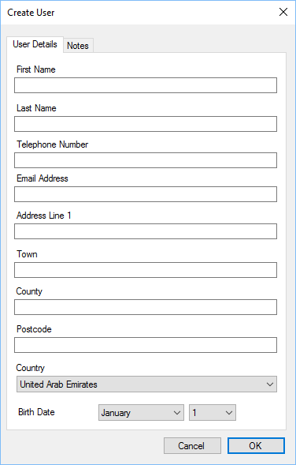

Enter the customer details in the relevant field.

If a customer does not have an email, leave the field blank and a unique reference will be provided. Customers without an email cannot be used for marketing purposes.

The birth date can be used to send out birthday offers to customers.

#### View Customer Details

You can view all customer details in the POS.

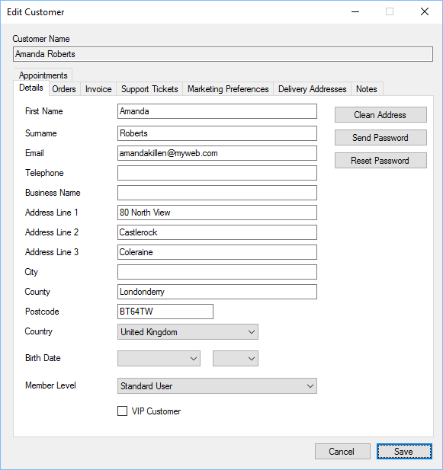

You can update the customer basic details.

Clean Address - Attempts to remove duplicate entries from the address.

Send Password - Sends an email to the customer with a reminder of their password.

Reset Password - If for some reason the customer is not receiving emails, this option will generate a random password, you can inform the customer of the password so they can login.

#### View Customer Orders

You can view all customer orders.

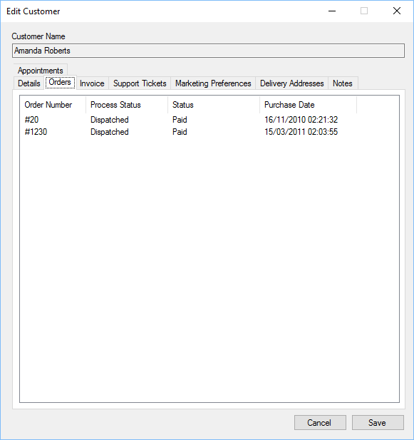

Double click an order to open it.

#### View Customer Invoices

You can view all customer invoices within the POS.

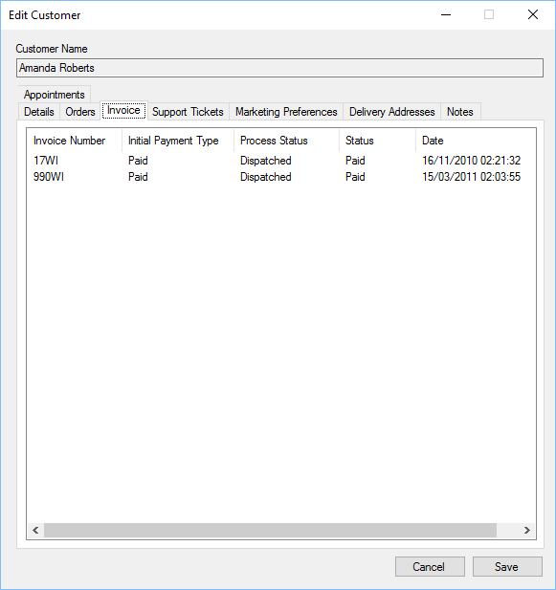

Double click an invoice to open it.

#### View Customer Support Tickets

You can view all support tickets created by a customer.

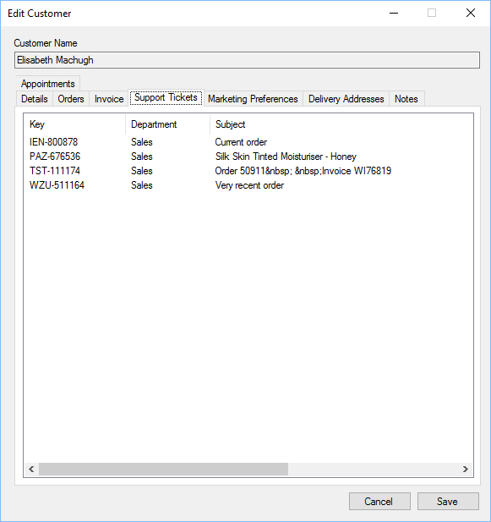

Double click a ticket to open/view the support ticket.

#### View Customer Marketing Preferences

You can view and update marketing preferences for a customer.

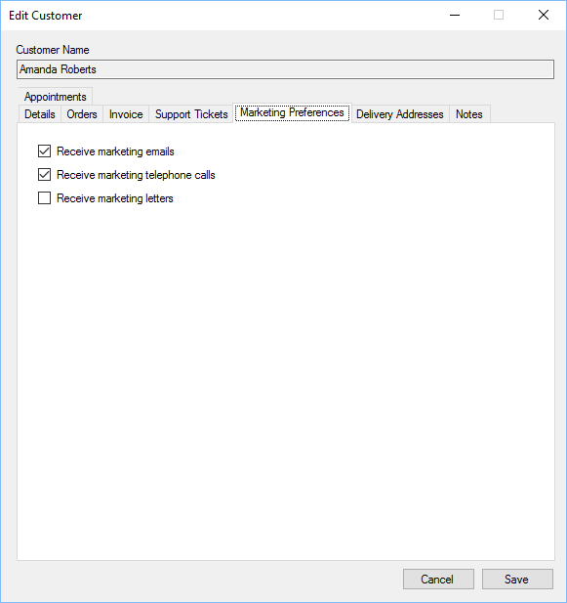

Place a tick in each option that applies.

#### View Customer Delivery Addresses

You can view and edit delivery addresses within the POS.

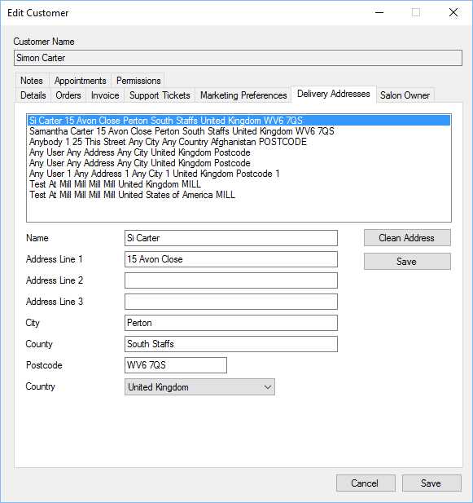

Select the address you wish to view, once you have made changes, click the Save button next to Address Line 1 to save changes.

#### View Customer Notes

You can add any notes you wish to a customer record.

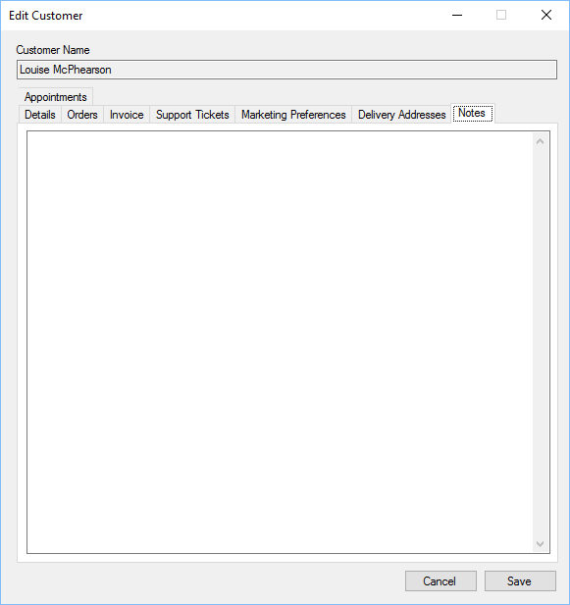

#### View Customer Appointments

You can view all appointments the customer has had in the Appointments tab.

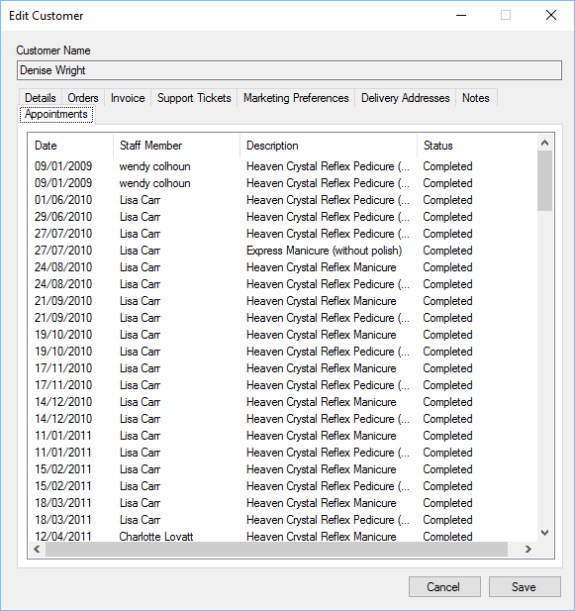

Double click an appointment to view/edit.

#### Export Customers

To export customers, choose Export from within the Customers menu.

##### Step 1

Select the countries where the customers reside. You can select all or multiple countries.

##### Step 2

You can limit which customers to export by selecting various options.

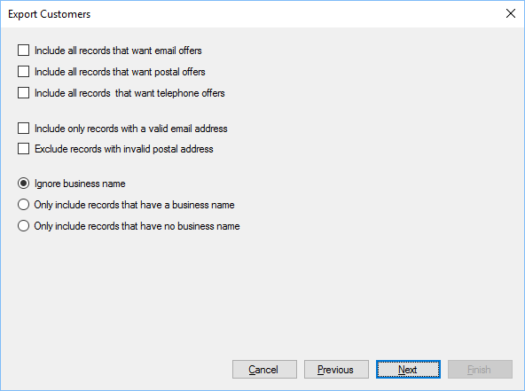

Email Offers - Only includes customers who have opted in to receiving email offers.

Postal Offers - Only includes customers who have opted in to receiving postal offers.

Telephone Offers - Only includes customers who have opted in to receive telephone offers.

Valid Email - If ticked, only customers with a valid email address will be included.

Valid Postal - If ticked, only customers with a valid postal address will be included.

Ignore Business Name - If selected, the business name is ignored.

Have Business Name - If selected, only customers with a business name will be included.

No Business Name - If selected, only customers without a business name will be included.

##### Step 3

The records can be further filtered using the member level.

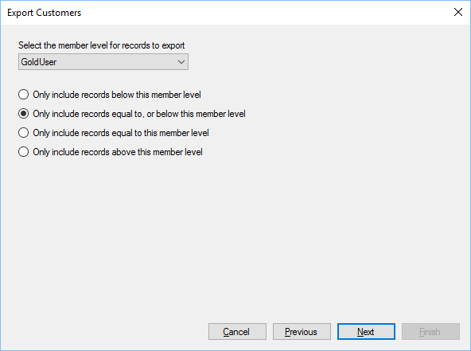

Member Level - Select the desired member level.

The other options specify how to filter based on member level.

##### Step 4

List the fields you wish to export.

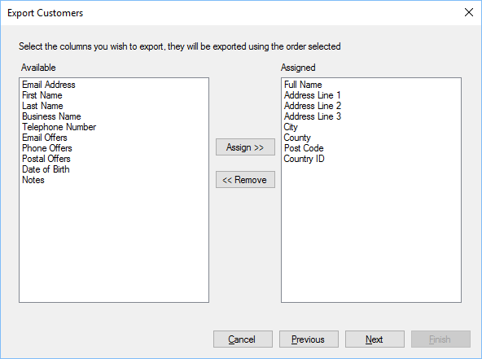

Available - Fields which are available for export.

Assigned - Fields which will be exported. These are exported in the order they appear.

Assign - Select a field in the available section, click assign to move it to the assigned section.

Remove - Select a field in the assigned section, click the remove button to remove it.

You can also double click a field within the Available and Assigned sections to move it to the opposite list.

##### Step 5

Click next during this stage to build a list of customers that will be exported.

##### Step 6

Select the file where the data will be saved to.

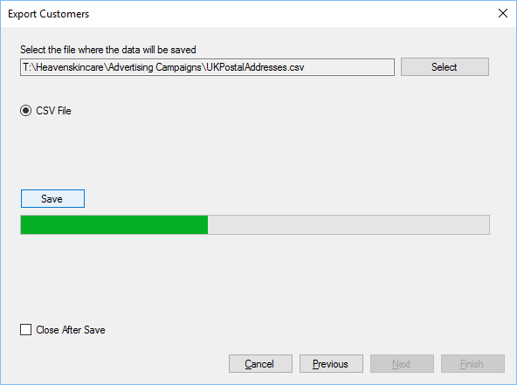

Select - Select the folder and file name where the data will be saved to.

CSV File - Save as CSV file.

Save - Click Save to save the data.

Close After Exit - If ticked, the export wizard will close automatically after saving data.

## Staff

### Settings

The following sections show the settings introduced with the staff module.

#### Leave

Leave settings affect how staff request and manage leave requests within the company.

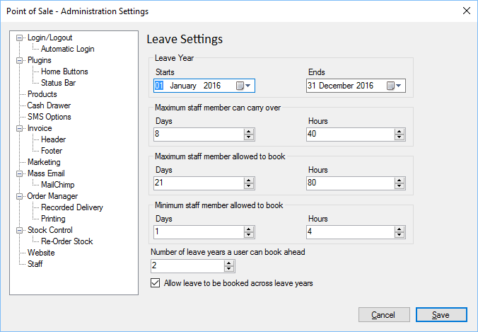

Leave Year - Defines the leave period for the company.

Carry Over - Defines how much leave can be carried over, if it has not been taken. This can be set to zero if leave is not allowed to be carried over.

Maximum Booking - Maximum consecutive time a staff member can book during a leave request.

Minimum Booking - Minimum time a staff member can book.

Leave Years - Defines how many years in advance, a member of staff can book leave.

Across Years - Defines whether staff can book leave across leave years or not.

### Manage Staff

To administer staff members you can select Staff menu and then click Manage Staff, you will be presented with the following form:

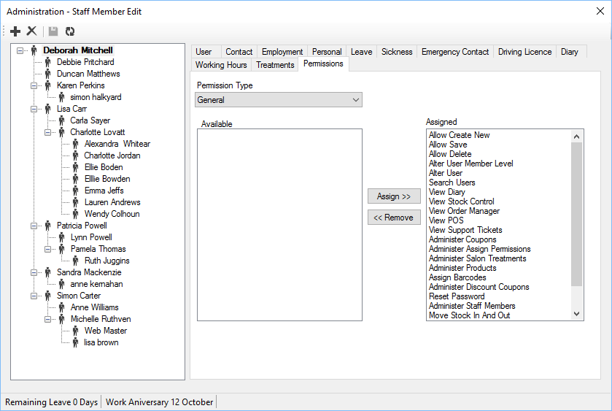

#### Toolbar Icons

The following list describes what the toolbar icons represent:

 Add new staff member.

Remove selected staff member. This includes checks to make sure the staff member can be deleted, if not, a notification will appear.



Save changes the selected staff member.



 Refreshes the staff list.

#### Staff Members

The left part of the form shows the staff in a hierarchical representation. Clicking on the staff member will show you their details on the right hand side.

To move a member of staff select the staff member, drag the staff member by holding the left mouse button down, drag the staff member over the member of staff who they will report to and release the left mouse button.

#### Create Staff Member

There is a wizard for creating new staff members.

##### Step 1

Select the member of staff from the existing customer list, if the staff member has never been a customer, create a new record when you select.

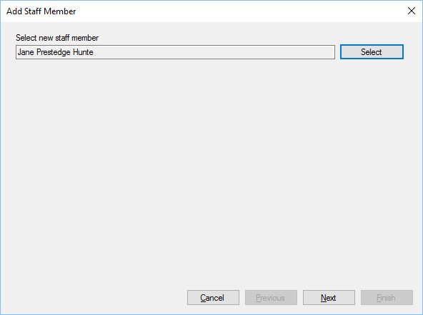

##### Step 2

Enter personal information about the staff member.

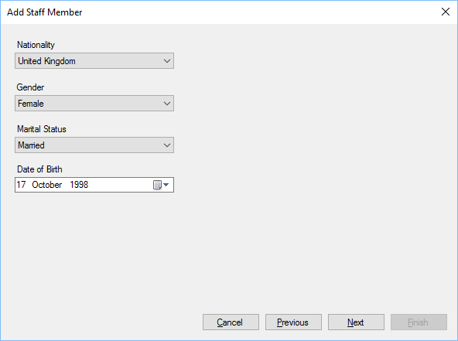

##### Step 3

Enter employment details.

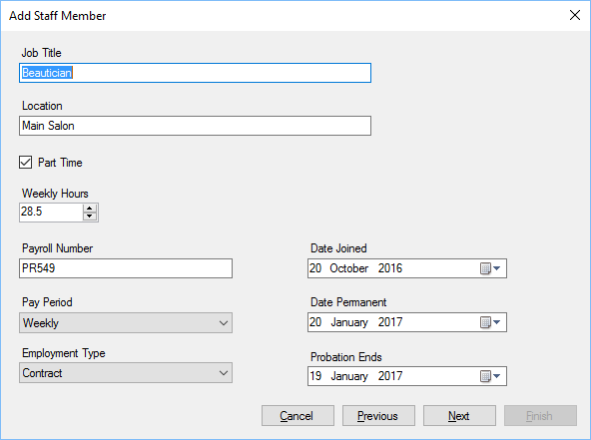

##### Step 4

Enter leave entitlements

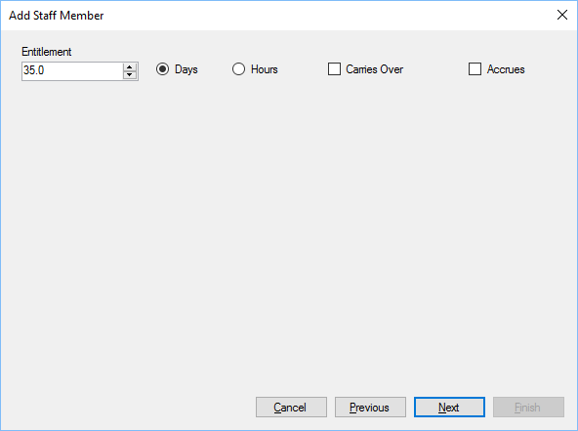

##### Step 4

Select line manager and member level.

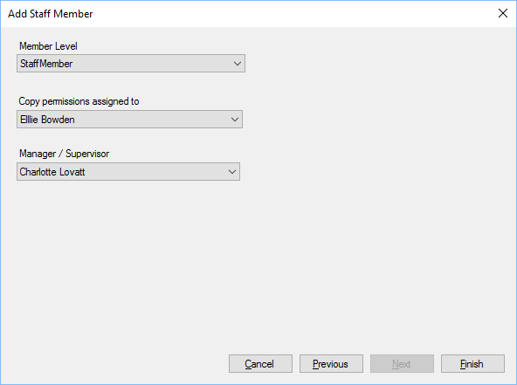

Member Level - The default member level for the staff member.

Copy Permissions - Optionally select another member of staff who’s permissions will be copied.

Manager/Supervisor - Select the staff member who the new staff will report to.

Click Finish to create the staff member.

#### Remove Staff member

To remove a member of staff, select the staff member you wish to remove and click the  tool bar button.

When a member of staff is being removed, checks will be made to ensure they have no future appointments etc.

### Details

These store basic staff member details including contact details and member level.

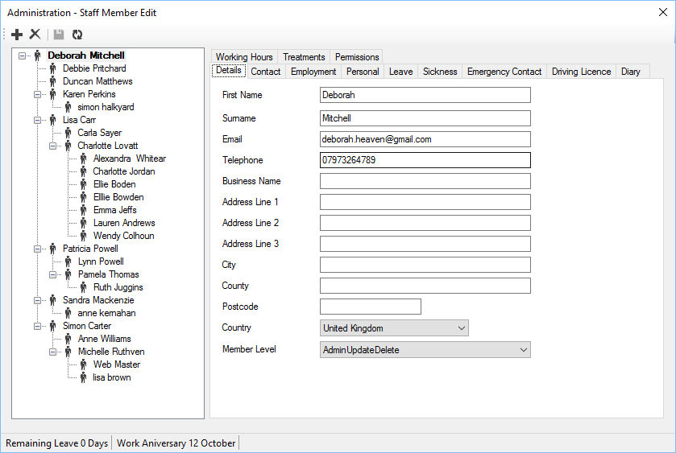

Details holds basic staff details for the member of staff

Member Level:

There are several varieties of member level, these represent what pages a member of staff can view on the website. These work in conjunction with permissions assigned to each user.

### Contact

The contact section holds various telephone numbers for staff members.

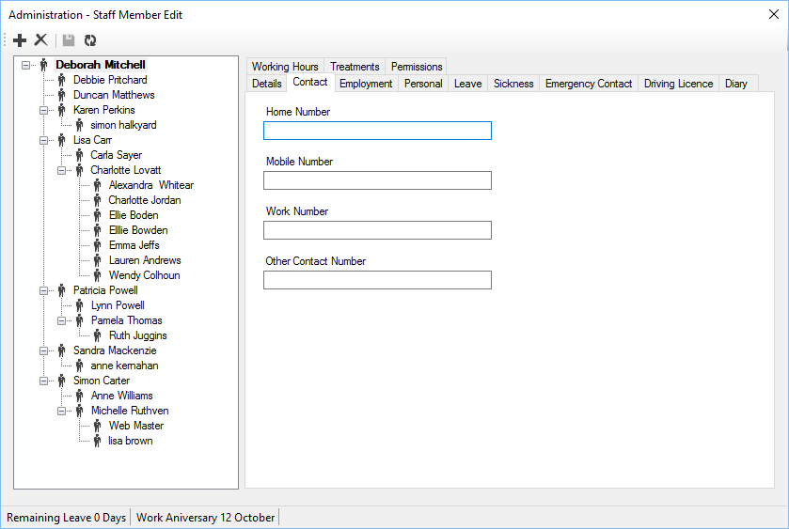

### Employment

The employment details for users are held within this section.

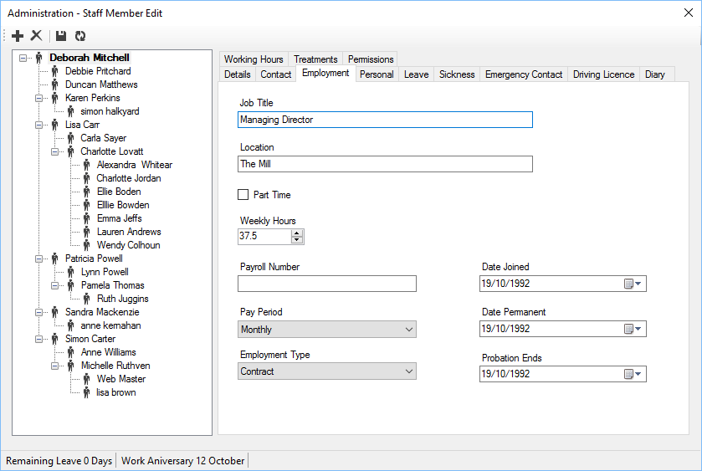

Job title - Job title for staff member.

Location - Location where staff member works from.

Part Time - Indicates the staff member is a part time, if ticked. If left unticked the staff member is considered full time.

Weekly Hours - The standard number of working hours for a staff member.

Payroll Number - Employees payroll number.

Pay Period - Frequency of pay.

Employment Type - Type of employment.

Dates - Date of joining/when permanent employment starts if a probation period is defined.

### Personal

Personal information for staff member.

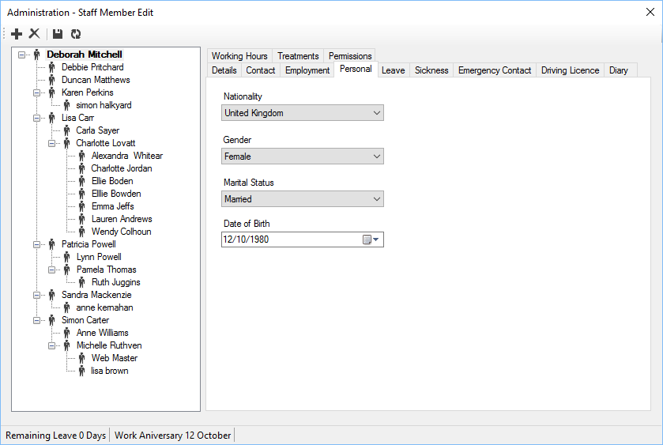

Allows companies to keep personal information on each staff member.

### Leave

Stores Leave/Holiday entitlement and requests for staff members.

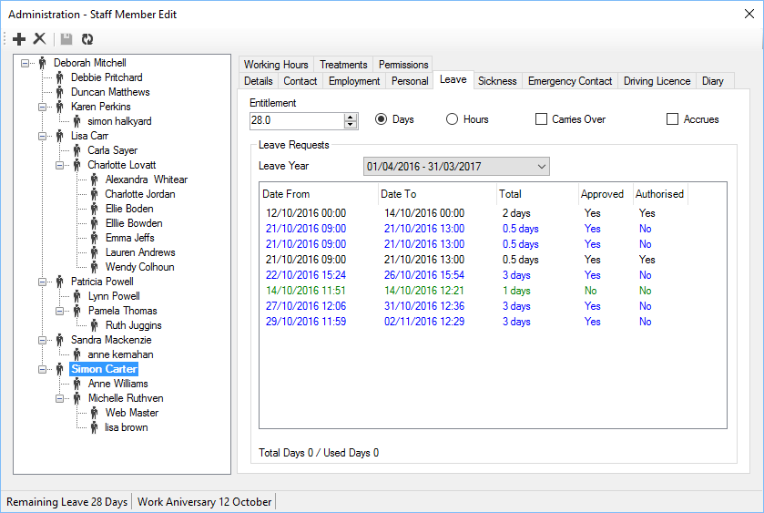

Entitlement - Staff members leave entitlement.

Days - Signifies that the entitlement is in days.

Hours - Signifies that the entitlement is in hours.

Carries Over - If ticked, any unused leave can be carried over to the next leave year, if unused.

Accrues - If ticked, the leave entitlement is accrued in line with the staff members working hours.

### Sickness

You can manage staff sickness within the POS, whilst viewing staff members, if you have permission. Select the Sickness tab. There is a pop up menu which will be activated when you right click the list in the Sickness tab.

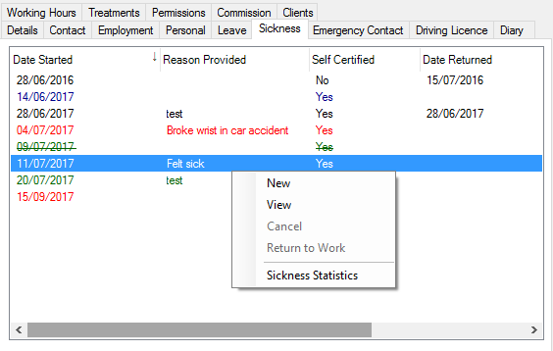

New - Initiates a new wizard to create a new sick record.

View - View the selected sick record.

Cancel - Cancel a pre-booked sick absence.

Return to Work - Initialises a return to work wizard for completing the staff sickness record.

Sickness Statistics - Displays statistics for the current staff members sickness. This will show the current leave year compared to all previous leave years.

The sick records are colour coded for easy reference as follows:

Black - Closed record.

Blue - Open record, currently off sick.

Green - Pre-booked event set for a future date, this covers such things as hospital attendance etc.

Red - Future event that is not pre booked.

~~Green~~ - Cancelled pre-booked future record.

#### New

To create a new sick wizard you can click New or select the appropriate menu from the main Staff menu, this will initialise a wizard that will guide you through booking a member of staff off sick.

##### Step 1

Sselect the member of staff

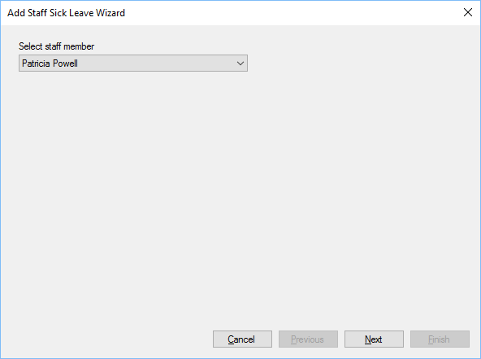

##### Step 2

Enter the date and time the sick leave started along with the date and time you were notified. Pre Booked is specifically for instances where a member of staff will attend hospitals etc.

You should enter as much details as known, this cannot be updated at a later date.

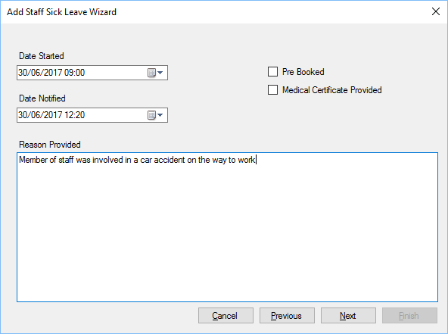

##### Step 3

During step 3, which will only be shown if the staff member has appointments, you can cancel or reassign the appointments.

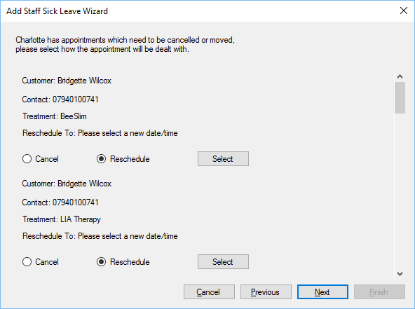

At this stage you can contact the customers to offer to reschedule the appointment, or cancel it, if you click the select button a new window will open which will bring up a list of appointments slots, at a similar time, that can be used:

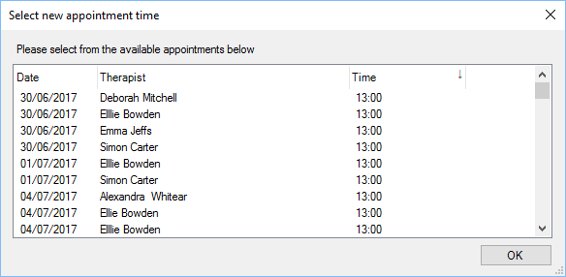

Select the desired appointment slot and click OK.

##### Ste 4 – Summary

Step 4 is the final stage, if you click finish, the member of staff will be marked as off sick within the diary, the appointments will be cancelled or rescheduled as required.

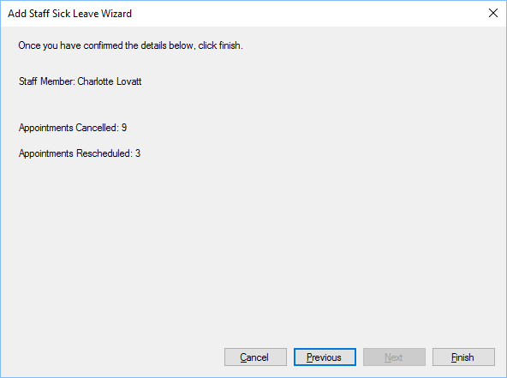

#### View

If you have the correct permissions you can view sickness records, right click the sickness record you wish to view and click View:

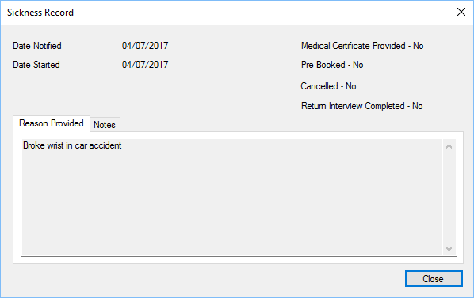

#### Return To Work

When a member of staff returns to work you can need to select Return to Work menu, enter the date/time the staff member returned, notes are optional but should be included if a return to work interview is completed.

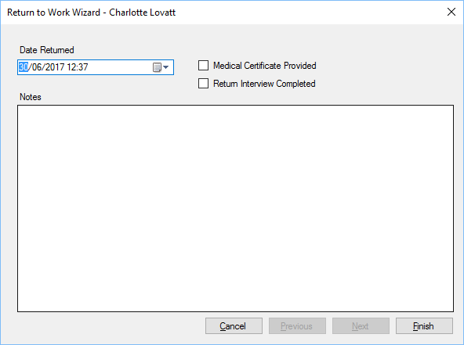

#### Sickness Statistics

The statistics gives a brief overview of the staff members sickness history:

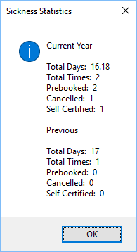

### Emergency Contact

Stores emergency contact details for a member of staff, should an emergency arise.

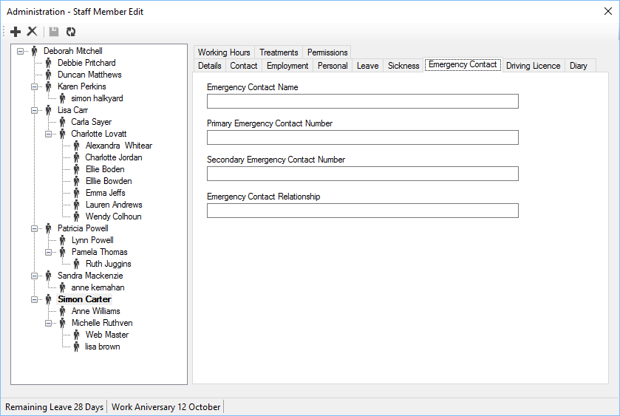

Name - Name of emergency contact.

Primary Number - Telephone number of emergency contact.

Secondary Number - Secondary emergency contact number.

Relationship - Relationship of emergency contact to staff member.

### Driving Licence

Staff driving licence details can be included if required.

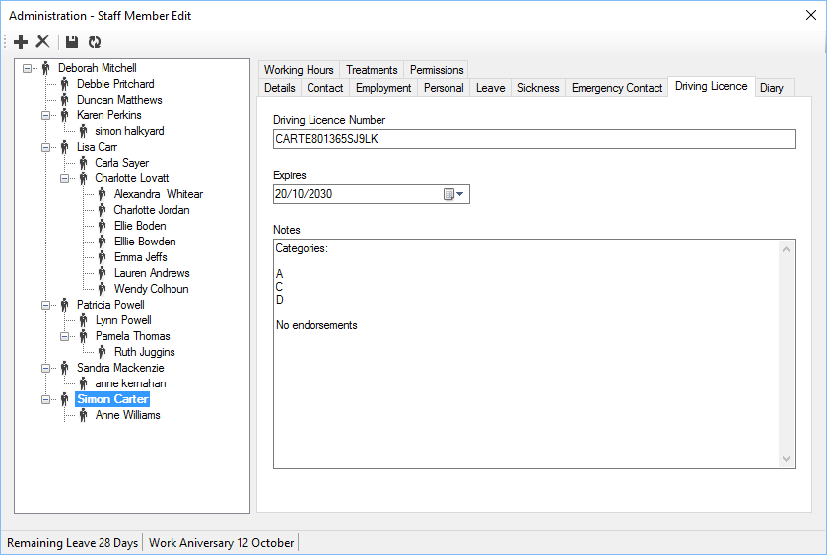

Licence Number - Driving Licence Number.

Expires - Licence expiry date.

Notes - Free notes, could be used to note the categories, endorsements etc.

A notification will appear if the licence expiry date is due.

### Diary

If the staff member is to be included within the diary, you can edit the settings in the diary tab:

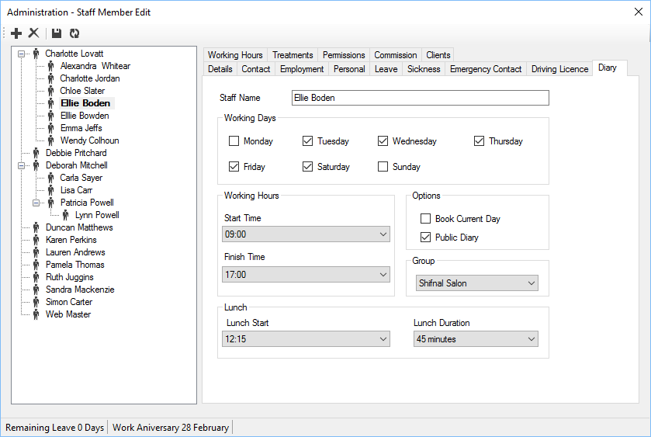

If the staff member has no diary option then click “Create Diary”, to remove the staff members diary click “Delete Dairy”.

Staff Name - Name that appears within the diary.

Working Days - Standard working days for the staff member.

Working Hours - Standard working hours for the staff member.

Lunch - Specify standard lunch times for the staff member.

Book Current Day - Allows members of the public to book an appointment via the website[[5]](#endnote-1) for the current day.

Public Diary - Allows members of the public to book an appointment via the website.

### Working Hours

Working hours can be used to create specific shift patterns for a member of staff.

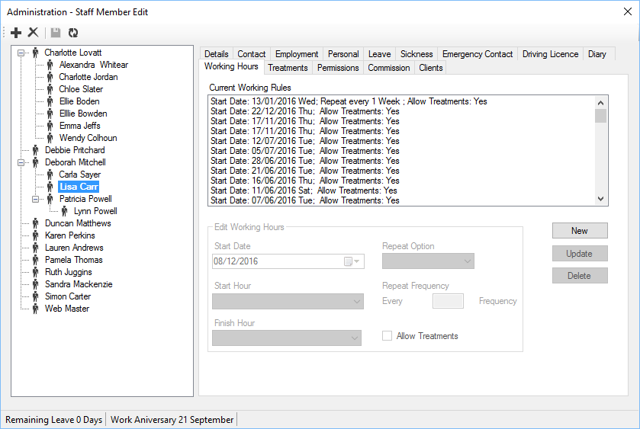

A working rule will override the standard working days/hours on the Diary tab.

New - Create a new working rule.

Update - Updates the selected working rule.

Delete - Deletes the selected working rule.

Start Date - Date the rule starts.

Start Hour - Start of the working day for that rule.

Finish Hour - End of the working day for that rule.

Repeat Option - Determines how often a rule will repeat, this can be None, Week, Month and Year

Repeat Frequency - Determines how often the rule repeats.

Allow Treatments - Determines whether treatments are allowed to be book for the staff member for this rule.

Please note, the system will find the first rule that applies for a given day, if multiple rules overlap.

Examples:

1. A member of staff works Monday to Thursday from 9am till 5pm and 10am till 1.30pm on a Friday; On the Diary tab select Monday to Thursday, leave Friday, Saturday and Sunday unticked. Set the working hours from 9am till 5pm. On the working Hours tab, create a new working rule and set the start date to the previous Friday, set the start hour to 10am and finish hour to 1.30pm. Set the repeat option to Weekly and the repeat frequency to 1.

### Treatments

The treatments tab indicates what treatments a member of staff is able to complete, this allows the diary booking system to only show/select what treatments are assigned.

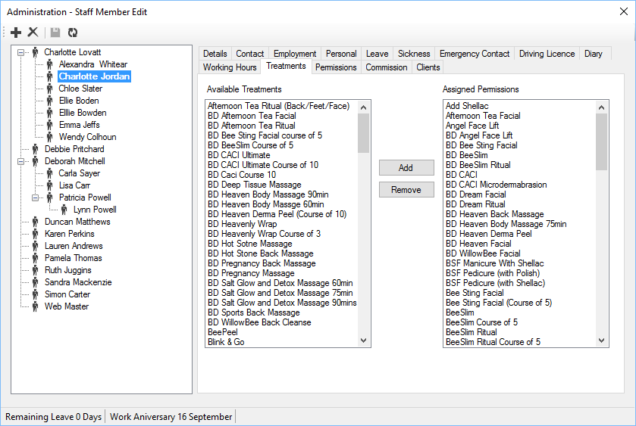

To add an existing treatment, either highlight it in the Available Treatments list and click “Add”, or double click the item within the Available Treatments.

To remove a treatment from the assigned treatment list, either double click the treatment to be removed, or highlight it and click “Remove”.

### Permissions

Each staff member can have the specific permissions required to complete their role:

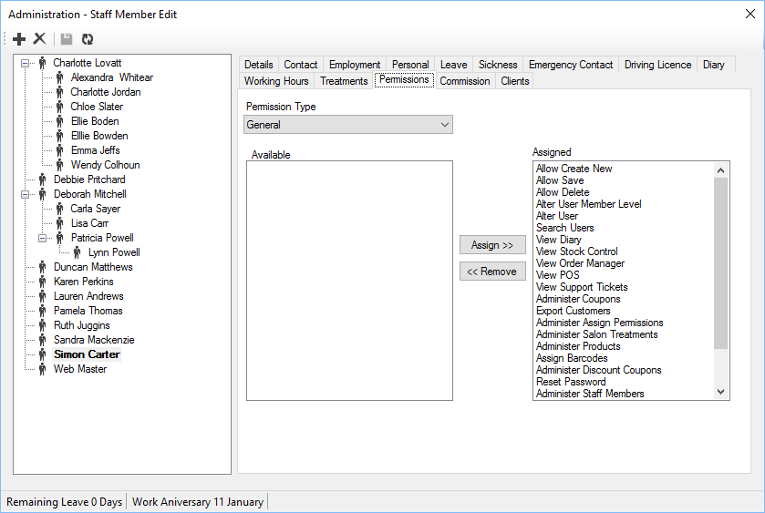

There are several Permission Types[[6]](#endnote-2), they are:

General - General permissions affecting the use of the POS.

Accounts - Account specific permissions for use with Invoice and Orders.

Calendar - Calendar/Diary specific permissions.

Website - Website specific permissions.

Reports - Report specific permissions.

Stock Control - Stock Control specific permissions.

To assign a permission either double click the permission from the Available list, or highlight the required permission and click “Assign”.

To remove a permission for a staff member, either double click the assigned permission or highlight the assigned permission and click “Remove”.

### Commission

The commission tab shows commission payments that have been made to the employee.

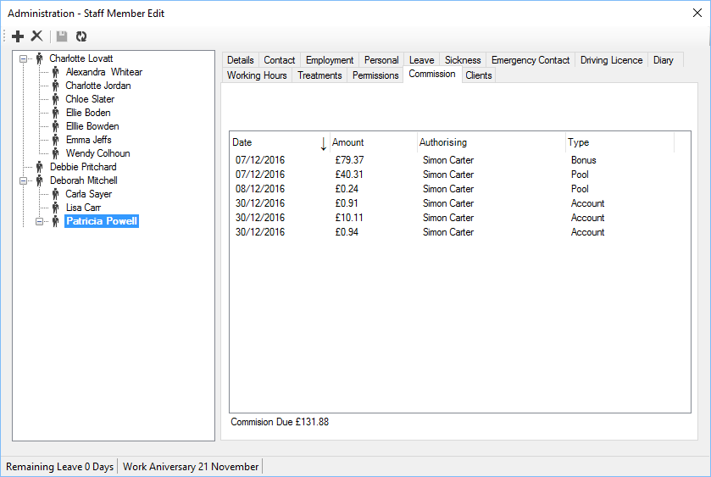

Date - Date the payment was made, or will be made.

Amount - Commission amount to be paid.

Authorising - Member of staff authorising the payment.

Type - Type of commission, see Staff Commission for more details.

Note, these can include payments scheduled for the future.

## Staff Commission

The POS can calculate commission in three ways, they are:

Commission Pools - Commission pools generates commission on specific sales types to be placed in a pool and shared between specific, or all members of staff.

Sales Commission - Sales commission is specific for account managers, those staff that are managing distributors and retailers etc.

Bonus Payments - Bonus commission is designed for one off bonus payments for members of staff.

Affiliate Commission - Commission based on affiliates driving sales to the website.

Commission data is generated automatically when an invoice is received and marked as paid, for all methods of commission, except Bonus.

Cancelled invoices will be removed from the commission data and any payments that are not already made will be deleted automatically.

### Settings

There are generic settings which affect how data is viewed when viewing commission.

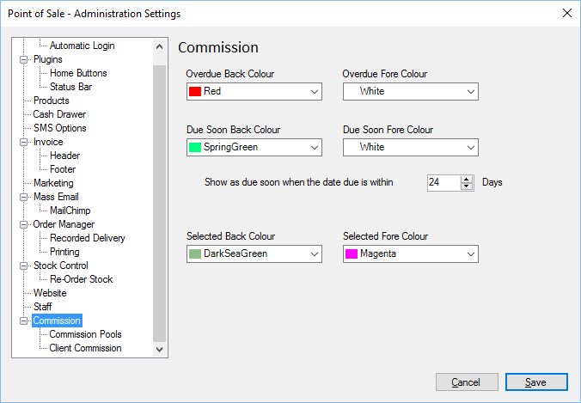

The colour is used to depict overdue, items due for payment soon, and those marked as selected when viewing.

Show as Due Soon - This value shows which items are due to be paid soon. Also no payments due after the specified time frame will be authorised for payment.

### Commission Pools

Commission Pools apply commission to a pool that can be used to share between staff in specific groups. You can create as many groups as required and commission is provided on the Payment Type.

#### Settings

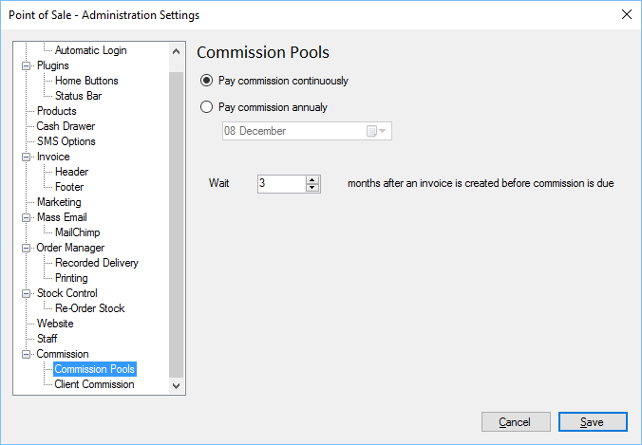

Continuously - If checked, then pool commission is paid continuously, using Wait period after an invoice is received.

Annually - If checked, then the pool commission is paid annually on the Date specified. Invoices received after the Wait period will be payable the following year.

Date - If commission is paid annually, select the date at which commission is paid.

Wait - Minimum number of months to wait after an invoice is received, before commission is payable. This is to allow for cancellations and returns etc.

#### Pools

There is no limit on the number of commission pools you can create. Each pool can link to any payment type and/or location.

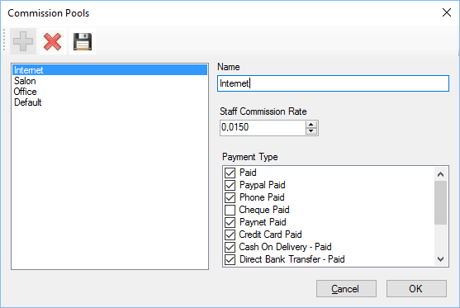

Name - Name of the commission pool.

Commission Rate - The rate of commission to be applied to each sale for the commission pool.

Location - The location works with the diary, if you have several salons, and staff spread throughout you can create a pool that is location specific.

Payment Type - The types of payment for which commission is applied to the commission pool.

When a sale is completed, the POS will calculate what commission is provided for the payment type, based on the commission rate. For example, shown above are internet sales, with a commission rate of 0.015%.

The commission would be calculated as:

(Total sale – (postage + tax)) \* 0.015%

So a sale valued at £105.50, with tax at £ 16.67 and postage at £5.50 would be calculated like:

Commission = (105.5 – (5.50 + 16.67) ) \* 0.015 = 0.0125

£0.0125 would be included in the commission pool for Internet sales.

#### Generate Data

You can generate, or regenerate the data for sales on all pools at any time. Only commissionable items that have not been paid will be included.

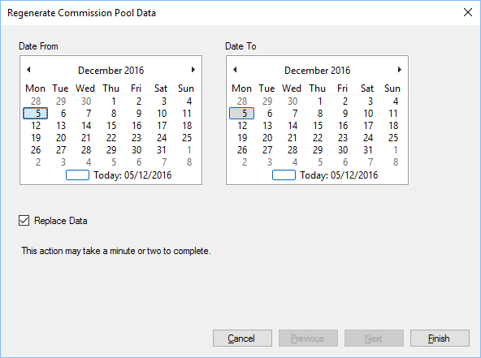

Date From - Start date of invoices to calculate.

Date To - End date of invoices to calculate.

Replace Data - If ticked, existing data that has not been paid will be recalculated. This option can be used if the commission rate for a pool is changed.

Click Finish to create the commissionable data.

#### Pool Commission Data

You can view the commissionable data at any time, this shows the generated data based on existing invoices, and the Pool that they have been allocated to.

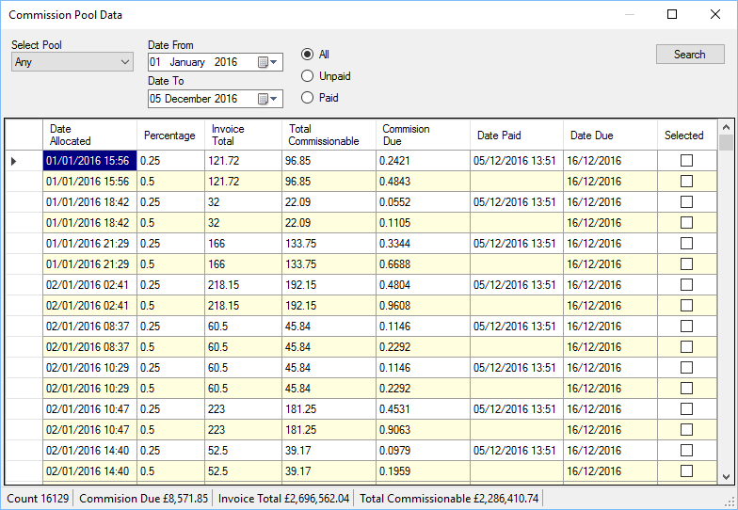

Select Pool - You can select an individual pool or all pools to view the data.

Date from/To - Select the date period required.

All/Unpaid/Paid - Select the payment type.

Search - Click search to view the data.

The data returned will show the date allocated, this is the date of invoice, the percentage which is derived from the pool commission.

You can select the individual items which you want to pay commission on, tick the selected column item to select a commissionable item.

You can right click the grid to select all data, un select all data or inverse the selection.

To pay commission on selected items, right click the grid to show the popup menu and select “Pay Commission” this will load a wizard which will take you through the steps required to pay commission on the selected items.

The date paid shows the date that commission payment data was generated, the user who generated the payment is recorded and shown in staff records.

The date due is the date when the payment is due to the staff member, based on Settings.

#### Pay Commission/Pay Pool Commission

The wizard for generating pool commission payments can be invoked when viewing the commission data, or by selecting “Pay Pool Commission” from the main form.

##### Step 1

Select the pool for which commission is to be paid.

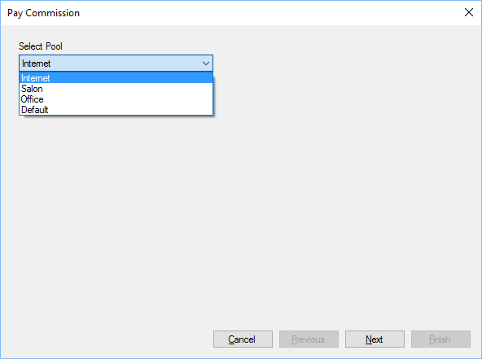

This step is skipped if invoked when viewing Pool Commission Data.

##### Step 2

You can select the staff to which the commission payments will be split between.

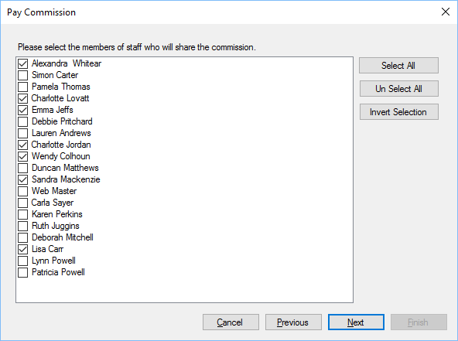

If the commission pool is for a particular location, then the staff within that location will be initially selected, otherwise no staff will be selected.

##### Step 3

There are three options for splitting data between employees.

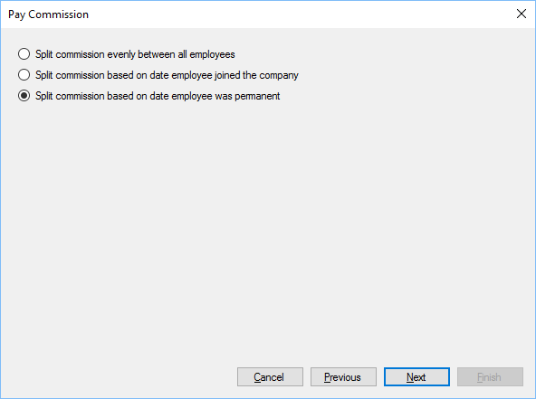

Split Evenly - This option will split commission evenly between all selected employees.

Joining Date - This option will split payments based on when an employee joined the company, if the invoice was generated prior to the employee joining the company then they will not be allocated a split of the commission for the invoice.

Permanent Date - This option is similar to the joining date, if the invoice was generated prior to the employee being made a permanent member of staff, then that employee will not be allocated a split of the commission for the invoice.

##### Step 4

During this stage you can view how the commission is split based on previous settings and the number of employees.

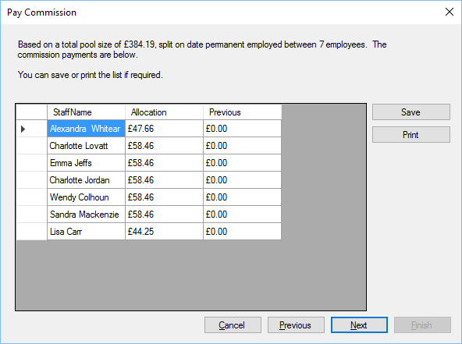

You can save or print the list for future reference, payment data, once generated will be saved with the employee’s record for future reference.

The previous column shows previous allocations from the selected pool data, if available.

##### Step 5

If you click finish on Step 5 the commission data is saved for each employee receiving commission and the commissionable items are marked as paid.

Please note it may take a minute or two to complete this task.

### Account Commission

Account commission is specifically for employees who manage accounts for resellers etc. Each time a managed account purchases through the POS or website, then commission is calculated for the employee. The commission data is generated automatically.

An employee can be allocated a specific commission rate for a sale; from this a rate can be back allocated to the employee’s manager, until the employment chain is complete.

For instance James is the director in charge of all regions within a country, John is a regional sales manager for a specific area, Alice and Steph both work for John managing individual accounts for the area.

Both Steph and Alice receive 30% commission on all sales they make, but, from this they have to pay 5% to John, who is also on commission but does not directly manage any accounts. 5% of all sales generated for each area is provided to James as the director.

Steph makes a sale for £2428.62, excluding Tax @ £403.85 and Shipping @ £0, the commissionable rate would be:

2428.62 – (403.84 + 0) = 2024.78

Steph’s commission rate is 30% which equates to £607.43 of which 5% would be given to John and 5% of John’s commission would go to James, this equates to:

Total Commission: £607.43

Steph: £607.43 – (5% going to John @ £30.37) leaving £577.06.

John: £30.37 - (5% goes to James @ £1.52) leaving £28.85.

James: £1.52

The account commission is designed to allow resellers (account managers) to generate their own sales, or have more resellers that they control and provide a level of commission for all people up the chain.

*Please note, Commission is generated down to 4 decimal places to allow for greater precision when calculating commission payments, therefore there will be a slight difference in the figures above to allow for rounding*.

#### Settings

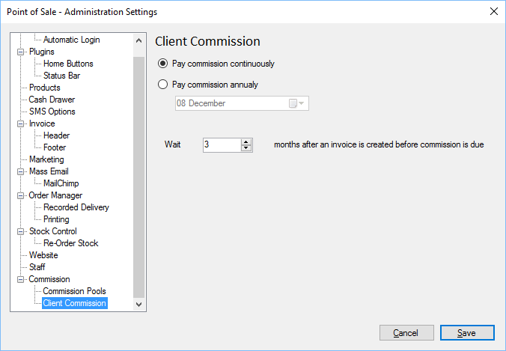

Continuously - If checked, then pool commission is paid continuously, using Wait period after an invoice is received.

Annually - If checked, then the pool commission is paid annually on the Date specified. Invoices received after the Wait period will be payable the following year.

Date - If commission is paid annually, select the date at which commission is paid.

Wait - Minimum number of months to wait after an invoice is received, before commission is payable. This is to allow for cancellations and returns etc.

#### Generate Data

You can generate, or regenerate the data for sales on all account commission at any time. Only commissionable items that have not been paid will be included.

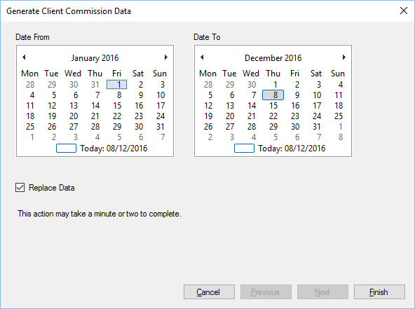

Date From - Start date of invoices to calculate.

Date To - End date of invoices to calculate.

Replace Data - If ticked, existing data that has not been paid will be recalculated. This option can be used if the commission rate for a pool is changed.

Click Finish to create the commissionable data.

#### Account Commission Data

You can view the commissionable data at any time, this shows the generated data based on existing invoices, and the Pool that they have been allocated to.

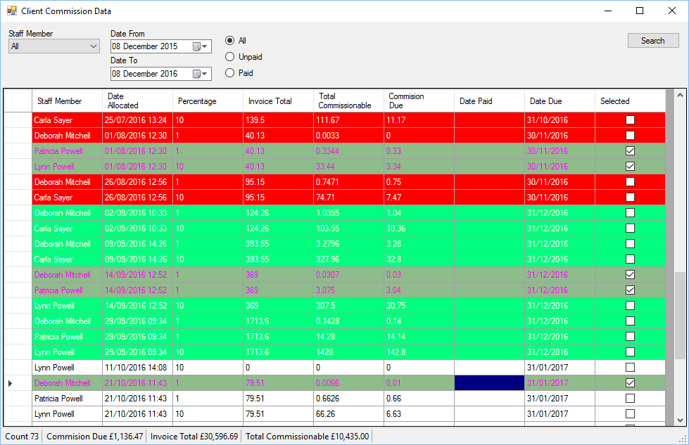

Staff Member - You can select an individual member of staff or all staff members to view the data.

Date from/To - Select the date period required.

All/Unpaid/Paid - Select the payment type.

Search - Click search to view the data.

The data returned will show the date allocated, this is the date of invoice, the percentage of commission, the amount of the invoice, the commissionable amount and the commission due amount.

You can select the individual items which you want to pay commission on, tick the selected column item to select a commissionable item.

You can right click the grid to select all data, un select all data or inverse the selection, you can also select all overdue items or those that will be due for payment soon.

To pay commission on selected items, right click the grid to show the popup menu and select “Pay Commission” this will load a wizard which will take you through the steps required to pay commission on the selected items.

The date paid shows the date that commission payment data was generated, the user who generated the payment is recorded and shown in staff records.

The date due is the date when the payment is due to the staff member, based on Settings.

### Bonus Payment

The POS allows for one off bonus payments, allowing users to detail who will receive what payment and allowing for manual adjustment prior to committing.

#### Step 1

The first step is to enter the total amount of money that will be split between employees.

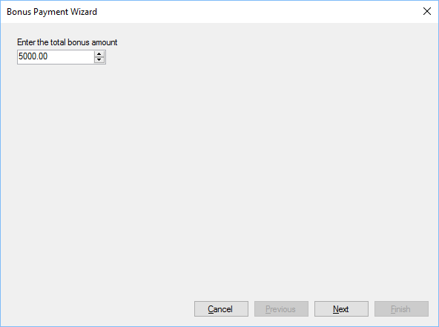

#### Step 2

Select the employees who will share the bonus.

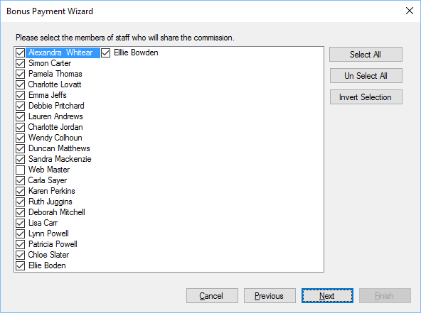

#### Step 3

Select how the data is split between the employees.

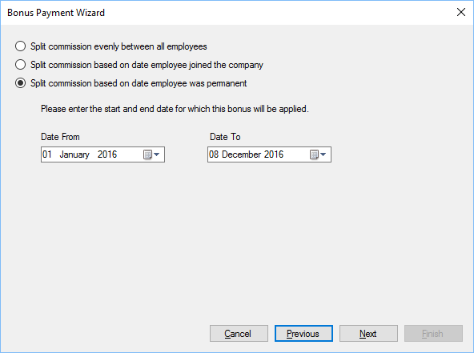

Split Evenly - This option will split commission evenly between all selected employees.

Joining Date - This option will split payments based on when an employee joined the company, if the invoice was generated prior to the employee joining the company then they will not be allocated a split of the bonus for the invoice.

Permanent Date - This option is similar to the joining date, if the invoice was generated prior to the employee being made a permanent member of staff, then that employee will not be allocated a split of the bonus for the invoice.

#### Step 4

Verify the payments and how the money was divided.

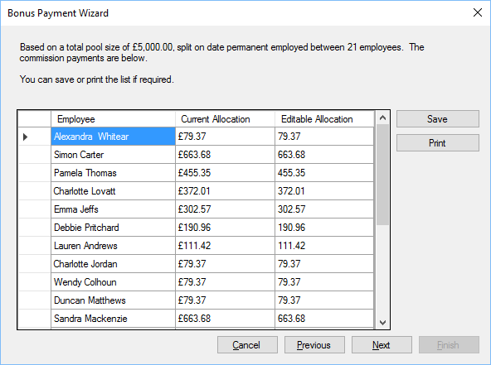

Employee - Employee who will receive a share of the bonus.

Current Allocation - This is the amount that is provided based on the selection criteria in step 3.

Editable Allocation - The final figure can be edited prior to saving changes, allocated bonus amounts can be increased or decreased.

#### Step 5

Specify when the payment is due for the employees during the last step

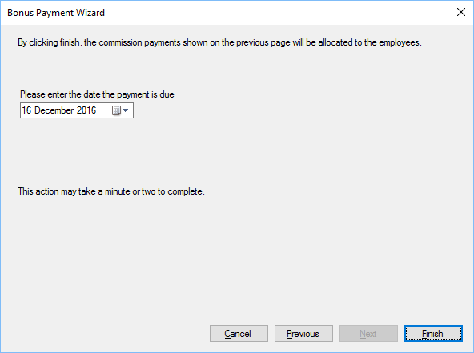

When you click finish, the bonus payment is allocated and the payment date is set, this is viewable in the Commission section when Manage Staff.

## Affiliate Marketing and Commission

Affiliate marketing is the process of earning a commission by promoting other people's (or company's) products. You find a product you like, promote it to others, and earn a piece of the profit for each sale that you make.

The POS and website now incorporate affiliate marketing and commission.

There are two different types of affiliate marketing supported at present, they are:

* Commission on Sales
* Pay per Click

### Commission on Sales

Affiliates can generate commission based on sales they drive to your website, from their own website. This is completed via two ways:

True Link - The affiliate’s website is registered within the POS, any referrals from the website are automatically logged and if a sale is made by the customer, commission is allocated to the affiliate. The advantage of this method is that the link requires no adjustment and is preferable for SEO rankings within websites.

Affiliate ID - The affiliate is given a unique identifier which they include on a link to your website. When a customer follows the link and purchases, the commission is allocated to the affiliate. This method does will not improve SEO.

#### SEO Links

Search engines rank pages using an algorithm that checks how many links are pointing to a web page. Web pages that have more links will always rank higher, using an affiliate id the following two webpages appear different to the search engine.

http://www.mywebsite.com/Index.aspx

http://www.mywebsite.com/Index.aspx?AffID=XXXXXXX

It is the same page, but for SEO reasons they are treated as separate pages, in the above examples the true link is the first example and the affiliate link is the second (XXXXXXX is unique id provided to the affiliate).

### Affiliate Settings

#### The customer plugin module introduces one new setting screen shown in Standard Icons

Throughout the POS, there are a number of standard buttons displayed on many of the forms shown, these are designed to indicate actions available across a number of areas. The buttons are always displayed on the top of each form.



If the button appears “greyed out” it is disabled and cannot be used. When the mouse is hovered over each button a hint will appear indicating what action the button will perform.

|  |  |
| --- | --- |
|  | Add or insert. |
| C:\Users\Simon\AppData\Local\Microsoft\Windows\INetCache\Content.Word\action_Cancel_16xLG.PNG | Delete or cancel. |
| C:\Users\Simon\AppData\Local\Microsoft\Windows\INetCache\Content.Word\icon_edit_16.png | Edit |
|  | Save |
|  | Refresh or reload. |
|  | Mark as paid. |
| C:\Users\Simon\AppData\Local\Microsoft\Windows\INetCache\Content.Word\user_16xLG.PNG | View user or view customer. |
| C:\Users\Simon\AppData\Local\Microsoft\Windows\INetCache\Content.Word\column_16xLG.PNG | Print label. |
|  | Print or print invoice. |
| C:\Users\Simon\AppData\Local\Microsoft\Windows\INetCache\Content.Word\notebook_16xLG.PNG | Notes or staff notes. |
|  | Customer notes. |
| C:\Users\Simon\AppData\Local\Microsoft\Windows\INetCache\Content.Word\Team_16xLG.PNG | Change sales person for invoice. |
|  | Issue refund to customer. |
|  | Enter or view tracking details. |
| C:\Users\Simon\AppData\Local\Microsoft\Windows\INetCache\Content.Word\calendar_16xLG.PNG | Select date, select number of days or update invoice date. |
| C:\Users\Simon\AppData\Local\Microsoft\Windows\INetCache\Content.Word\Close_16xLG.PNG | Close the current form. |
| C:\Users\Simon\AppData\Local\Microsoft\Windows\INetCache\Content.Word\lightningBolt_16xLG.PNG | Search or Execute. |
|  | Select count or Number 5 |

Administration Settings.

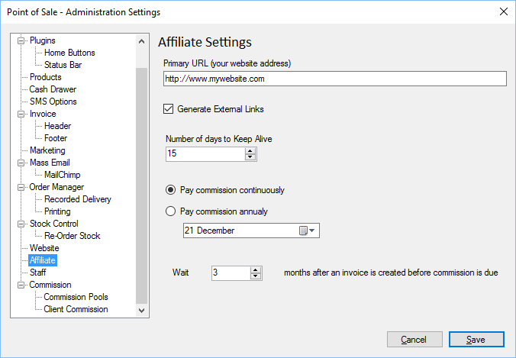

Primary URL - The primary URL is the URL for your website.

External Links - If ticked, the URL supplied to the affiliate will open in a new window, if un-ticked, the URL supplied will navigate away from the affiliates website.

Keep Alive - This is the number of days in which the user is provided to make a sale and it be attributed to the affiliate.

Continuously - If checked, then commission is paid continuously, using Wait period after an invoice is received.

Annually - If checked, then the commission is paid annually on the Date specified. Invoices received after the Wait period will be payable the following year.

Date - If commission is paid annually, select the date at which commission is paid.

Wait - Minimum number of months to wait after an invoice is received, before commission is payable. This is to allow for cancellations and returns etc.

### Setting Up Affiliates

Any user within the system can be an affiliate, the first thing to do is create a user account, when you view the user there is an Affiliate Tab.

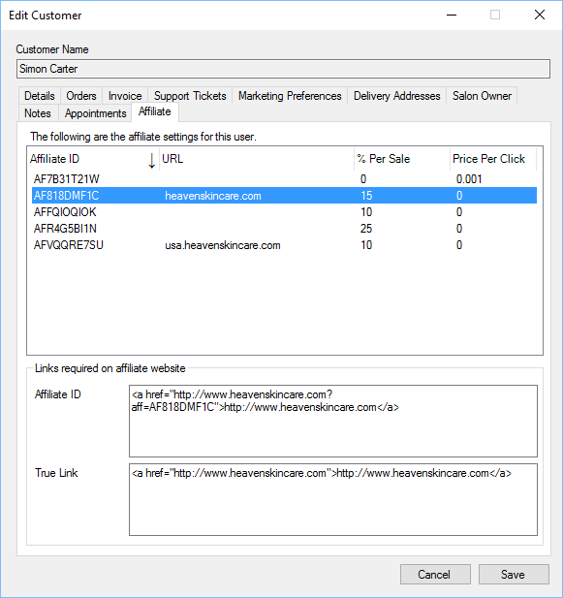

Affiliate Settings - Each affiliate can have multiple affiliate settings.

Affiliate ID Link - The affiliate ID link is the link used by the affiliate on their website.

True Link - The true link is the link used by the affiliate on their website, if their website is registered.

You can right click anywhere in the affiliate settings list for a menu which will allow you to create, delete and edit the affiliate settings.

### Affiliate Settings.

The settings for the affiliate are shown below.

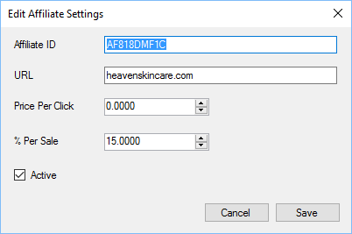

Affiliate ID - A unique ID, up to 40 characters long. This will be automatically generated by the POS when affiliate settings are created. You can create your own[[7]](#footnote-5) if required.

URL - The affiliate’s URL.

Price Per Click - The price given to the affiliate when a user clicks the link on their website.

% Per Sale - The percentage of commission given to the affiliate when a user clicks the link on their website and purchases a product from you.

Active - Determines whether the affiliate link is active or not.

### True Link URL

The true link URL is not the full URL of the affiliates website, it contains only the host name. To understand this a URL (or web address as it is commonly known) is split into three parts:

<http://www.mywebsite.com/Index.aspx>

In this example the first part (http://) in orange is the protocol, the second part (www) in brown is a sub domain, the third part (mywebsite.com) in purple is the host name and the last part in red (/index.aspx) is the page to display.

When using true link for affiliates only the host name (mywebsite.com) is required and allowed.

### Affiliate Commission Data

You can view the affiliate commissionable data at any time, this shows the generated data based on existing invoices, and the affiliates settings.

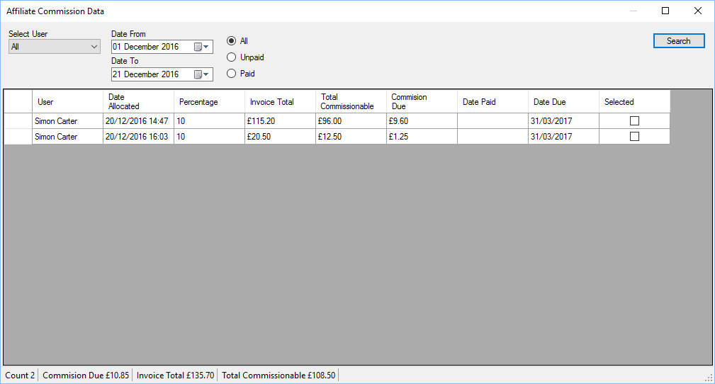

Select User - You can select an individual affiliate or all to view the data for all affiliates.

Date from/To - Select the date period required.

All/Unpaid/Paid - Select the payment type.

Search - Click search to view the data.

The data returned will show the date allocated, this is the date of invoice, the percentage of commission, the amount of the invoice, the commissionable amount and the commission due amount.

You can select the individual items which you want to pay commission on, tick the selected column item to select a commissionable item.

You can right click the grid to select all data, un select all data or inverse the selection, you can also select all overdue items or those that will be due for payment soon.

To pay commission on selected items, right click the grid to show the popup menu and select “Pay Commission” this will load a wizard which will take you through the steps required to pay commission on the selected items.

The date paid shows the date that commission payment data was generated, the user who generated the payment is recorded.

The date due is the date when the payment is due to the affiliate member, based on Settings.

### Pay Commission

The wizard for generating affiliate commission payments can be invoked when viewing the affiliate commission data, or by selecting “Pay Affiliate Commission” from the Administration\Customers menu.

##### Step 1

Select the affiliate for which commission is to be paid.

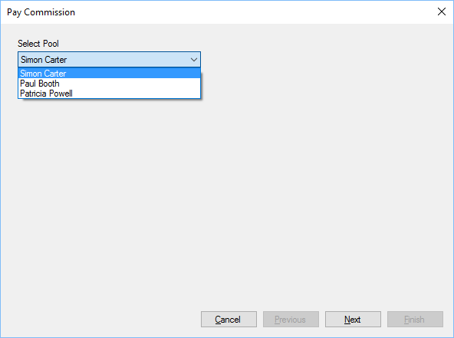

This step is skipped if invoked when viewing Affiliate Commission Data.

##### Step 2

During this stage you can view the commission payments that will be made.

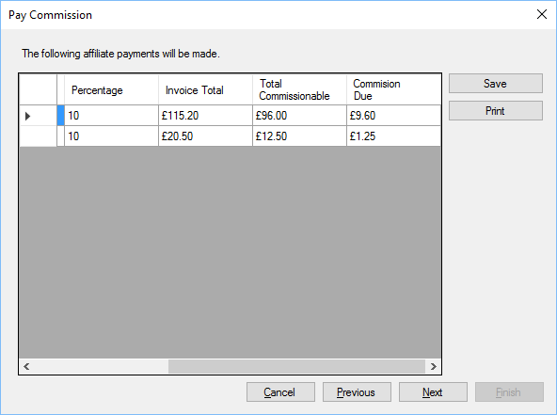

You can save or print the list for future reference, payment data, once generated will be saved with the affiliate’s record for future reference.

##### Step 3

If you click finish on Step 3 the commission data is saved for the affiliate receiving commission and the commissionable items are marked as paid.

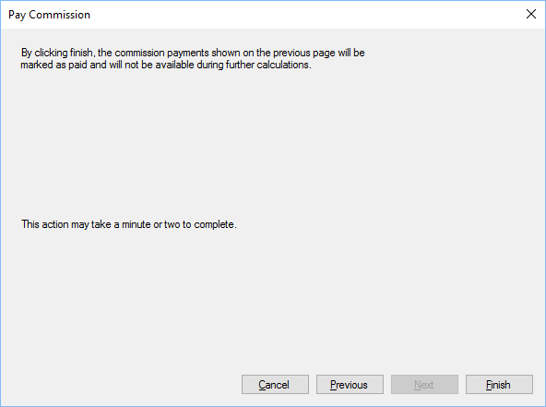

Please note it may take a minute or two to complete this task.

## Cash Drawer

The POS includes a module for users to verify Cash held in remote sites.

There are three options available, all from selecting the Accounts menu then the cash menu, they are:

Till - Provides options for users to audit cash kept in a till.

Safe - Provides options for users to audit cash kept in a safe.

Petty Cash - Provides options for users to audit petty cash.

All transactions taking place within the

Settings

The Cash Drawer plugin module introduces one page in the Standard Icons

Throughout the POS, there are a number of standard buttons displayed on many of the forms shown, these are designed to indicate actions available across a number of areas. The buttons are always displayed on the top of each form.



If the button appears “greyed out” it is disabled and cannot be used. When the mouse is hovered over each button a hint will appear indicating what action the button will perform.

|  |  |
| --- | --- |
|  | Add or insert. |
| C:\Users\Simon\AppData\Local\Microsoft\Windows\INetCache\Content.Word\action_Cancel_16xLG.PNG | Delete or cancel. |
| C:\Users\Simon\AppData\Local\Microsoft\Windows\INetCache\Content.Word\icon_edit_16.png | Edit |
|  | Save |
|  | Refresh or reload. |
|  | Mark as paid. |
| C:\Users\Simon\AppData\Local\Microsoft\Windows\INetCache\Content.Word\user_16xLG.PNG | View user or view customer. |
| C:\Users\Simon\AppData\Local\Microsoft\Windows\INetCache\Content.Word\column_16xLG.PNG | Print label. |
|  | Print or print invoice. |
| C:\Users\Simon\AppData\Local\Microsoft\Windows\INetCache\Content.Word\notebook_16xLG.PNG | Notes or staff notes. |
|  | Customer notes. |
| C:\Users\Simon\AppData\Local\Microsoft\Windows\INetCache\Content.Word\Team_16xLG.PNG | Change sales person for invoice. |
|  | Issue refund to customer. |
|  | Enter or view tracking details. |
| C:\Users\Simon\AppData\Local\Microsoft\Windows\INetCache\Content.Word\calendar_16xLG.PNG | Select date, select number of days or update invoice date. |
| C:\Users\Simon\AppData\Local\Microsoft\Windows\INetCache\Content.Word\Close_16xLG.PNG | Close the current form. |
| C:\Users\Simon\AppData\Local\Microsoft\Windows\INetCache\Content.Word\lightningBolt_16xLG.PNG | Search or Execute. |
|  | Select count or Number 5 |

Administration Settings section.

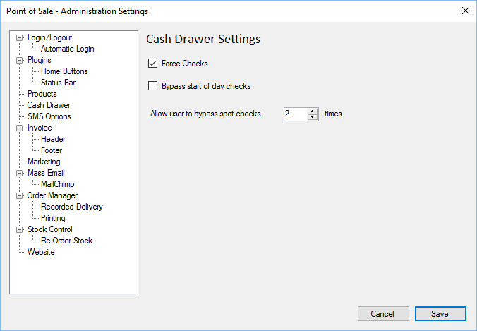

Force Checks - If ticked the POS will force the user to complete an audit of the Till at random times of the day.

Bypass Start of Day - If this options is ticked, then the start of day check will not be fored. If unticked, then the POS will force whoever logs in first to perform a start of day check of the cash drawer.

Till, Safe or Petty Cash are logged with the current logged in user.

### Settings

#### The Cash Drawer plugin module introduces one page in the Standard Icons

Throughout the POS, there are a number of standard buttons displayed on many of the forms shown, these are designed to indicate actions available across a number of areas. The buttons are always displayed on the top of each form.



If the button appears “greyed out” it is disabled and cannot be used. When the mouse is hovered over each button a hint will appear indicating what action the button will perform.

|  |  |
| --- | --- |
|  | Add or insert. |
| C:\Users\Simon\AppData\Local\Microsoft\Windows\INetCache\Content.Word\action_Cancel_16xLG.PNG | Delete or cancel. |
| C:\Users\Simon\AppData\Local\Microsoft\Windows\INetCache\Content.Word\icon_edit_16.png | Edit |
|  | Save |
|  | Refresh or reload. |
|  | Mark as paid. |
| C:\Users\Simon\AppData\Local\Microsoft\Windows\INetCache\Content.Word\user_16xLG.PNG | View user or view customer. |
| C:\Users\Simon\AppData\Local\Microsoft\Windows\INetCache\Content.Word\column_16xLG.PNG | Print label. |
|  | Print or print invoice. |
| C:\Users\Simon\AppData\Local\Microsoft\Windows\INetCache\Content.Word\notebook_16xLG.PNG | Notes or staff notes. |
|  | Customer notes. |
| C:\Users\Simon\AppData\Local\Microsoft\Windows\INetCache\Content.Word\Team_16xLG.PNG | Change sales person for invoice. |
|  | Issue refund to customer. |
|  | Enter or view tracking details. |
| C:\Users\Simon\AppData\Local\Microsoft\Windows\INetCache\Content.Word\calendar_16xLG.PNG | Select date, select number of days or update invoice date. |
| C:\Users\Simon\AppData\Local\Microsoft\Windows\INetCache\Content.Word\Close_16xLG.PNG | Close the current form. |
| C:\Users\Simon\AppData\Local\Microsoft\Windows\INetCache\Content.Word\lightningBolt_16xLG.PNG | Search or Execute. |
|  | Select count or Number 5 |

Administration Settings section.



Force Checks - If ticked the POS will force the user to complete an audit of the Till at random times of the day.

Bypass Start of Day - If this options is ticked, then the start of day check will not be fored. If unticked, then the POS will force whoever logs in first to perform a start of day check of the cash drawer.

### Till

Users can audit the till and specify how money is moved in/out of the till.

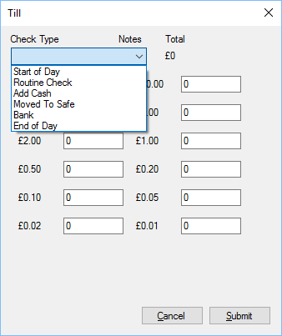

When entering denominations you enter the quantity of the denomination, i.e. if you have £53 made up from 2 x £20, 1 x £10, 1 x £2 and 1 x £1 you would enter 2 in the £20 section, 1 in the £10 section, 1 in the £2 section and 1 in the £1 section.

The total, at the top of the form, will update to show the total amount input during the transaction.

#### Till - Check Type

There are 6 check types for the Till

Start of Day - To be used at the start of the day to verify what cash is available.

Routine Check - Routine check to be completed at random times of the day.

Add Cash - If cash is moved into the till for whatever reason, other than a sale involving cash.

Moved to safe - Cash that is removed from the till and placed into the safe.

Bank - Cash that is removed and taken to the bank.

End of Day - The check that should be completed at the end of the day.

### Verify Till

The verify till option, allows users to verify the totals in the till. If an item has (Calculated), then the POS has calculated what the value should be, based on sales and other cash movement for the.

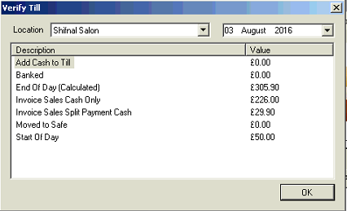

Location - Select the location you wish to view.

Date - Date of action.

Add Cash to Till - Sum of the amount of cash added to the till.

Banked - Sum of the amount of cash that has been moved to the bank.

End of Day - Sum of the amount of cash that has been verified at the end of the day.

Invoice Sale Cash - Sum of cash received in the till where the payment was cash only.

Invoice Sale Split - Sum of cash received in the till where the payment was split.

Moved to Safe - The sum of cash removed from the till and placed in the safe.

Start of Day - The sum of cash input at the start of the day.

### Safe

Users can audit the safe and specify how money is moved in and out of the safe.

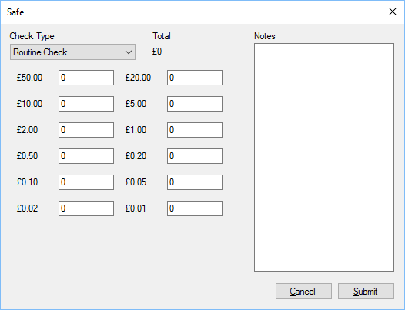

When entering denominations you enter the quantity of the denomination, i.e. if you have £53 made up from 2 x £20, 1 x £10, 1 x £2 and 1 x £1 you would enter 2 in the £20 section, 1 in the £10 section, 1 in the £2 section and 1 in the £1 section.

The total, at the top of the form, will update to show the total amount input during the transaction.

There is a section for notes so as users can detail the actions taken, if required.

For security only a minimum number of users should have access to the safe.

#### Safe - Check Type

There are 6 check types for the safe

Start of Day - To be used at the start of the day to verify what cash is available.

Routine Check - Routine check to be completed at random times of the day.

Add Cash - If cash is moved into the safe for whatever reason.

Remove Cash - Cash that is removed from the safe for whatever reason.

Bank - Cash that is removed and taken to the bank.

End of Day - The check that should be completed at the end of the day.

### Verify Safe

The verify safe option, allows users to verify the totals in the safe.

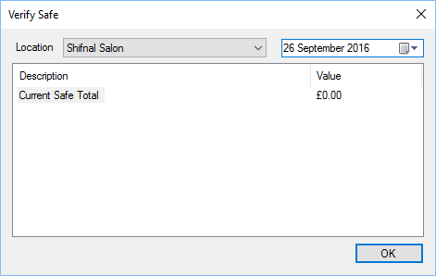

Location - Select the location you wish to view.

Date - Date of action.

Current Safe Total - Sum of the amount of cash currently available in the safe.

### Petty Cash

Users can audit petty cash and specify how money is moved in and out.

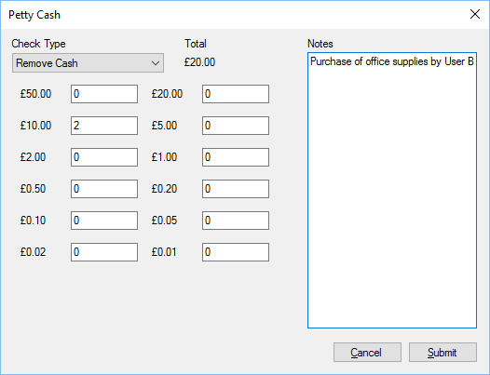

When entering denominations you enter the quantity of the denomination, i.e. if you have £53 made up from 2 x £20, 1 x £10, 1 x £2 and 1 x £1 you would enter 2 in the £20 section, 1 in the £10 section, 1 in the £2 section and 1 in the £1 section.

The total, at the top of the form, will update to show the total amount available in the till.

There is a notes section that should be used so as a full audit can be carried out.

Users who remove or add cash should log what the transaction detail is, for instance:

User A removes 2 x £20 notes to give to User B logging the transaction as Purchase. User B purchases goods, and returns £3.81 to the User A, along with a receipt. User A logs a new transaction using check type Add Cash, returning £3.81 to the petty cash drawer.

#### Petty Cash - Check Type

There are 8 check types for the Petty Cash

Start of Day - To be used at the start of the day to verify what cash is available.

Routine Check - Routine check to be completed at random times of the day.

Add Cash - If cash is moved into the till for whatever reason, other than a sale involving cash.

Remove Cash - Cash is removed from Petty Cash for another reason.

Purchase - Cash is removed so a purchase can be made.

Moved to safe - Cash that is removed from the till and placed into the safe.

Bank - Cash that is removed and taken to the bank.

End of Day - The check that should be completed at the end of the day.

### Verify Petty Cash

The verify till option, allows users to verify the totals in the till. If an item has (Calculated) then the POS has calculated what the value should be, based on sales and other cash movement for the.



Location - Select the location you wish to view.

Date - Date of action.

Add Cash to Till - Sum of the amount of cash added to the till.

Banked - Sum of the amount of cash that has been moved to the bank.

End of Day - Sum of the amount of cash that has been verified at the end of the day.

Invoice Sale Cash - Sum of cash received in the till where the payment was cash only.

Invoice Sale Split - Sum of cash received in the till where the payment was split.

Moved to Safe - The sum of cash removed from the till and placed in the safe.

Start of Day - The sum of cash input at the start of the day.

## Currency Watch

Currency watch is a plugin module which displays currency converted to other values, and resides in the status bar of the POS (see Home Button and Status Bar Items for more info).

You can get live updates on currency values, converted to other currencies when you wish to monitor.



The status bar will show the current conversion value, along with an indicator:

↑ = Value has gone up.

- = Value is the same.

↓ = Value has gone down.

If one of the currencies you are watching changes its value, the status bar item will flash red, moving the mouse over the status bar item will prevent further flashing and show a hint window with the values:

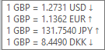

### Currency Watch Options

You can configure which currencies to watch using the options available in User Settings.

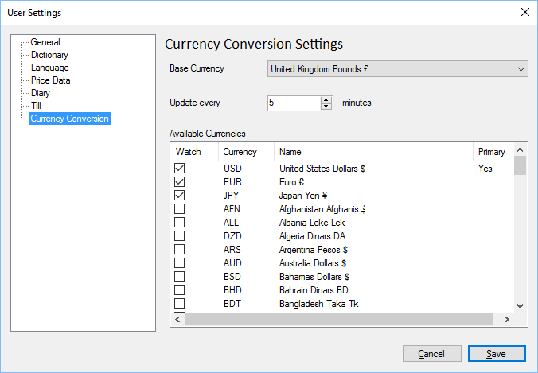

Base Currency - This currency is what all other conversions will be compared against.

Update Every - Specify the update interval in minutes.

Available Currencies - A list of all currencies which can be viewed and values retrieved.

Watch - If a tick is in the box the currency value will be watched and updates on its value, compared to the Base Currency, shown.

Currency - Currency Code

Name - Name of Currency

Primary - Indicates whether or not this currency is the primary currency which will be shown in the status bar.

## Database Backup

There are 2 options in the tools menu for backing up your database.

Backup Database - Creates a backup of your database and places the backup in the \Service\Backups\ folder.

Backup and Upload - Creates a backup of your database and sends it to a secure remote server for safekeeping.

Backups are kept for a maximum of 7 days on the secure server.

## Diary

The diary is a complete solution for managing bookings within the salon.

The diary can be activated by clicking the icon (left) from the main POS screen. This will load the diary to today’s date.

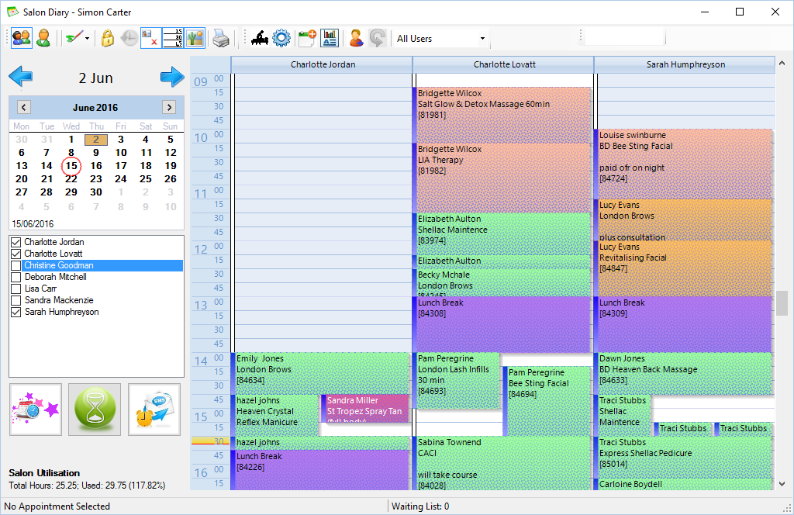

The diary itself can be broken down into three parts, at the top is a toolbar containing options to change how the diary looks, below and on the left hand side is the date selector, current staff list for the site and extra options below. The main part of the diary shows the appointments for staff members.

### Settings

The diary plugin module introduces two new settings pages.

#### Text Magic Integration

#### Text magic integration can be found in the Standard Icons

Throughout the POS, there are a number of standard buttons displayed on many of the forms shown, these are designed to indicate actions available across a number of areas. The buttons are always displayed on the top of each form.



If the button appears “greyed out” it is disabled and cannot be used. When the mouse is hovered over each button a hint will appear indicating what action the button will perform.

|  |  |
| --- | --- |
|  | Add or insert. |
| C:\Users\Simon\AppData\Local\Microsoft\Windows\INetCache\Content.Word\action_Cancel_16xLG.PNG | Delete or cancel. |
| C:\Users\Simon\AppData\Local\Microsoft\Windows\INetCache\Content.Word\icon_edit_16.png | Edit |
|  | Save |
|  | Refresh or reload. |
|  | Mark as paid. |
| C:\Users\Simon\AppData\Local\Microsoft\Windows\INetCache\Content.Word\user_16xLG.PNG | View user or view customer. |
| C:\Users\Simon\AppData\Local\Microsoft\Windows\INetCache\Content.Word\column_16xLG.PNG | Print label. |
|  | Print or print invoice. |
| C:\Users\Simon\AppData\Local\Microsoft\Windows\INetCache\Content.Word\notebook_16xLG.PNG | Notes or staff notes. |
|  | Customer notes. |
| C:\Users\Simon\AppData\Local\Microsoft\Windows\INetCache\Content.Word\Team_16xLG.PNG | Change sales person for invoice. |
|  | Issue refund to customer. |
|  | Enter or view tracking details. |
| C:\Users\Simon\AppData\Local\Microsoft\Windows\INetCache\Content.Word\calendar_16xLG.PNG | Select date, select number of days or update invoice date. |
| C:\Users\Simon\AppData\Local\Microsoft\Windows\INetCache\Content.Word\Close_16xLG.PNG | Close the current form. |
| C:\Users\Simon\AppData\Local\Microsoft\Windows\INetCache\Content.Word\lightningBolt_16xLG.PNG | Search or Execute. |
|  | Select count or Number 5 |

Administration Settings section and allows the diary users to send text notifications about upcoming appointments through the SMS Alerts option.

The homepage for Text Magic is: <https://www.textmagic.com/>

All settings for this option are available from the Text Magic home page.

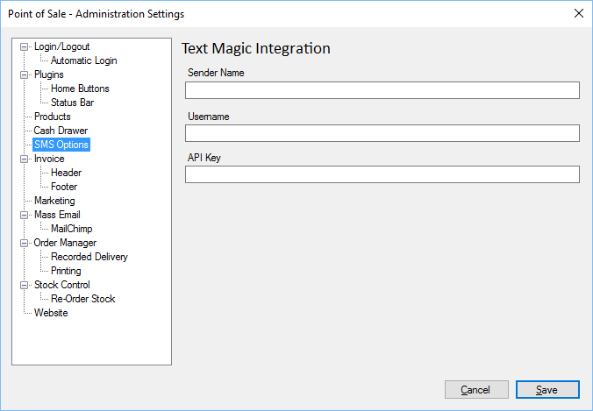

Sender Name - Sender Name as provided by Text Magic.

Username - Username as provided by Text Magic.

API Key - API Key as provided by Text Magic.

#### User – Diary Settings

The Diary Settings can be found in the User settings section.

If Maximum diary age of 1 month is checked, then no appointments older than 1 month will be loaded, this can considerably speed up the loading of the diary.

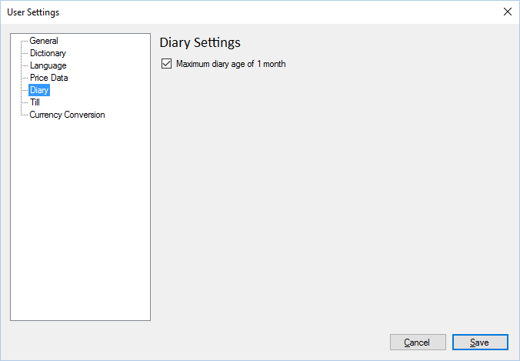

### Staff Selection

When in team view, you can choose which staff members are shown within the diary by putting a tick next to the staff member’s name. See Advanced Settings to permanently hide a staff member.

### Salon Utilisation

Salon utilisation provides a quick overview on the current salon view and availability.

### Toolbar

The toolbar contains options to quickly change how the diary operates.



Team View. This icon will show all staff members for 1 day.

Week View. This icon will show an entire week’s worth of appointments for one member of staff.

 Colour scheme. The diary can be rendered in a variety of colour schemes by selecting this icon.

Ignore working hours. Allows staff to ignore what working hours are specified for a member of staff. If ticked appointments can be created when the member of staff is not shown as working.

Show’s cancelled appointments.

Show’s minutes within the calendar.

Image overlays. If image overlays are on, then appointments can have a variety of different images shown in the bottom right of the appointment to indicate it’s state.

Prints the current diary view to the default printer.

Allows users with the correct rights to edit the treatments that are available within the booking system.

Advanced Settings for the diary.

New Appointments. If the diary is linked to a website where users can book appointments, then the appointment requested by users can be viewed here.



Reports. Shows the available salon reports.

Swap user. Allows another member of staff to log on temporarily.

Revert user. When the staff member has been swapped, the revert user will log the previously active user onto the diary.

### Date Selector

The date selector allows staff to change the current contents of the diary to a specific date or range of dates.

The current day will be highlighted in red, the selected date will have an orange background.

#### Team View

When team view is shown staff can select a single day to view all appointments for the user.

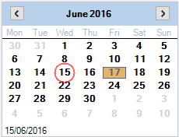

#### Week View

When week view is selected the appointments for the selected staff member will be shown for a week.

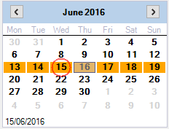

#### Colour Scheme

The diary has several colour schemes that can be used to change how it looks. Click the colour scheme button and select the scheme you wish to use.

#### Ignore Working Hours

The diary enforces strict working hours, and appointments cannot be created if they will go outside of the working hours for a staff member, if Ignore working hours is selected then appointments can be created outside of the staff members normal hours.

#### Image Overlays

The diary can overlay images over treatments to give staff members a quick overlook on specific items. Individual overlays can be turned off within the Advanced Settings, Image Overlays section.

#### Salon Treatments

Users can specify what treatments are available customers to book.

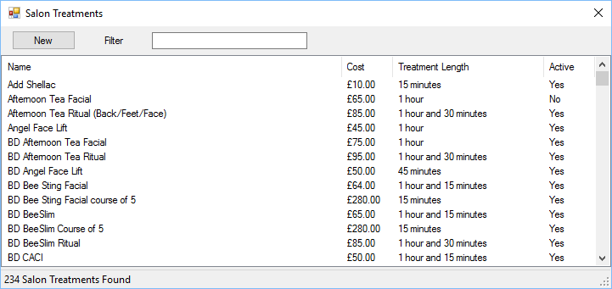

New - Creates a new salon treatment.

Filter - Filters the current list of treatments based on name or partial name.

Double click a treatment to edit.

##### Edit Salon Treatment

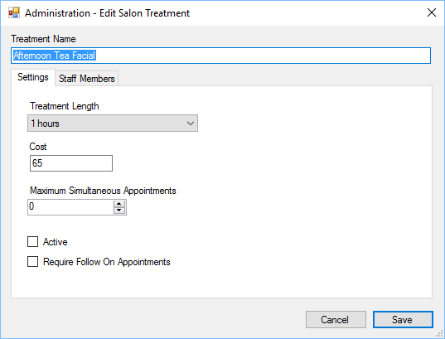

Treatment Name - Unique name of the treatment.

Treatment Length - Default length of the treatment.

Cost - Cost of the treatment.

Max simultaneous - If more than zero, only one appointment of its type can be created at a time. This option should be used if equipment is required and only a specific number of the required equipment is available. I.e. if you have one CACI machine then the number should be set to one.

Active - If ticked then the appointment will be active and users can select the appointment when making bookings.

Require Follow On - If ticked, this appointment will require a follow up treatment.

##### Staff Members

Staff members can only be booked for the appointments which they are assigned to.

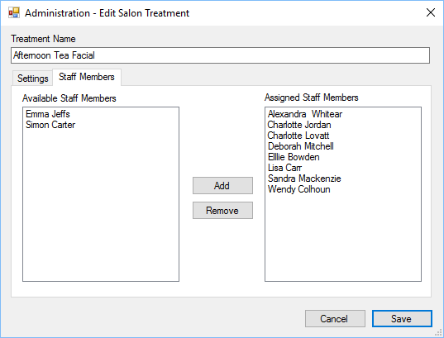

To assign a staff member to an appointment either double click the staff member from the Available list, or select them and click add. To remove a staff member, double click them from the Assigned list or select them and click remove.

### Advanced Settings

The diary has advanced settings which affect how it works.

#### General

General advanced settings

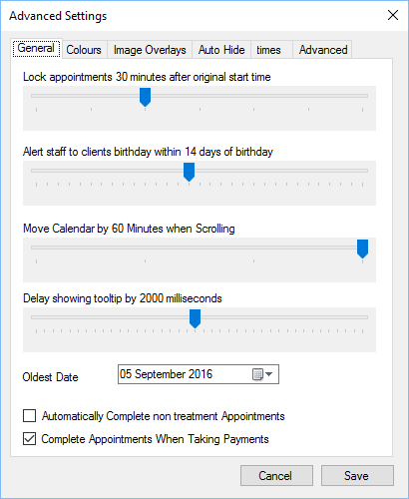

Lock Appointments - Automatically locks an appointment after it’s start time to prevent users making changes after the event.

Birthday Alert - When a client arrives and the appointment status is changed to Arrived, if the client has a birthday within xx amount of days of the appointment then an alert is shown to staff members.

Scrolling - Specifies how much the calendar is moved when scrolling up and down.

Tooltip Delay - Indicates the delay, in milliseconds before hint’s are shown.

Oldest Date - Indicates the oldest date to show within the calendar, you can not look at appointments prior to this date.

Auto Complete - When a non treatment appointment is in the diary, the appointment status will be marked as complete after the appointment time ends.

Complete when taking payments - If ticked, when a user takes payment for the treatment then the appointment status will be changed to Complete.

#### Colours

Users can specify the colour of appointments by the status.

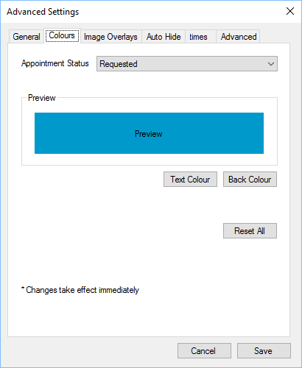

Select the appointment status from the list, a preview will be shown, select Text Colour and Back Colour to change the look.

Reset all will reset the colours back to their original settings.

Any changes here take effect immediately.

#### Image Overlays

Image overlays allow users to overlay appointments with images which depict different things which may be of use to a member of staff.

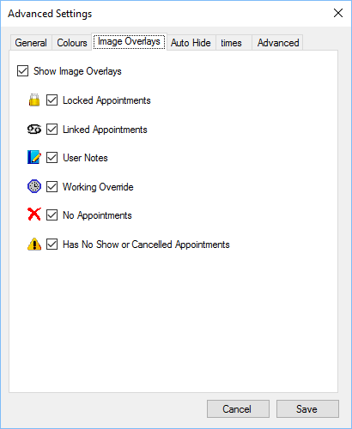

Locked Appointments - The appointment has been locked.

Linked Appointments - The appointment is linked to other appointments.

User Notes - The customer has notes within the system.

Working Override - Show next to the staff member name if the standard working hours for the staff member has been overridden. See

Working Hours for more information.

No Appointments - Shown next to the staff members name if treatments cannot be booked on that day.

No Show/Cancel - If a customer has previously booked appointments and has not shown or cancelled just prior to the appointment time, within the last six months, this icon will be shown.

#### Auto Hide

You can automatically hide staff from being shown in the

### Settings

The diary plugin module introduces two new settings pages.

#### Text Magic Integration

#### Text magic integration can be found in the Standard Icons

Throughout the POS, there are a number of standard buttons displayed on many of the forms shown, these are designed to indicate actions available across a number of areas. The buttons are always displayed on the top of each form.



If the button appears “greyed out” it is disabled and cannot be used. When the mouse is hovered over each button a hint will appear indicating what action the button will perform.

|  |  |
| --- | --- |
|  | Add or insert. |
| C:\Users\Simon\AppData\Local\Microsoft\Windows\INetCache\Content.Word\action_Cancel_16xLG.PNG | Delete or cancel. |
| C:\Users\Simon\AppData\Local\Microsoft\Windows\INetCache\Content.Word\icon_edit_16.png | Edit |
|  | Save |
|  | Refresh or reload. |
|  | Mark as paid. |
| C:\Users\Simon\AppData\Local\Microsoft\Windows\INetCache\Content.Word\user_16xLG.PNG | View user or view customer. |
| C:\Users\Simon\AppData\Local\Microsoft\Windows\INetCache\Content.Word\column_16xLG.PNG | Print label. |
|  | Print or print invoice. |
| C:\Users\Simon\AppData\Local\Microsoft\Windows\INetCache\Content.Word\notebook_16xLG.PNG | Notes or staff notes. |
|  | Customer notes. |
| C:\Users\Simon\AppData\Local\Microsoft\Windows\INetCache\Content.Word\Team_16xLG.PNG | Change sales person for invoice. |
|  | Issue refund to customer. |
|  | Enter or view tracking details. |
| C:\Users\Simon\AppData\Local\Microsoft\Windows\INetCache\Content.Word\calendar_16xLG.PNG | Select date, select number of days or update invoice date. |
| C:\Users\Simon\AppData\Local\Microsoft\Windows\INetCache\Content.Word\Close_16xLG.PNG | Close the current form. |
| C:\Users\Simon\AppData\Local\Microsoft\Windows\INetCache\Content.Word\lightningBolt_16xLG.PNG | Search or Execute. |
|  | Select count or Number 5 |

Administration Settings section and allows the diary users to send text notifications about upcoming appointments through the SMS Alerts option.

The homepage for Text Magic is: https://www.textmagic.com/

All settings for this option are available from the Text Magic home page.



Sender Name - Sender Name as provided by Text Magic.

Username - Username as provided by Text Magic.

API Key - API Key as provided by Text Magic.

#### User – Diary Settings

The Diary Settings can be found in the User settings section.

If Maximum diary age of 1 month is checked, then no appointments older than 1 month will be loaded, this can considerably speed up the loading of the diary.



Staff Selection section of the diary.

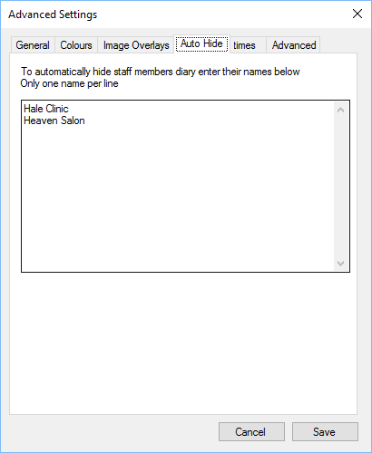

Add the staff members name to the list. Only one name per line can be shown.

This option can be used if you have a “dummy” staff member setup for appointments, but you do not want them to be shown in the list.

For example, if you have a clinic which is used by other staff members for appointments, on different days, but wish to hide it, add the name to the list.

#### Times

Lunch breaks can be automatically added for each staff member within the diary.

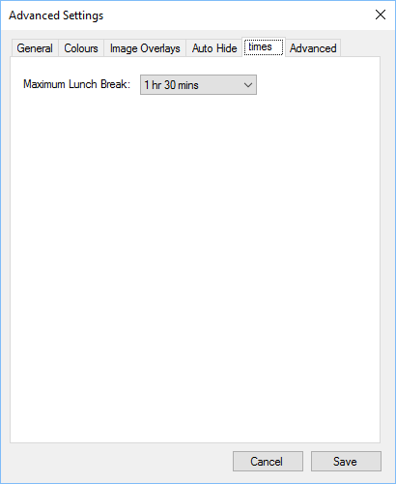

Specify the maximum lunch break time that can be automatically added to a staff member’s diary.

#### Advanced

Advanced diary settings.

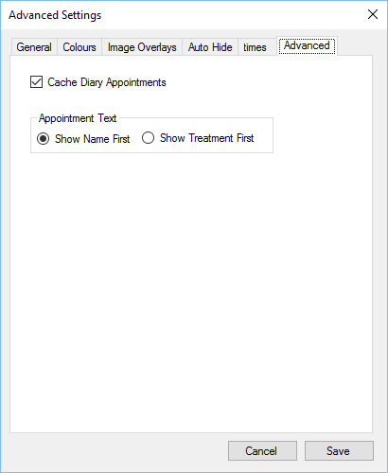

Cache - If ticked diary appointments will be saved in memory, this makes it quicker to show the appointments, but, external updates may be slower to show.

Appointment Text - Determines whether a customers name is shown on the first line of the appointment within the diary, or the treatment is shown.

If you have multiple sites viewing the same diary sheet, and staff at both locations can add appointments, then caching appointments could potentially allow for appointments to be booked simultaneously. See the Replication section for more information.

### Appointment Menu

Within the diary you can right click on an appointment or anywhere else, which a staff members section for more options.

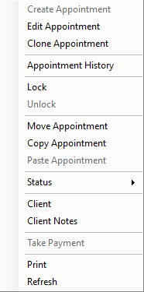

Create Appointment - Create a new appointment at the selected time for the staff member. If the selected appointment slot already has an appointment this option will be greyed out.

Edit Appointment - Edit an existing appointment.

Clone Appointment - Clone’s the selected appointment. (see Paste Appointment).

Appointment History - Show’s the Appointment , who has made changes etc.

Lock - Lock’s the appointment, once locked no changes can be made by other users.

Unlock - Unlocks an appointment that was previously locked.

Move Appointment - Prepares to move an existing appointment (see Paste Appointment).

Copy Appointment - Copies the selected appointment (see Paste Appointment).

Paste Appointment - If an appointment has been Cloned, Selected to be moved or Copied, you can paste the appointment into the diary on a different date, time and for a different staff member.

Status - Change the status of the appointment.

Client - View client details for the selected appointment.

Client Notes - View client notes for the selected appointment.

Take Payment - Opens the Till and adds the selected appointment into the list of items to pay for.

Print - Prints the current diary view.

Refresh - Updates the current diary view. See the Replication section for further information.

Depending on what is located where you right click will depend on which options are available or disabled (greyed out).

### Appointment Statuses

There are seven default statuses that can be applied to each appointment, they are:

Requested - The appointment has been requested by a customer, this is the default status used when customers created an appointment on the website.

Confirmed - The appointment is confirmed.

Arrived - The customer has arrived. Upon changing to the arrived status, several checks will be made by the diary, including birthday checks, and validating client details. See the section on **Error! Reference source not found.** for more information.

Cancelled by User - The appointment was cancelled by the customer, with little or no notification. This setting should be used in conjunction with company policy to determine when an acceptable time scale for customers for which customers can cancel appointments.

Cancelled by Staff - The appointment was cancelled by a member of staff.

No Show - The customer did not arrive at the salon or contact staff members to notify them.

Completed - The appointment is completed.

The appointment status plays a great part within the POS and accuracy is imperative. For instance if a customer has previous no show or cancelled by user appointments, staff will be notified when attempting to book appointments in the future.

Other system functions may rely on specific statuses, for example, surveys could be taken for those customers who have completed a treatment to gauge level of happiness etc.

### Create or Edit Appointment

To create an appointment right click on the time slot, for the selected staff member and click Create Appointment from the menu, to edit an existing appointment either double click the appointment or right click and select Edit appointment.

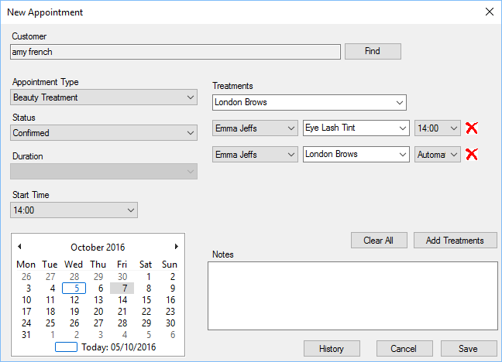

When creating an appointment the first thing you should do is Find the Customers

, you can create a new customer if they are not already registered within the system.

Appointment Type - Type of appointment.

Status - Current status of the existing appointment or the status that will be applied to a new appointment.

Duration - For beauty treatments the duration is taken from the treatment settings. For other appointment types you can select the duration of the appointment.

Start Time - The time the appointment will start.

Date - Date of the appointment.

Treatments - List of available treatments for the staff member. Please see Staff Treatments or Salon Treatments for more information on available treatments.

Clear All - Clears all appointments.

Add Treatments - See

Add Treatments for more information.

Notes - Specific notes for this treatment.

History - See The Add Treatment gives staff members more control when adding treatments to an appointment.

The Add Treatments section show’s all available treatments for the selected member of staff; you can filter the list by the name of the treatment for brevity.

At the bottom of the form are the treatments selected for this appointment. Double click a treatment to add it to the selected treatments list.

You can add a previous treatment to the list of selected treatments by double clicking it.

for more information.

Cancel - Cancels any changes made to the appointment if the appointment already exists, if it’s a new appointment it closes the form and does not create an appointment.

Save - Saves any changes made to the appointment.

Customers can book multiple treatments at a time, the treatments will be listed in order they are included. You can remove an existing treatment by clicking the red X next to the treatment name.

You can specify a different staff member for the treatments, this will provide flexibility in bookings.

The time of the initial appointment will always be shown, subsequent linked appointments can either have their time set automatically or manually. If Automatic is selected the treatments will follow each other based on treatment length.

You can view previous treatments the customer has had in the

Add Treatments section.

All changes to appointments will be logged to the staff member who is making them and will be visible in the

#### Add Treatments

The Add Treatment gives staff members more control when adding treatments to an appointment.

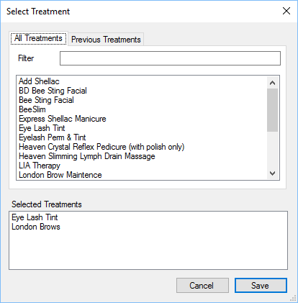

The All Treatments section show’s all available treatments for the selected member of staff, you can filter the list by the name of the treatment for brevity.

At the bottom of the form are the treatments selected for this appointment. Double click a treatment to add it to the selected treatments list.

#### Previous Treatments

This displays a list of previous treatments the customer has completed.

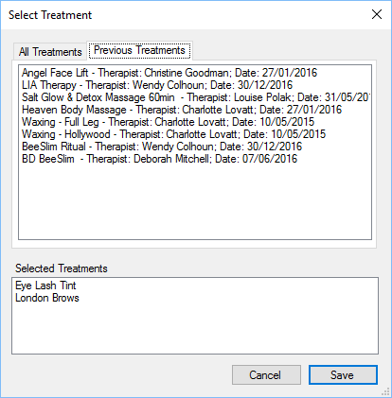

You can add a previous treatment to the list of selected treatments by double clicking it.

#### Appointment History

The appointment history can be shown for each customer when creating or editing an appointment.

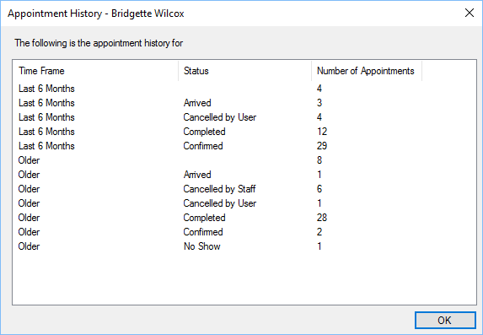

The history is broken down into the last six months of data, grouped by Status and older appointments grouped by Status.

This is provided for information only for staff members to consider when booking an appointment.

### Appointment Changes

All changes to an appointment by staff are logged and viewable if the user has permission to view appointment history.

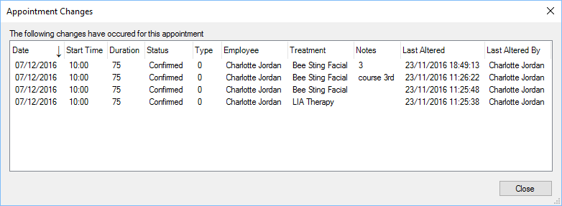

The above form shows what and who made changes and on what date and time.

### Reports

The diary provides several different reports for management purposes.

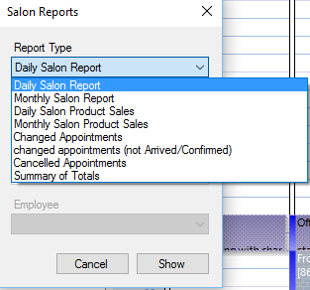

Daily Salon - Provides a breakdown of sales and treatments for a specific day.

Monthly Salon - Provides a breakdown of sales and treatments for a month.

Daliy Salon Product Sales - Breakdown of product sales by staff member for a specific day.

Monthly Salon Product Sales - Breakdown of product sales by staff member for a month.

Changed Appointments - Breakdown of appointment changes by staff member for a date range, for all appointments.

Changed Appointments (exclusions) - Breakdown of appointment changes by staff member for a date range with exclusions.

Cancelled Appointments - Breakdown of cancelled appointments by staff member.

Summary of Totals - Total appointments for date range by appointment status.

### New Appointment Wizard

The new appointment wizard allows staff to select up to 3 treatments and find the next available space within the diary.

#### Step 1

Select the treatments that are required, you can select upto 3 treatments.

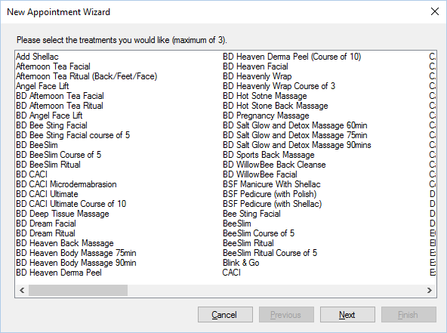

#### Step 2

Step 2 allows staff to select the preferred date for the appointment, the earliest start time and optionally the therapist that can complete the treatment.

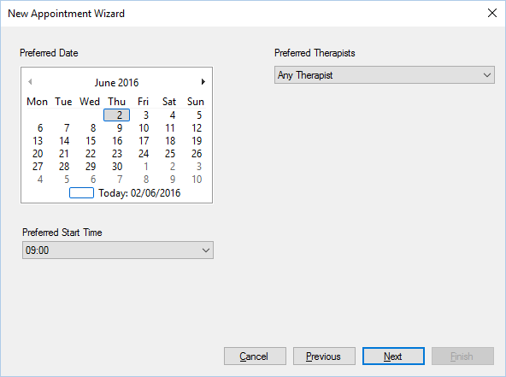

Please note only therapists that have the treatment assigned to them will be shown.

#### Step 3

Step 3 is the final step, it will show the very next available date and time for each therapist that can complete the appointment.

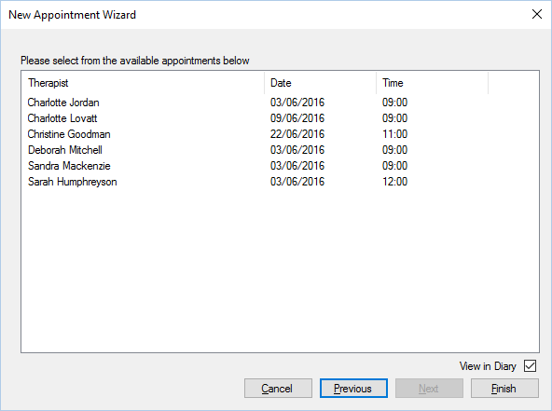

At this point you need to select the appointment date time that suits and click Finish. Upon doing so you will be able to select the customer for the appointment, or create a new customer.

If “View in Diary” is ticked then the diary will show the newly created appointment when complete.

### Waiting List

The waiting list option allows staff to add customers to a waiting list, if an appointment slot should become available then an alert will be shown.

You can manually activate the waiting list by clicking the waiting list button (left) or double clicking the “Waiting List” item in the status bar.

#### Availability

Whenever an appointment is cancelled, the POS will look through the waiting list and determine if any customers on the waiting list could fill the vacant time slot. If a customer could fill the vacant time slot then a notification will appear in the bottom right corner of the screen.

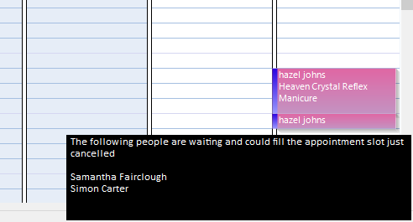

The notification will appear for about 45 seconds and if clicked the Waiting List will be shown.

#### Step 1

During this stage you can either add a new customer to the waiting list, or edit an existing customer on the waiting list.

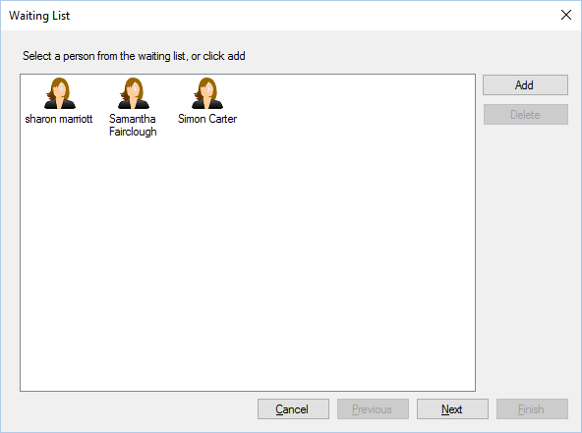

To edit an existing customer you can either select them and click next, or double click. If you double click the customer you will be taken to step 3 (bypassing the treatment selection).

To add a new customer to the waiting list you can click “Add”.

To delete a customer, select them and click “Delete”, you will be prompted to confirm deletion.

#### Step 2

During step 2 you can select the customer and the required treatments.

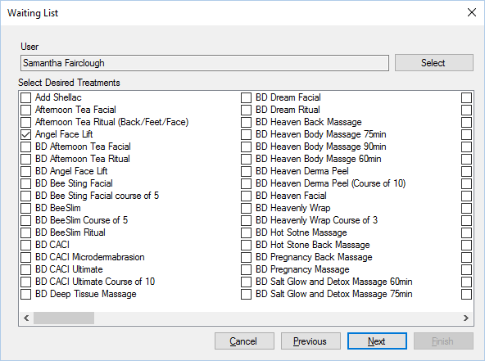

Once you have selected the customer and required treatments, click “Next”.

#### Step 3

Step 3 allows staff to select the preferred date, preferred start time and staff member.

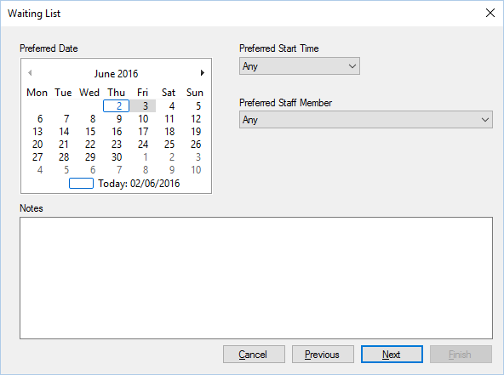

You can also add any notes for this customer at this point.

#### Step 4

Step 4, the final step, shows when the customer’s treatments can be completed.

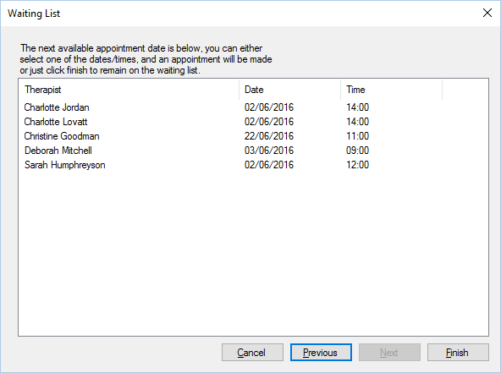

If you do not select an appointment at this stage, then the customer will be added to the waiting list, if you select an appointment you will be prompted to create the appointment.

Please note: As soon as you opt to create an appointment, the customer will be removed from the waiting list.

### SMS Alerts

The POS can send SMS alerts to customers who have treatments booked in. Alerts can only be sent for appointments within the next 5 days.

To send alerts, within the diary click the SMS alert button (left), this will load a new Wizard where you can type a message, check the appointments, validate the telephone numbers and view the message that will be sent.

#### Step 1

Step 1 allows you to configure the message that will be sent to customers.

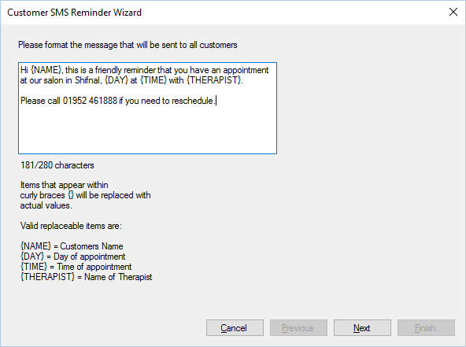

The message can contain 4 different place holders which when used will customise the message for each recipient.

The message can contain up to 280 characters.

#### Step 2

Step 2 allows staff to select which customers will receive the message.

Reminders can only be sent to mobile phones, within the UK all mobile phone’s start with 07, more importantly the UK country code is 0044 (or sometimes shown as +44). This format must be used when validating telephone messages to be sent.

When sending to an international number, the first 0 is removed, so, the telephone number below

07473812282

When formatted for sending via the alert wizard will be changed to

447473812282

If a message cannot be sent to the customer then it will be highlighted in red, the telephone number can be edited at this point by clicking the telephone number.

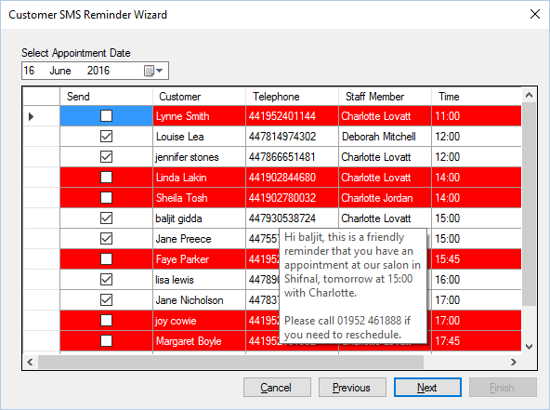

When you hover over a customer it will show the message formatted, this is what the customer will receive.

Only customers with a tick (✓) in the Send column will receive messages.

#### Step 3

During step 3, the final step, messages will be sent to customers. The wizard will tell you how many messages will be sent. To send the reminder alters click send.

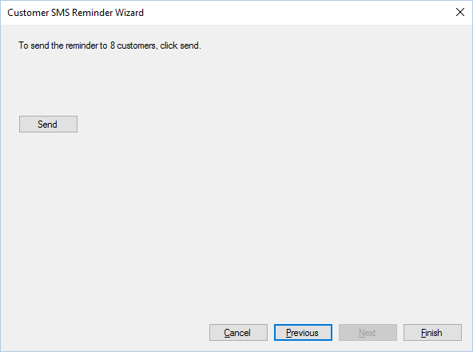

A reminder alert can only be sent once, for each appointment. Once a message has been sent you cannot send another.

You can check whether a notification has been sent or not by hovering over the appointment within the diary, it will either say “Reminder sent” or “Reminder not sent”.

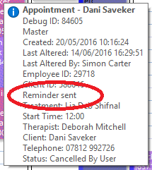

## Export

The POS can export user details for use in other programs and applications.

### Sage

The POS can export a CSV file that can be used to import customer records to the Sage application.

Select the accounts menu, then select Export to sage. The file, containing customer records for all invoices received, will be located in the POS folder.

## Help Desk

Customers can create support tickets on your website. The help desk facility allows staff to view and respond to the tickets.

There is a Home Button and Status Bar Items available which will show you the number of open tickets in the POS.

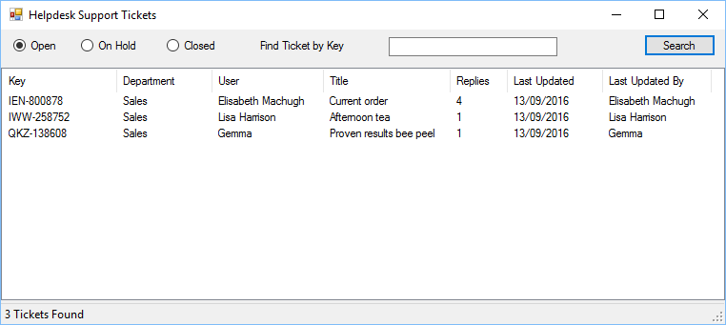

You can search for a ticket by type (Open, On Hold or Closed) or enter a ticket reference number. Click Search and the relevant tickets will be displayed in the list.

Double click a ticket to edit/view.

### View Ticket

You can view and respond to tickets within the POS.

To change the department or status change them using the options and click close. To reply to the ticket, enter your response and click Reply. Clicking the X in the top left will close the form without making any changes.

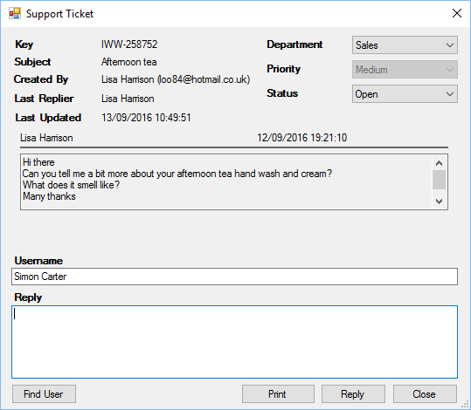

KEY - Ticket Reference Number.

Subject - Ticket subject as defined by the customer.

Created By - Customer that created the ticket.

Last Replier - Person who last responded on the ticket.

Last Updated - Date and time of the last response to the ticket.

Department - The department who the ticket is for.

Priority - The priority given to the ticket by the customer.

Status - Current status of the ticket.

Find User - Finds the user account associated with the ticket, if they have one.

Print - Prints the ticket in full.

Reply - Enter your reply in the text area provided and hit the Reply button. The ticket will close and be placed in the On Hold section.

Close - Closes viewing of the ticket. The status and department selected when viewing will determine the ticket status upon closing.

## Invoices

All invoices created can be viewed and manipulated via the POS.

### Settings

#### The Invoice plugin module introduces 3 setting options and can be found in the Standard Icons

Throughout the POS, there are a number of standard buttons displayed on many of the forms shown, these are designed to indicate actions available across a number of areas. The buttons are always displayed on the top of each form.



If the button appears “greyed out” it is disabled and cannot be used. When the mouse is hovered over each button a hint will appear indicating what action the button will perform.

|  |  |
| --- | --- |
|  | Add or insert. |
| C:\Users\Simon\AppData\Local\Microsoft\Windows\INetCache\Content.Word\action_Cancel_16xLG.PNG | Delete or cancel. |
| C:\Users\Simon\AppData\Local\Microsoft\Windows\INetCache\Content.Word\icon_edit_16.png | Edit |
|  | Save |
|  | Refresh or reload. |
|  | Mark as paid. |
| C:\Users\Simon\AppData\Local\Microsoft\Windows\INetCache\Content.Word\user_16xLG.PNG | View user or view customer. |
| C:\Users\Simon\AppData\Local\Microsoft\Windows\INetCache\Content.Word\column_16xLG.PNG | Print label. |
|  | Print or print invoice. |
| C:\Users\Simon\AppData\Local\Microsoft\Windows\INetCache\Content.Word\notebook_16xLG.PNG | Notes or staff notes. |
|  | Customer notes. |
| C:\Users\Simon\AppData\Local\Microsoft\Windows\INetCache\Content.Word\Team_16xLG.PNG | Change sales person for invoice. |
|  | Issue refund to customer. |
|  | Enter or view tracking details. |
| C:\Users\Simon\AppData\Local\Microsoft\Windows\INetCache\Content.Word\calendar_16xLG.PNG | Select date, select number of days or update invoice date. |
| C:\Users\Simon\AppData\Local\Microsoft\Windows\INetCache\Content.Word\Close_16xLG.PNG | Close the current form. |
| C:\Users\Simon\AppData\Local\Microsoft\Windows\INetCache\Content.Word\lightningBolt_16xLG.PNG | Search or Execute. |
|  | Select count or Number 5 |

Administration Settings section.

#### Invoice Settings

The invoice settings affect how the POS will deal with invoices.

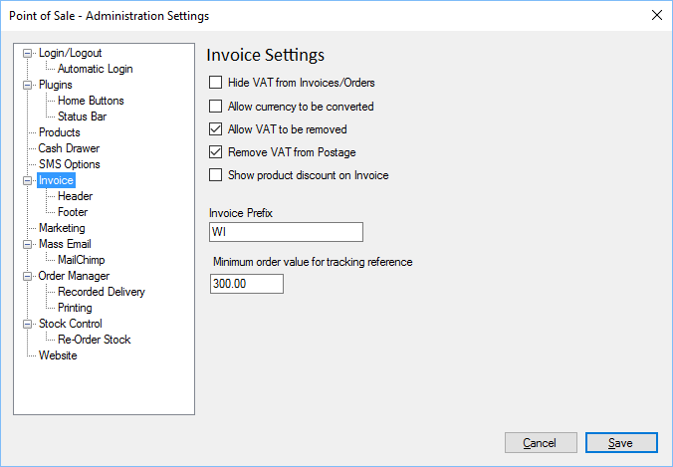

Hide VAT - Does not display tax on invoices or orders.

Currency conversion - Allows currencies to be converted, if the invoice was created with another currency than the standard currency used by the POS.

Allow Vat Removal - Allows tax to be removed from prices on invoices and orders.

Remove Postage VAT - Removes tax from the postage amount.

Show Discount - If a discount is on the invoice, it will only be shown if this box is ticked.

Invoice Prefix - The letters used to prefix invoices.

Tracking Value - When Dispatch Orders, users are prompted to enter a Tracking Reference, this check will be bypassed if the value of the order is below the amount specified.

#### Invoice Header Settings

You can change the image that is displayed on the top of invoices.

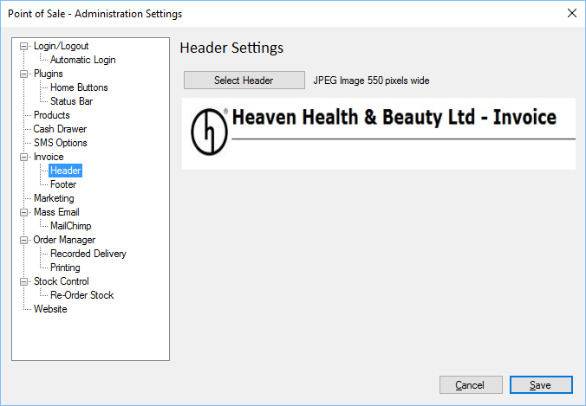

Click select header to choose a new header image, the image must be 550 pixels wide and will be displayed on the top of all invoices and orders.

#### Invoice Footer Settings

You can change what is displayed on the bottom of all invoices and orders.

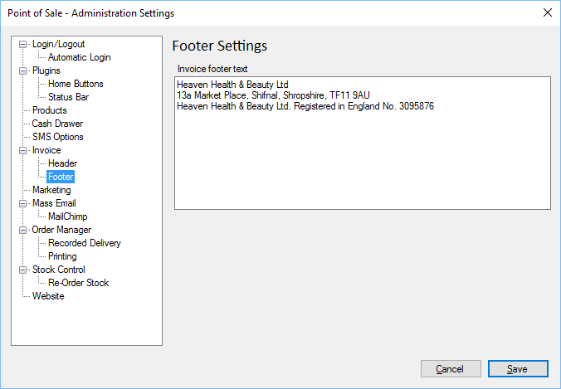

Enter the text that is to be displayed on the bottom of all invoices and orders in the Invoice Footer Text section.

### Invoice Manager

The invoice manager allows users to search for and view invoices using a variety of methods.

This form is split into two sections, the top half provides the options and the lower half show the invoices found during the search, which match the options.

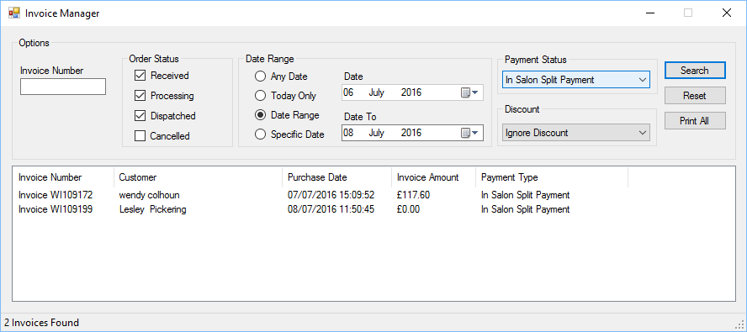

Invoice Manager - Enter an invoice number, without the user defined prefix. If this options is used, all other options are ignored.

Order Status - Put a tick in the status of the order you wish to view.

Date Range - Select one of the date options.

Date/Date To - Depending on the date option you have selected, you will need to select the date or date from/to.

Payment Status - Search invoices based on its payment status.

Discount - Search for invoices based on whether a particular Discount Coupons was used or not.

Search - Initiates a search of invoices, based on the options provided.

Reset - Resets the search options to the standard settings.

Print all - Prints all invoices in the list.

Double click an invoice to open / view it.

### View Invoice

You can view invoices from within the Invoice Manager or when viewing users:

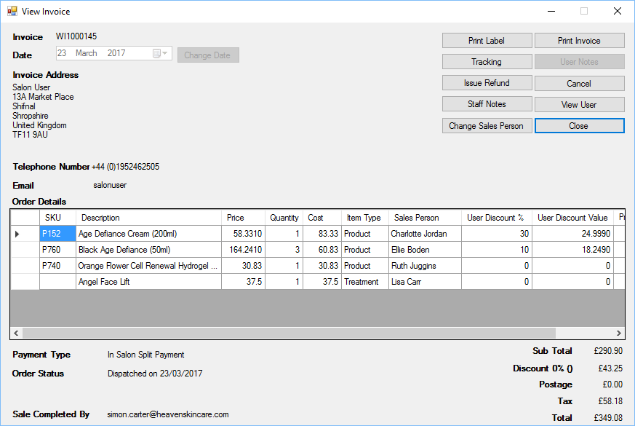

The invoice view allows you to view invoice details.

#### Invoice Actions

If you have permission you will be allowed to change the invoice date.

Print Label - Prints a label for the shipping address.

Print Invoice - Prints a copy of the invoice

Tracking - Allows the updating of the tracking reference

User Notes - Notes the user placed when making the order

Issue Refund - Issue a full or partial refund on the invoice

Cancel - Cancel’s the invoice.

Staff Notes - Staff notes are only visible to members of staff, notes can be up to 32000 characters long.

View User - View’s the user details for the user.

Change Sales Person - Allows the member of staff details, for individual items to be changed.

Close - Closes the view Invoce.

### Change Sales Person

Each invoice will have a staff member assigned, who made the sale, this can be changed when viewing the invoice. When viewing the invoice click “Change Sales Person”, you will then be shown a form like:

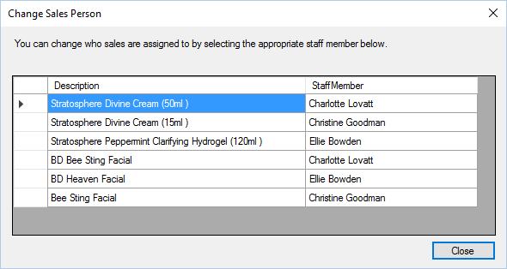

Click into the Staff Member column and you can select a new member of staff from the list.

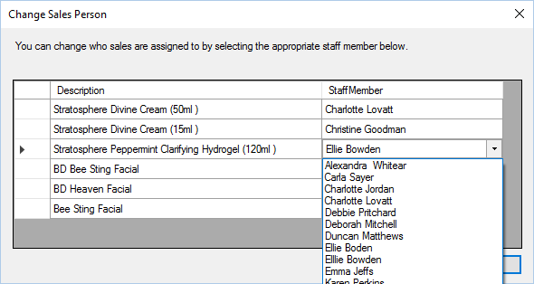

The changes are immediate.

### Cancel Invoice

When you cancel an invoice, you have an opportunity to move the stock back into stock control, but only if the invoice has been dispatched.

If the invoice has been dispatched you will see a form like:

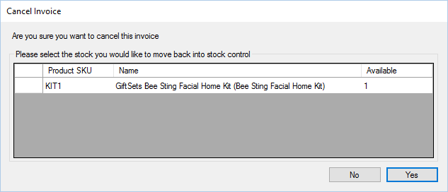

You can change the number available to return into stock, this number must not exceed the total available for the order.

When editing the quantity to put back into stock control, the Yes button will be unavailable, click elsewhere in the grid to end editing and enable the Yes button.

If the stock cannot be placed back into stock control, you will see a form like:

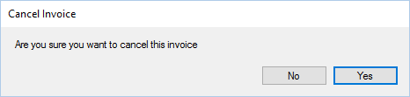

For both forms clicking yes will cancel the invoice, clicking no will not cancel the invoice.

### Issue Refund

You can issue a refund for all or partial amount on any invoice.

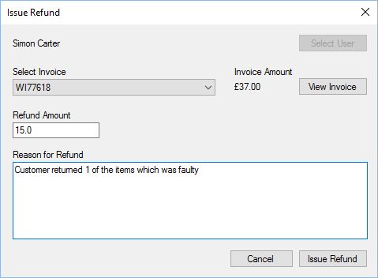

Select User - Select the user who will be issued a refund.

Select Invoice - Select the users invoice.

Invoice Amount - Displays the total amount for the invoice.

View Invoice - Allows users to view the invoice.

Refund Amount - The amount of money that will be refunded.

Reason for Refund - Enter a valid reason for the invoice to be refunded.

Issue Refund - Completes the transaction and marks the invoice as refunded.

## Marketing

The POS includes a marketing wizard which can be used to send emails to all customers in your database.

The marketing options are available from the Tools Menu, then selecting the Marketing menu. There are two options Create Marketing Email, and Update Marketing Files.

### Settings

#### The marketing plugin module introduces two new page to the Standard Icons

Throughout the POS, there are a number of standard buttons displayed on many of the forms shown, these are designed to indicate actions available across a number of areas. The buttons are always displayed on the top of each form.



If the button appears “greyed out” it is disabled and cannot be used. When the mouse is hovered over each button a hint will appear indicating what action the button will perform.

|  |  |
| --- | --- |
|  | Add or insert. |
| C:\Users\Simon\AppData\Local\Microsoft\Windows\INetCache\Content.Word\action_Cancel_16xLG.PNG | Delete or cancel. |
| C:\Users\Simon\AppData\Local\Microsoft\Windows\INetCache\Content.Word\icon_edit_16.png | Edit |
|  | Save |
|  | Refresh or reload. |
|  | Mark as paid. |
| C:\Users\Simon\AppData\Local\Microsoft\Windows\INetCache\Content.Word\user_16xLG.PNG | View user or view customer. |
| C:\Users\Simon\AppData\Local\Microsoft\Windows\INetCache\Content.Word\column_16xLG.PNG | Print label. |
|  | Print or print invoice. |
| C:\Users\Simon\AppData\Local\Microsoft\Windows\INetCache\Content.Word\notebook_16xLG.PNG | Notes or staff notes. |
|  | Customer notes. |
| C:\Users\Simon\AppData\Local\Microsoft\Windows\INetCache\Content.Word\Team_16xLG.PNG | Change sales person for invoice. |
|  | Issue refund to customer. |
|  | Enter or view tracking details. |
| C:\Users\Simon\AppData\Local\Microsoft\Windows\INetCache\Content.Word\calendar_16xLG.PNG | Select date, select number of days or update invoice date. |
| C:\Users\Simon\AppData\Local\Microsoft\Windows\INetCache\Content.Word\Close_16xLG.PNG | Close the current form. |
| C:\Users\Simon\AppData\Local\Microsoft\Windows\INetCache\Content.Word\lightningBolt_16xLG.PNG | Search or Execute. |
|  | Select count or Number 5 |

Administration Settings section.

#### Marketing File Settings

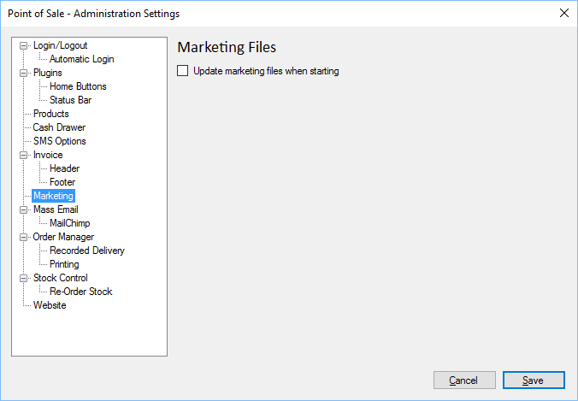

Update when Starting - Updates the marketing files when the POS starts.

#### Mail Chimp Integration

MailChimp is an online service who specialise in sending Mass Emails.

The company website is: <http://mailchimp.com/>

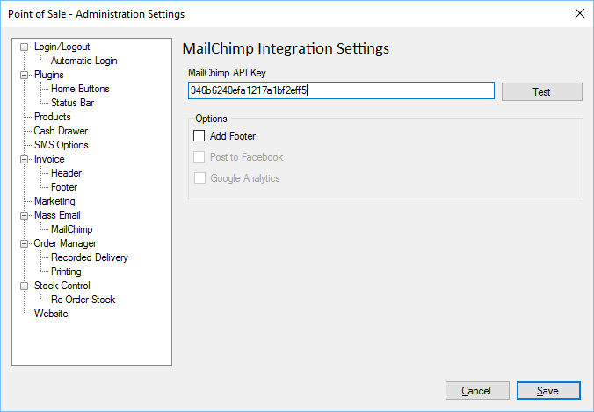

API Key - Unique Mail Chimp API Key as provided by Mail Chimp company.

Options - These are not currently integrated into the POS.

### Create Marketing Email

To create a marketing email, you will need to select Create Marketing Email from within the Tools\Marketing menu. This will launch the marketing wizard.

Please note, depending on the marketing template you select, some extra wizard pages may appear.

#### Campaign Name

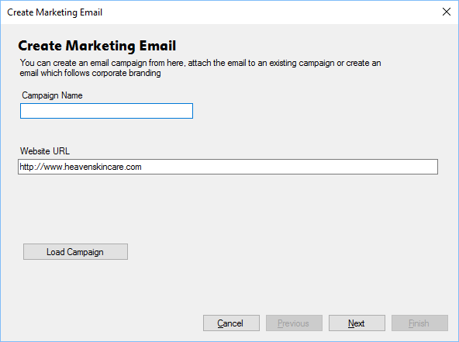

Campaign Name - Enter the campaign name during this step. The campaign name can only be 16 characters long and must only include the following characters: A to Z, a to z, 0 to 9 and - (hyphen).

Website URL - The website URL indicates the website where traffic will be redirected to.

Load Campaign - If you have previously saved a campaign you can load it by clicking Load Campaign and selecting there relevant file.

#### Select Template

There are a variety of templates with different options and styles. There is a preview of the selected template as well as a description of what it can contain.

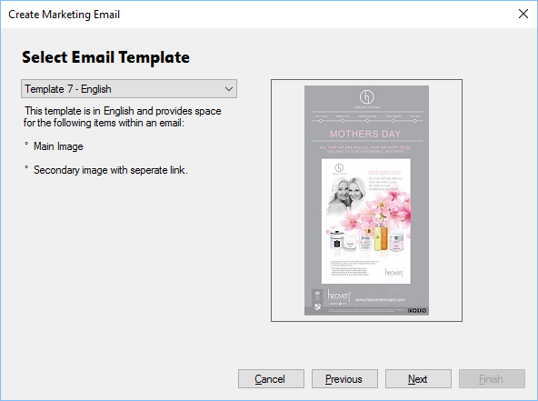

#### Landing Page

You can customise the landing page, this is the page where the user will be redirected if they click on the link in the marketing email.

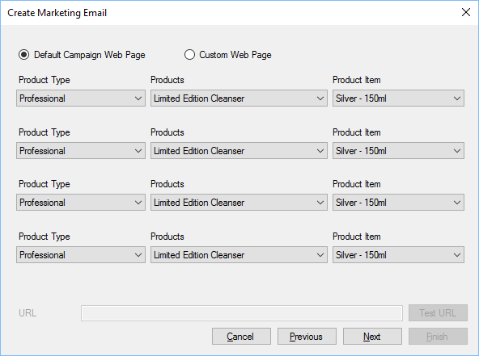

You can have up to 4 products showing on the landing page, or visit a custom web page, select the products in the lists provided. The custom web page can be provided in the URL section. The URL is made up of two parts, the website address you provided in Step 1 and the URL you specify in the field available.

For instance, if you want the customer to go to the Bee Peel page, the URL is:

<http://www.heavenskincare.com/Products/Stratosphere.aspx?ID=1751>

In this instance, because <http://www.heavenskincare.com> was specified in step 1, you only need to provide the last part of the link, this would be:

/Products/Stratosphere.aspx?ID=1751

You can test it works by clicking Test URL, which will open your web browser on the link.

#### Social Media

When the emails have sections available for social media, you can specify them during this stage.

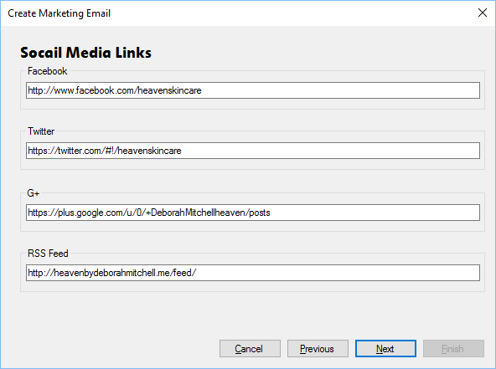

Enter your social media details and click Next.

#### Menu Items

If the email has menu items you can specify them on this page.

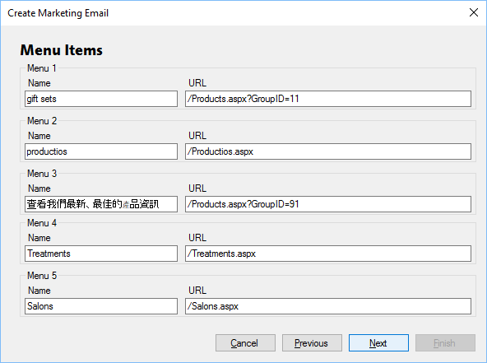

The URLs work the same as described in the Landing Page section. You can specify any name you wish in any language, as shown above.

#### Preview

Upon reaching this page you can preview how things will appear.

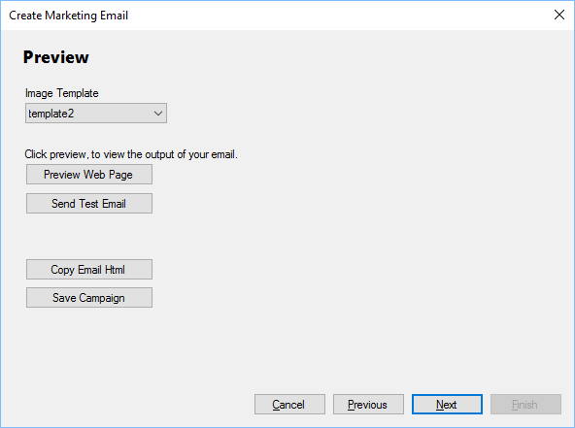

Image Template - Choose from the available image templates.

Preview Web Page - This will upload your campaign and open it in your web browser. This is the same page as customers will see if they click the link to “Open in a Browser” from within the email.

Send Test Email - Sends a test email to the currently logged in user.

Copy Email HTML - This will copy the HTML code used for the email.

Save Campaign - Saves the campaign so it can be changed at a later date.

#### Campaign

This page allows you to create the campaign, it is linked to the campaigns in your website.

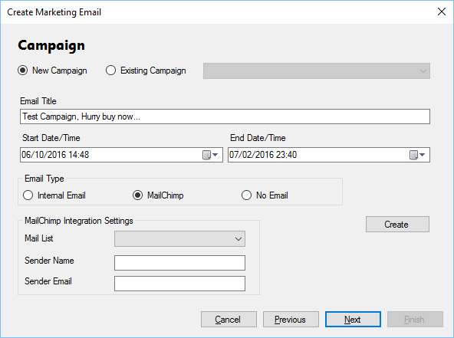

New Campaign - If this is a new campaign select this option. This is based on the campaign name provided in the Campaign Name section.

Existing Campaign - Updates an existing campaign. Select from the list of campaigns available.

Email Title - Title of the Email.

Start Date/Time - Date and time the campaign should start.

End Date/Time - Date and time the campaign should finish.

Internal Email - Sends the campaign using your website.

MailChimp - If you have Mail Chimp Integration, you can select this option.

No Email - The campaign will not send an email.

Mail List - Choose the MailChimp email list, this should prefill the Sender Name and Sender Email.

Create - Click create to create the MailChimp campaign.

#### Repeat Options

If using an internal campaign, you can choose to repeat sending the campaign.

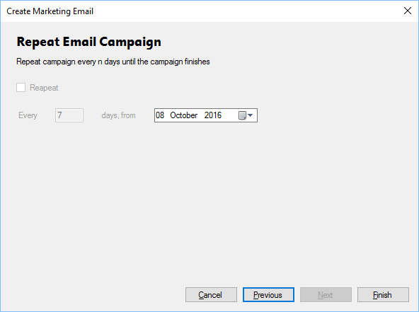

Click Finish to complete the process.

### Update Marketing Files

Marketing files are held on a central server, when there are updates, i.e. new email templates, you can select this option to download the updated files.

## Orders

Orders can be created via the POS using Create Order, or via a website.

Orders can have the following statuses:

* Order Received - Order has been received and is waiting to be processed.
* Order Processing - Order is being processed ready for dispatch.
* Order Dispatched - Order has been dispatched to the customer.

All orders will have an initial status of Order Received and customers can view the status of their order online.

### Settings

#### The orders plugin module introduces three new pages to the Standard Icons

Throughout the POS, there are a number of standard buttons displayed on many of the forms shown, these are designed to indicate actions available across a number of areas. The buttons are always displayed on the top of each form.



If the button appears “greyed out” it is disabled and cannot be used. When the mouse is hovered over each button a hint will appear indicating what action the button will perform.

|  |  |
| --- | --- |
|  | Add or insert. |
| C:\Users\Simon\AppData\Local\Microsoft\Windows\INetCache\Content.Word\action_Cancel_16xLG.PNG | Delete or cancel. |
| C:\Users\Simon\AppData\Local\Microsoft\Windows\INetCache\Content.Word\icon_edit_16.png | Edit |
|  | Save |
|  | Refresh or reload. |
|  | Mark as paid. |
| C:\Users\Simon\AppData\Local\Microsoft\Windows\INetCache\Content.Word\user_16xLG.PNG | View user or view customer. |
| C:\Users\Simon\AppData\Local\Microsoft\Windows\INetCache\Content.Word\column_16xLG.PNG | Print label. |
|  | Print or print invoice. |
| C:\Users\Simon\AppData\Local\Microsoft\Windows\INetCache\Content.Word\notebook_16xLG.PNG | Notes or staff notes. |
|  | Customer notes. |
| C:\Users\Simon\AppData\Local\Microsoft\Windows\INetCache\Content.Word\Team_16xLG.PNG | Change sales person for invoice. |
|  | Issue refund to customer. |
|  | Enter or view tracking details. |
| C:\Users\Simon\AppData\Local\Microsoft\Windows\INetCache\Content.Word\calendar_16xLG.PNG | Select date, select number of days or update invoice date. |
| C:\Users\Simon\AppData\Local\Microsoft\Windows\INetCache\Content.Word\Close_16xLG.PNG | Close the current form. |
| C:\Users\Simon\AppData\Local\Microsoft\Windows\INetCache\Content.Word\lightningBolt_16xLG.PNG | Search or Execute. |
|  | Select count or Number 5 |

Administration Settings section.

#### Order Manager Settings

These settings affect orders that are shipped via the Dispatch Orders section.

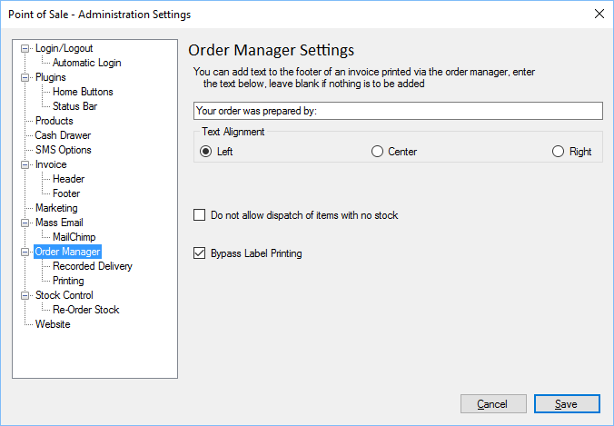

Prepared By - Text to specify who the order was prepared by.

Text Alignment - Determines where the Prepared By text is aligned on the invoice.

No Stock Dispatch - If ticked, users will not be allowed to dispatch any orders where there is no stock available.

Bypass Label Print - If ticked, the POS will not require that a label is printed prior to being dispatched.

#### Recorded Delivery Settings

This option can be used to provide a unique reference for recorded deliver.

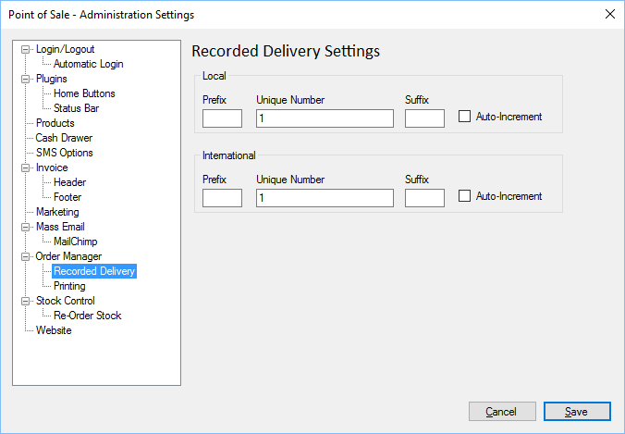

Local/International - Two identical sections for local and international settings.

Prefix - Text to prefix the unique number.

Unique Number - The starting unique number.

Suffix - The text appearing after the unique number.

Auto Increment - Determines whether the number is automatically incremented after use.

#### Label Printer Settings

Allows administrators to set which printer is the label printer which is used during Dispatch Orders.

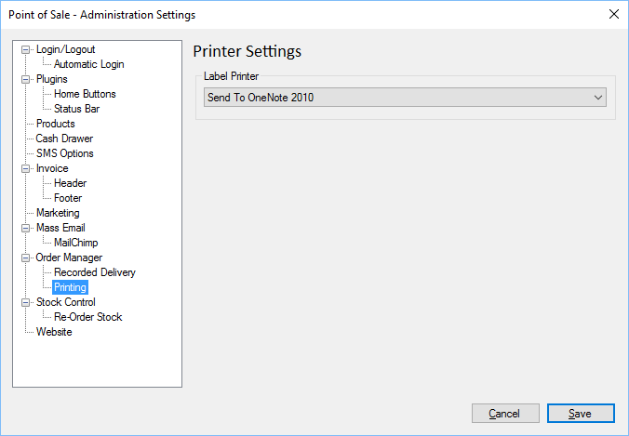

Label Printer - Select a printer from the list of installed printers.

### Create Order

You can create orders from within the POS.

This form is split into two sections, the left hand section shows all products, these can be filtered using the Filter field and product type, the right hand side shows the current sale.

To add a product into the order, click the product once. Repeatedly clicking the product item will increase the quantity.

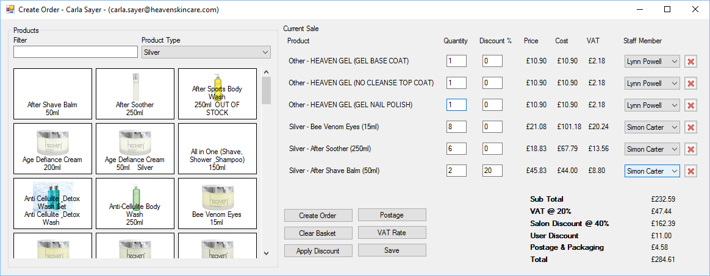

Product - The product being added to the order.

Quantity - The quantity of products.

Discount - The discount to be given on each individual product.

User Discount - The user discount given on each product item.

Price - Price of the product.

Cost - Cost of the product (Price \* Quanity).

VAT - The amount of tax being applied to the product.

Staff Member - The staff member making the sale.

Delete - Click the red X to remove the item from the current sale.

Create Order - Creates the order, this will prompt for printing and whether the order has been paid for.

Clear Basket - Clears the contents of the current sale.

Apply Discount - Adds a discount to the total value of the sale.

Postage - Set the price of the postage for the sale.

VAT Rate - Set’s the tax rate for the sale.

#### Save - Save’s the order so it can be re-opened at a later date. See Popup Menu

If you right click on any of the product items in the current sale, you will be presented with a popup menu:

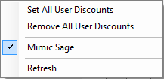

Set All Discounts - Sets all user discounts to a specific amount.

Remove All discounts - Removes the user discounts from all products.

Mimic Sage - Duplicates Sage discount structure.

Refresh - Refreshes all sale data.

Open Saved Order section for more information.

#### Popup Menu

If you right click on any of the product items in the current sale, you will be presented with a popup menu:



Set All Discounts - Sets all user discounts to a specific amount.

Remove All discounts - Removes the user discounts from all products.

Mimic Sage - Duplicates Sage discount structure.

Refresh - Refreshes all sale data.

### Open Saved Order

If you have previously saved orders when using the Create Order facility, you can re-open them to continue to make changes.

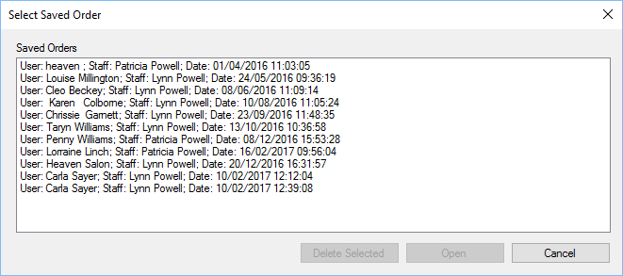

This section will show all saved orders, the customer the order is for, the member of staff who made the order and the date and time it was last saved.

### Find Order

Allows users to find an order, based on its order number.

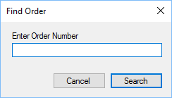

Enter the order number and click search, if the order is found, the View Customer Details will be shown.

### View Orders Received

When an order is received via a website or created using Create Order then it can be viewed by looking at Orders Received. To load orders received Select the “Orders” menu then select “View Orders Received” menu. This will display the following:

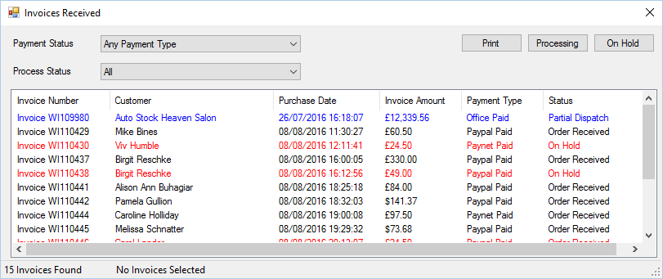

You can limit the invoices to specific payment types by selecting the drop down list for Payment Status.

Invoices can be printed or have their status changed to “Order Processing” or “On Hold”, to complete this select the invoices you wish to process and click “Processing” or “On Hold”, the order will be removed from this form when it’s stats is changed to “Processing”.

You can select multiple invoices by holding the Ctrl key and clicking each order with the mouse.

Items that appear red have zero stock availability.

You can limit the invoices to specific Process Status by selecting the drop down list for Process Status.

### View Unpaid Orders

Allows users, to view orders which have been received, but not paid for.

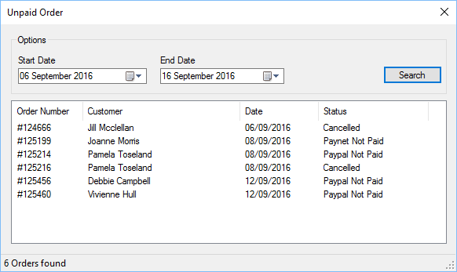

Start Date - Start date of search.

End Date - End date of search.

Search - Searches for all unpaid orders within the date period shown.

Double click an order to view it.

### Dispatch Orders

Orders can be dispatched using the “Order Dispatch” form.

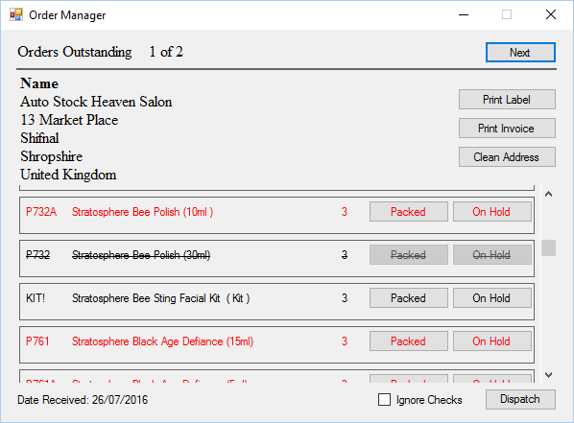

Items that appear in red have zero stock availability.

Items that appear in black have stock in and are available to be dispatched.

Items that appear with the text ~~struck through~~ they have already been dispatched.

All orders that have a status of “Order Processing” or “Partially Dispatched” will appear within the order dispatch form.

To process an order you must print a label, invoice and click “Packed” or “On Hold” for each item requested by the customer, this ensures that you have selected all items for the order.

Next - Loads the next available order awaiting dispatch.

Print Label - Prints a label for the current customer.

Print Invoice - Prints a customer invoice for inclusion within the shipment.

Clean Address - Removes duplicate entries from the address.

Staff Notes - If an invoice has Staff Notes a prompt alert will be shown and notes button enabled.

Ignore Checks - Disables checking of print invoice/label.

#### Tracking Reference

Once all items have been packaged up for dispatch, click the Dispatch button. Upon doing so you will be presented with a new form which prompts for a tracking reference:

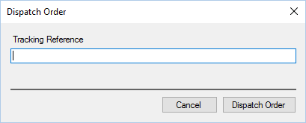

You can enter or scan a tracking reference at this point. The tracking reference, if set, will be shown to the customer and using the delivery company website allow customers to track their order.

The system can be configured to bypass the tracking reference for orders below a pre-determined amount.

By clicking “Dispatch Order” the order will be marked as dispatched which can be viewed by the customer online.

## Stock Control

The POS includes complete integrated stock management system.

Each Product Items within the system will be shown as stock within stock control.

### Settings

#### The stock control plugin introduces two new pages to the Standard Icons

Throughout the POS, there are a number of standard buttons displayed on many of the forms shown, these are designed to indicate actions available across a number of areas. The buttons are always displayed on the top of each form.



If the button appears “greyed out” it is disabled and cannot be used. When the mouse is hovered over each button a hint will appear indicating what action the button will perform.

|  |  |
| --- | --- |
|  | Add or insert. |
| C:\Users\Simon\AppData\Local\Microsoft\Windows\INetCache\Content.Word\action_Cancel_16xLG.PNG | Delete or cancel. |
| C:\Users\Simon\AppData\Local\Microsoft\Windows\INetCache\Content.Word\icon_edit_16.png | Edit |
|  | Save |
|  | Refresh or reload. |
|  | Mark as paid. |
| C:\Users\Simon\AppData\Local\Microsoft\Windows\INetCache\Content.Word\user_16xLG.PNG | View user or view customer. |
| C:\Users\Simon\AppData\Local\Microsoft\Windows\INetCache\Content.Word\column_16xLG.PNG | Print label. |
|  | Print or print invoice. |
| C:\Users\Simon\AppData\Local\Microsoft\Windows\INetCache\Content.Word\notebook_16xLG.PNG | Notes or staff notes. |
|  | Customer notes. |
| C:\Users\Simon\AppData\Local\Microsoft\Windows\INetCache\Content.Word\Team_16xLG.PNG | Change sales person for invoice. |
|  | Issue refund to customer. |
|  | Enter or view tracking details. |
| C:\Users\Simon\AppData\Local\Microsoft\Windows\INetCache\Content.Word\calendar_16xLG.PNG | Select date, select number of days or update invoice date. |
| C:\Users\Simon\AppData\Local\Microsoft\Windows\INetCache\Content.Word\Close_16xLG.PNG | Close the current form. |
| C:\Users\Simon\AppData\Local\Microsoft\Windows\INetCache\Content.Word\lightningBolt_16xLG.PNG | Search or Execute. |
|  | Select count or Number 5 |

Administration Settings section.

#### Stock Control Settings

These settings affect the display of the Stock Control form.

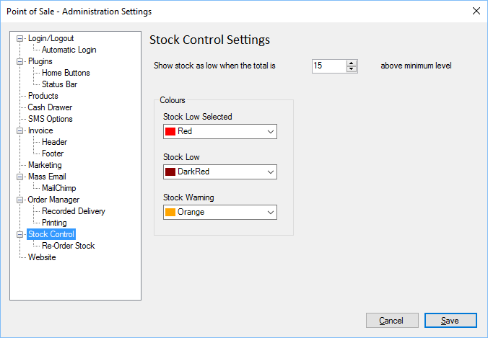

Show Stock Low - The value at which stock will appear low and be set to the colour defined below.

Stock Low Selected - The colour of a stock item when it is selected and the stock is low, i.e. in the example above, if the minimum level was set to 3 and the stock availability was 10, then it would be this colour when selected.

Stock Low - As above, except the stock item is not selected by the user.

Stock Warning - Colour used to indicate the quantity of stock is becoming low.

#### Automatic Stock Reordering

These settings affect the automatic stock reordering, see Auto Stock Re-Order section for more information.

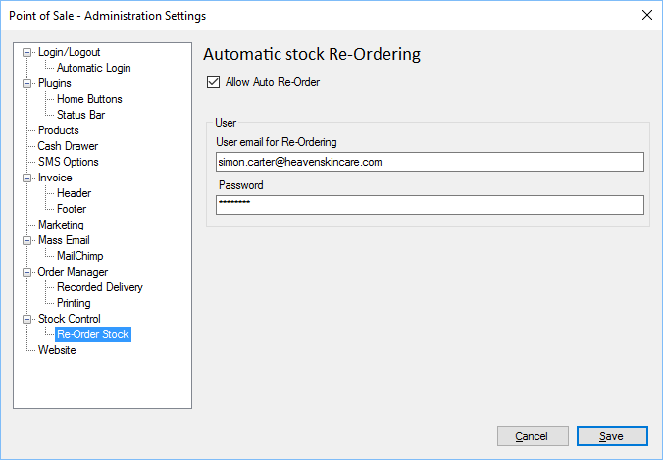

Allow Auto Reorder - If ticked then automatic stock re-ordering is enabled.

User Email - This is the email used to sign up to our website.

Password - This is the password used when you signed up to our website.

### Stock Control

You can control all aspects of your stock from within the POS.

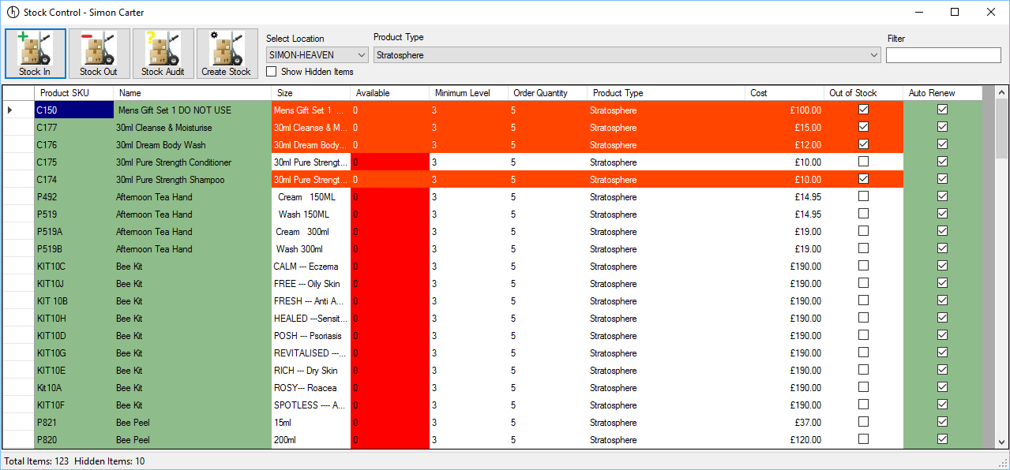

If you have multiple installations, across many sites, you can view the stock for each site by changing the Location. Please note, you can only complete Stock In, Stock Out, Stock Audit and Create Stock for your current location. If you change the location from your current location then the options will be disabled.

You can filter the view by using the filter, add the name (or partial name) of the product you wish to see.

Show Hidden Items - Items can be hidden locally, to declutter the screen, if you have hidden items the quantity will be shown in the status bar at the bottom of the form, put a tick in “Show Hidden Items” to view them. The product name will appear red (default) but can be changed in settings.

Minimum Level - This represents the minimum quantity that should be available in stock. If the quantity is below this, then the Available column will be red[[8]](#endnote-3). If the number is approaching the minimum level, then the column will appear yellow. This figure can be changed to another value.

Order Quantity - This is the minimum amount that should be ordered when re-ordering stock.

Out of Stock - If ticked it indicates the item is out of stock.

Auto Renew - If ticked then the stock item will be included in the Auto Stock Re-Order facility and the column, as well as the Sku and Name column will appear green.

You can right click on any stock item for more options:

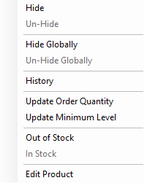

Hide - Hide’s the stock item on the local computer.

Un-Hide - Un-hide’s the stock item on the local computer.

Hide Globally - Hide’s the stock item throughout the site.

Un-Hide Globally - Un-hide’s the stock item throughout the site.

History - Show’s the history of the stock item, see Stock History for more information.

Update Order Quantity - Allows users to change the order quantity.

Update Minimum Level - Allows users to change the minimum stock level.

Out of Stock - Allows users to change the status to out of stock for the stock item.

In Stock - Allows user to change the status to in stock for the stock item.

Edit Product - Allows the user to edit the product directly, if they have permission.

### Stock In

If you need to move stock into the system, you can specify the quantities in Stock In.

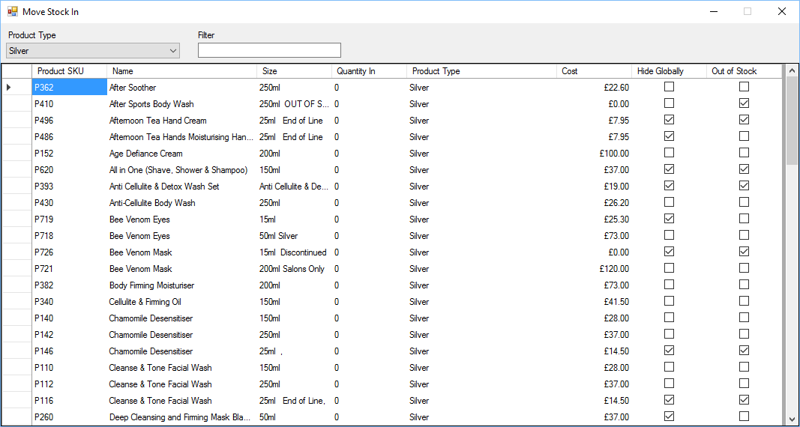

Specify the quantity of stock being moved in for each stock item. You can filter the products using the filter.

When complete click the X in the top right corner.

Only stock with a “Quantity In” above 0 (zero) will be moved into stock.

Stock being moved out will be logged against the user moving stock out. See Stock History for more details.

### Stock Out

Stock will automatically be moved out during the Dispatch Orders process, however, there may be other times when you need to be moved out of the location.

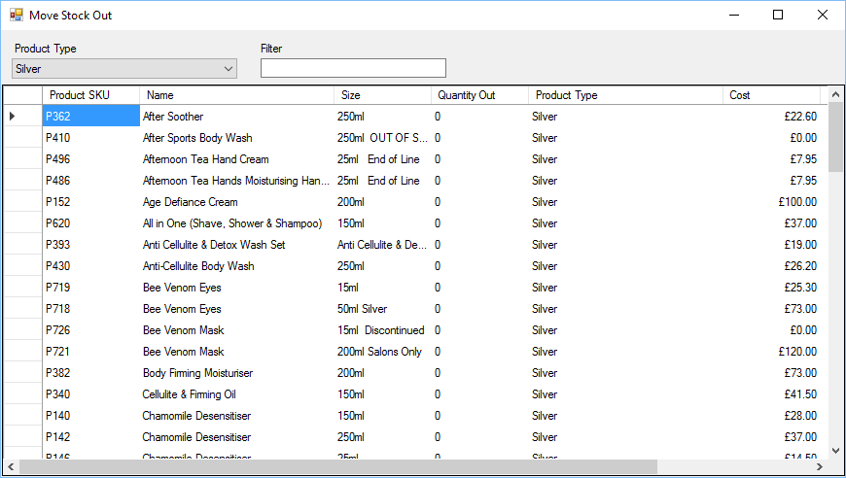

Enter the number of items to be moved out in “Quantity Out” column, then click the X in the top right of the form to move the stock out.

Specify the quantity of stock being moved in for each stock item. You can filter the products using the filter.

Only stock with a “Quantity Out” above 0 (zero) will be moved out of stock.

You will be prompted to enter a reason for the stock being moved out

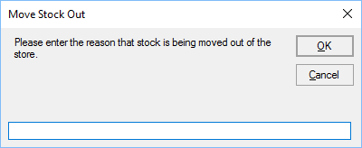

Once a description has been entered click OK to move the stock out, or Cancel to cancel moving the stock out.

Stock being moved out will be logged against the user moving stock out. See Stock History for more details.

### Stock Audit

An audit of current stock can be completed at any time, either in part or all stock.

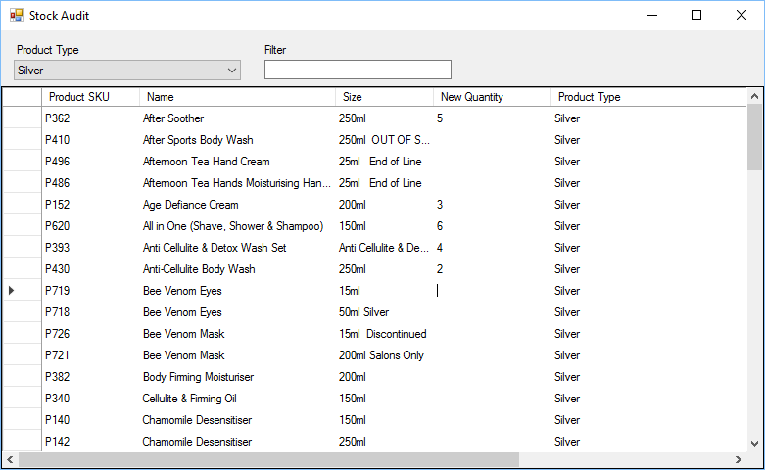

Once a full or partial stock audit has been completed enter the quantity of stock for each product item in the “New Quantity” column, if a partial audit is being completed then leave the item blank.

Click the X in the top right corner, you will be presented with a new form

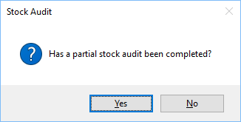

If you click Yes, only stock items with a value in the “New Quantity” will be updated, if you click No then all stock items will be updated, the items without a value will be set to 0 (zero).

Stock being moved out will be logged against the user moving stock out. See Stock History for more details.

### Create Stock

Create stock allows users to easily add stock into the system, as well as remove associated stock items.

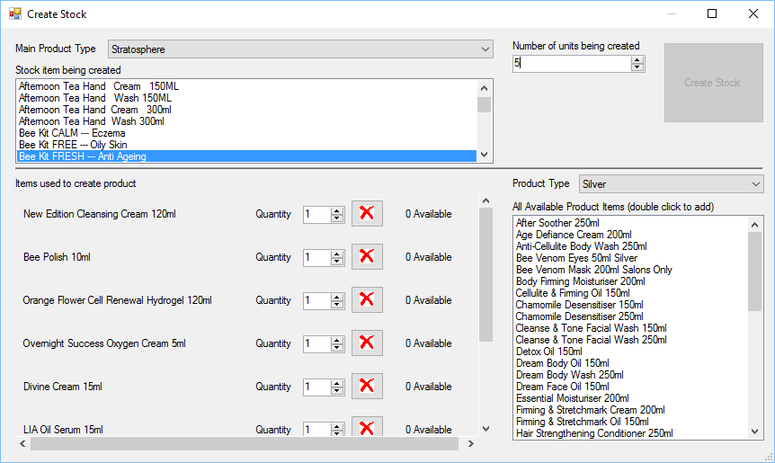

If for example you have a kit, that uses multiple stock items, select the stock item being created in the list at the top, this will automatically show the associated stock items below along with their stock levels.

You can specify how many items are used to create the item, if one of the items does not appear you can select the item by “double clicking” from the list on the right, this will automatically add it to the list.

You can then enter the number of stock items being created and click “Create Stock”

When you click Create Stock, the specified number of items will be added to the stock control, conversely at the same time the items being used will automatically be removed from stock.

So in the example above, to create 5 anti-ageing kits, 5 New Edition Cleansing Cream will be removed, 5 Bee Polish 10 ml will be removed and so on.

If some of the stock is not available then the option to “Create Stock” will be greyed out.

### Stock History

You can view the history of a stock item, to see which user has done what with the stock item, as well as use within invoices.

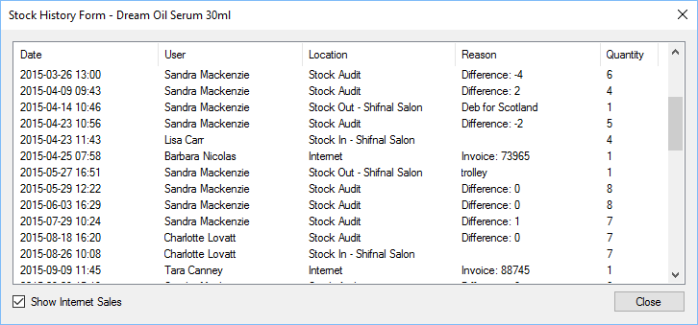

### Auto Stock Re-Order

Stock can be automatically re-ordered at any time, select the auto stock re-order option.

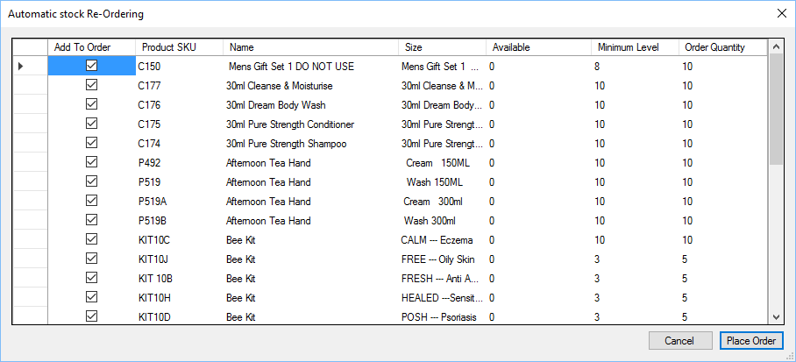

All stock items that have stock below the minimum stock level will be displayed, along with the total available and Minimum Level.

The order quantity is initially based on the Minimum Level and goes up in multiples of the stock items’ order quantity.

You can change the Order Quantity if required.

Once the correct quantities are set click Place Order, this will create an order with Head Office.

There is no option to pay for the goods during this process, instead head office should be contacted to complete the order.

Please see the section on Settings for details of how to configure auto stock re-order.

## Till

The POS includes a Till for use in salons.

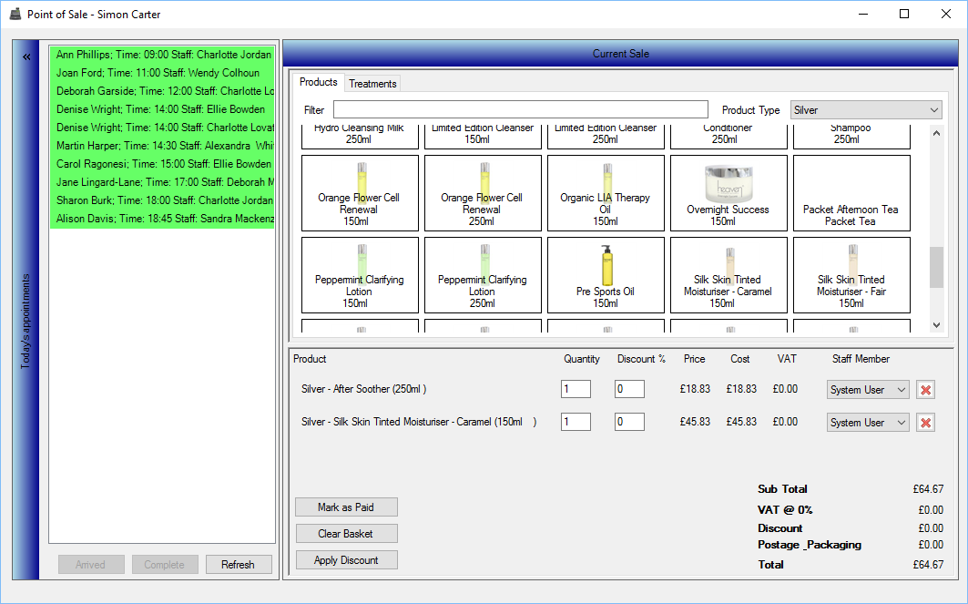

The till can be broken down into several sections

### Appointments

The appointment section is on the left hand side and show’s all upcoming appointments for the day using the customer name, time and member of staff.

Arrived - Select the customer and click arrived when they enter the salon. You may get alerts about birthdays or inaccurate data. If the data is inaccurate you can update it straight away.

Complete - Select the customer’s appointment and click complete, this will add the appointment to the customer’s basket, ready to complete the sale.

Refresh - Refreshes the list of appointments shown.

You can collapse and expand the Appointments section by clicking on the blue header.

### Adding Products/Treatments

You can add products and services to the current till to complete a sale with a customer.

Filter - You can filter the product list by entering the name, or part of the name.

Product Type - Select the product type.

You add a product by clicking it with a mouse, or if you have a touch screen tap it. If you keep adding the product it will increase the quantity.

### Current Sale

The current sale shows the products and treatments that will be sold to the customer.

Product - Name of the product or treatment.

Quantity - Quantity of each product or treatment being sold.

Discount - Users can give the individual product or treatment a discount, it can only be a percentage of the total.

Price - Unit price, you can hover the mouse over for more detailed price information.

Cost - This is the unit price x quantity.

VAT - Cost of tax for the product.

Staff Member - This is the member of staff who will be responsible for the sale. This option links into staff reports.

Delete - Click the red X to delete the item from the current sale.

Mark as Paid - Initiates the sale, See

### Apply Discount

There are three types of discount that can be applied to a sale.

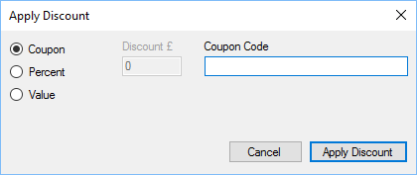

Coupon - If the customer has a coupon, you can enter, or scan the coupon code into the Coupon code section. The discount to be applied will be set to the coupon value.

Percent - Percentage discount to be applied.

Value - Enter a monetary value to be discounted.

Completing a Sale section for more details.

Clear Basket - Clear’s the contents of the current sale.

Apply Discount - Provides users with an opportunity to apply a discount to the sale. See

Apply Discount

### Apply Discount

There are three types of discount that can be applied to a sale.



Coupon**[[9]](#footnote-6)** - If the customer has a coupon, you can enter, or scan the coupon code into the Coupon code section. The discount to be applied will be set to the coupon value.

Percent - Percentage discount to be applied.

Value - Enter a monetary value to be discounted.

### Completing a Sale

Upon clicking Mark as paid you will be prompted to enter the client details.

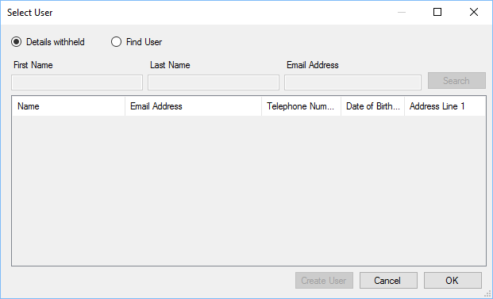

Where possible you should always find or create a user for the sale, this will provide future opportunities for marketing etc.

Click OK to continue or cancel to return to the Till.

### Entering Payment

After clicking OK you will need to enter the payment details.

Select the payment type to be used, you can select from:

Cash - Used when the sale is cash only.

Card - Used when the sale is credit/debit card only.

Cheque - Used when cheque payment is made.

Split Payment - Used when a combination of payment types will be used.

When making a payment via Card/Cheque you will be provided with a section to make notes, if required.

### Redeeming a Voucher

Vouchers can be redeemed using Split Payment, to redeem a voucher scan the voucher when the Split Payment option is selected. You can scan multiple vouchers and the totals will be summed up.

### Cash Payment

There is a handy little calculator on the cash payment screen. 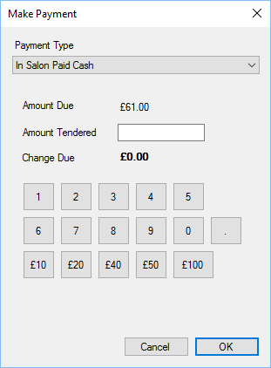

You can enter the amount tendered manually, or use the numbers 0 to 9 to enter the value. If a customer provides for instance 2 x £20 notes and 2 x £10 notes, click the £20 button twice and the £10 button twice. The amount of change due will be shown in bold.

### Split Payment

Split payment allows customers to pay using several different methods, including vouchers.

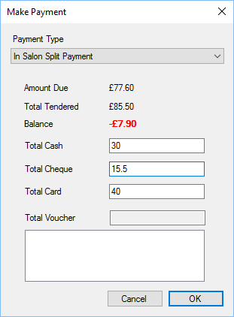

Amount Due - Total amount to be paid by the customer.

Total Tendered - The amount of payment currently tendered by the customer.

Balance - The amount still due from the customer, if the customer has tendered an amount over what is due, it will appear red and have a minus number. This is the amount of change that should be given back.

Total Cash - Total cash value tendered by the customer.

Total Cheque - Total cheque value tendered by the customer.

Total Card - Total card value tendered by the customer.

Total Voucher**[[10]](#footnote-7)** - Total voucher value tendered by the customer.

Click OK where you will be prompted to print an invoice for the customer.

## Update All Images

All images for products, celebrities etc are held on a central server. When new images are uploaded to the website a fresh list of images is created, this usually happens once an hour.

You can click the tools menu and then select “Update All Images” to get the list of most recent images available.

## Updater

The updater plugin is a non visual plugin which periodically checks for updates to the POS system. If an update is found it is downloaded and the user is prompted to update their version of the POS.

A user can choose to ignore an update at the time, but it will be automatically run when the POS is restarted.

## Training Schedule

The training schedule allows users to book a training course with up to 3 participants.

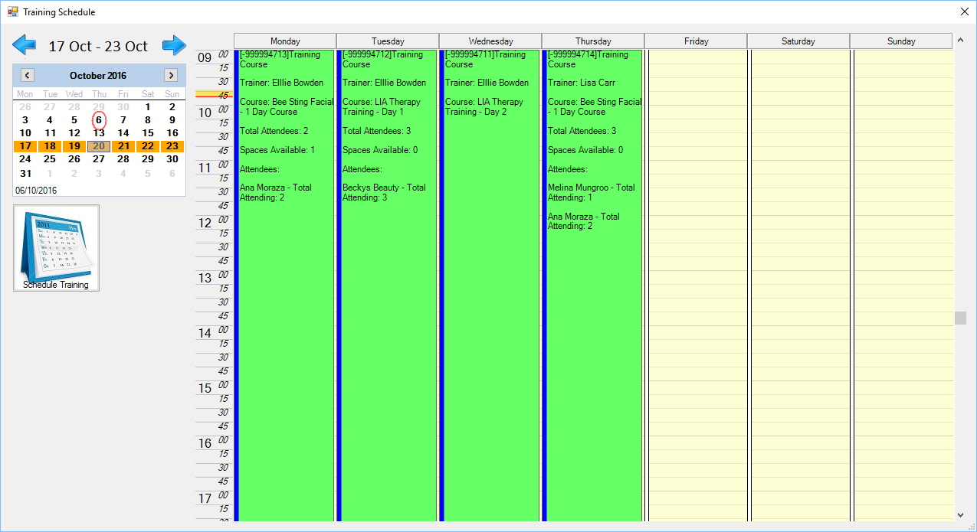

Schedule Training - Loads a wizard interface to book a training course.

### New Training Course Wizard – Step 1

Selects basic course details.

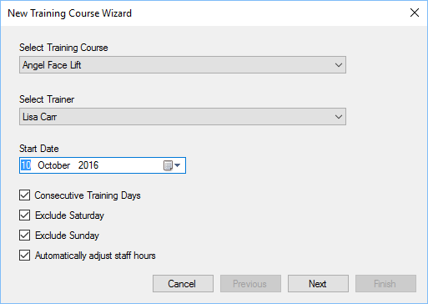

Training Course - Select the course to be created.

Trainer - Select the user who will run the course.

Start Date - Date the course should start.

Consecutive Days - If ticked the course will run on consecutive days.

Exclude Saturday - If ticked the course will not be scheduled on a Saturday.

Exclude Sunday - If ticked the course will not be scheduled for a Sunday.

Adjust Staff Hours - If ticked then staff who are involved will automatically have their working hours adjusted to fit the course.

### New Training Course Wizard – Step 2

This step is only shown if Consecutive days is not selected in step 1, and allows users to specify the dates for the course.

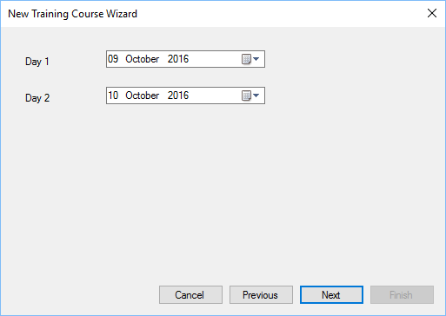

Select the individual dates for each day.

### New Training Course Wizard – Final Step

Confirm course details and create the course.

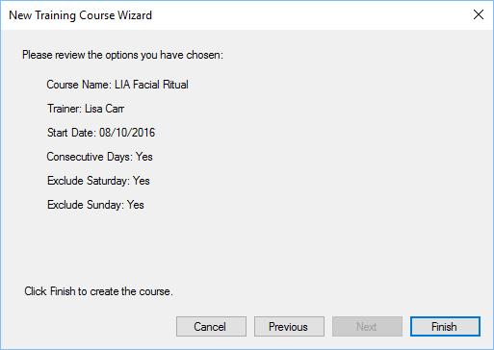

Click Finish to create the course.

### Edit Training Course

Each training course can have 3 attendees; these are based on Salon’s, not individual people.

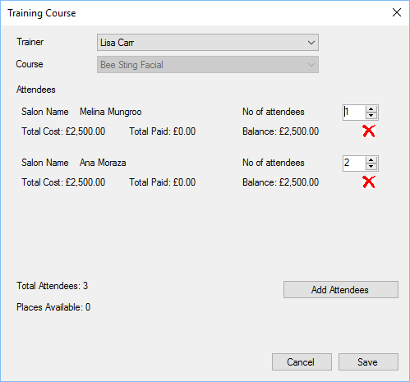

Trainer - User running the course.

Course - Course being run.

Attendees - Salon’s which are sending attendees.

Add Attendees - Add attendees to the course.

#### Edit Training Course – Add Attendees

To add attendees, select the salon and click OK.

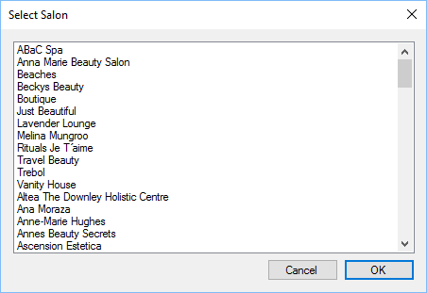

## Voucher Management

Voucher management allows users to manage[[11]](#footnote-8) existing vouchers within the system.

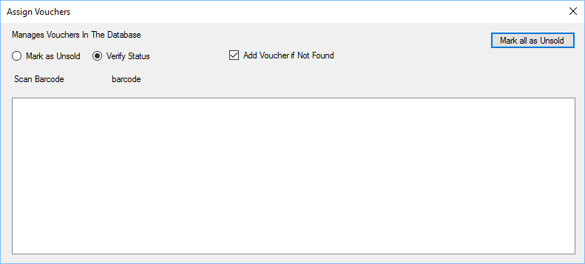

Mark as Unsold - If this option is selected, when a barcode on the back of the voucher is scanned, it will mark the voucher as unsold. This allows vouchers to be recycled.

Verify Status - If this option is selected, when a barcode on the back of a voucher is scanned, it will show the status of the voucher in the list below.

Add Voucher - If the add voucher option is ticked, when a barcode is scanned it will add the voucher to the system.

Mark all as Unsold - If the verify status is selected, you can scan a group of vouchers and mark them as unsold. Allowing them to be recycled.

### Create Vouchers

Vouchers are created via the reporting module and are designed to work with Avery Labels of any size. By default the label type L7160 and L7161 are supported, however you can print customised label sizes.

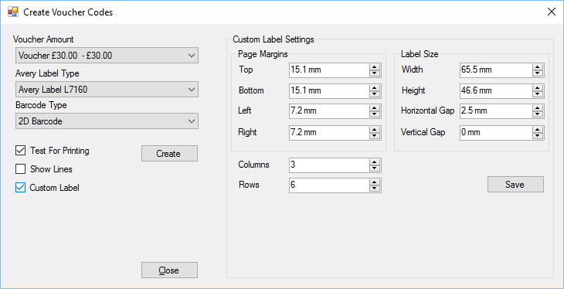

Voucher Amount - Specifies the amount of the voucher. These voucher amounts are also Product items, linked to a product called Voucher.

Avery Label Type - Specifies default label sizes that are pre-supported.

Barcode Type - Type of barcode to create, default is 2D Barcode.

Test For Printing - If ticked the barcodes generated will not be included in the barcode. If unticked then the barcodes will be usable within the pos.

Show Lines - If ticked then the labels will be printed with a border, this is useful with custom labels and test for printing.

Create - Creates the voucher codes using the above settings.

Custom Label Settings - When printing on other label types, the custom label settings allow users to specify the exact label types.

Save - Saves custom label settings.

Close - Closes the voucher generating form.

## Website Administration

Website administration is split into multiple sections.

### Settings

#### The website administration plugin module introduces one page to the Standard Icons

Throughout the POS, there are a number of standard buttons displayed on many of the forms shown, these are designed to indicate actions available across a number of areas. The buttons are always displayed on the top of each form.



If the button appears “greyed out” it is disabled and cannot be used. When the mouse is hovered over each button a hint will appear indicating what action the button will perform.

|  |  |
| --- | --- |
|  | Add or insert. |
| C:\Users\Simon\AppData\Local\Microsoft\Windows\INetCache\Content.Word\action_Cancel_16xLG.PNG | Delete or cancel. |
| C:\Users\Simon\AppData\Local\Microsoft\Windows\INetCache\Content.Word\icon_edit_16.png | Edit |
|  | Save |
|  | Refresh or reload. |
|  | Mark as paid. |
| C:\Users\Simon\AppData\Local\Microsoft\Windows\INetCache\Content.Word\user_16xLG.PNG | View user or view customer. |
| C:\Users\Simon\AppData\Local\Microsoft\Windows\INetCache\Content.Word\column_16xLG.PNG | Print label. |
|  | Print or print invoice. |
| C:\Users\Simon\AppData\Local\Microsoft\Windows\INetCache\Content.Word\notebook_16xLG.PNG | Notes or staff notes. |
|  | Customer notes. |
| C:\Users\Simon\AppData\Local\Microsoft\Windows\INetCache\Content.Word\Team_16xLG.PNG | Change sales person for invoice. |
|  | Issue refund to customer. |
|  | Enter or view tracking details. |
| C:\Users\Simon\AppData\Local\Microsoft\Windows\INetCache\Content.Word\calendar_16xLG.PNG | Select date, select number of days or update invoice date. |
| C:\Users\Simon\AppData\Local\Microsoft\Windows\INetCache\Content.Word\Close_16xLG.PNG | Close the current form. |
| C:\Users\Simon\AppData\Local\Microsoft\Windows\INetCache\Content.Word\lightningBolt_16xLG.PNG | Search or Execute. |
|  | Select count or Number 5 |

Administration Settings.

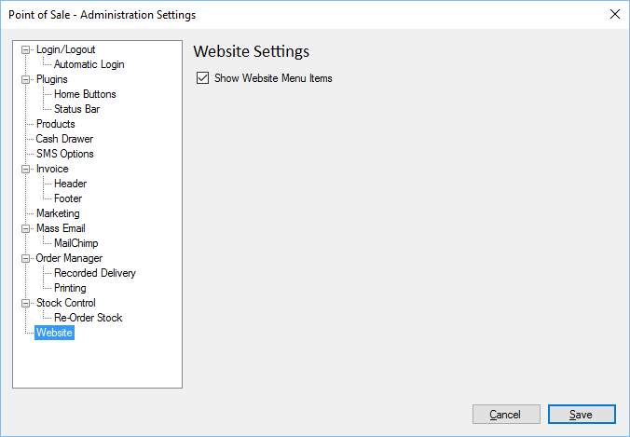

Show Website Menu - If ticked the Website Administration menu items will be shown.

### Countries

Countries can be configured to act differently for users who visit the website, or for POS users, when creating invoices or orders for customers within specific countries.

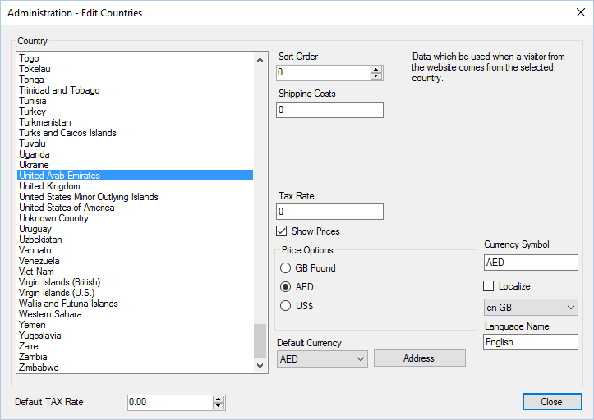

Country - Select the country you wish to edit.

Sort Order - Determines the order in which the country is displayed, a lower number means it will be displayed first. If several countries share the same sort order then it will be further sorted on the country name.

Shipping Costs - Shipping costs for the country.

Tax Rate - Specifies the rate of tax for the country. For example, if the main base of operation is within the UK then the VAT rate will apply to all countries within the EU. For countries outside of the EU then a zero VAT rate will apply.

Show Prices - Determines whether price data is shown for visitors from that country, on the website.

Price Options - You can specify up to 3 prices for an individual product item. You can select which price option is used for the country.

Currency Symbol - The default currency symbol that should be used for this country.

Localize - The default localization for the country. This is used if the website allows users to select different languages.

Language Name - The name of the language that will be used if this country is localizable.

Default Currency - The default currency to be used for the country. When using the pos, this value is used for all orders/invoices created, if selected in the options (see User settings

User settings can be accessed by all POS users.

User – General options).

Address - Allows administrators to define which fields are show/required for that country.

#### Address Options

Each country can have the address configured so that different address lines are shown/hidden or made mandatory for the user:

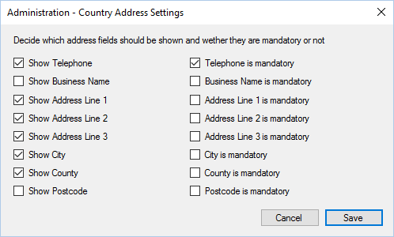

Select which options should be shown (on the left), and which items are mandatory (right) and click save.

### Customer Comments

If configured, customers can add feedback online. These will appear within the POS and can be viewed, altered or deleted prior to being shown online.

Select Administration menu, then Website menu, then Comments menu. This will display the following form:

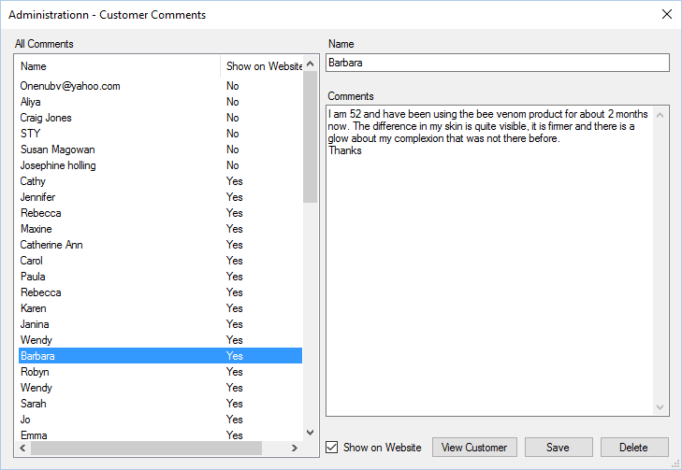

Select the comment you wish to view.

Show on Website - If ticked the comment will be viewable online.

View Customer - If the user who made the comment was logged in to the website, then you can view their details.

Save - Saves any changes made to the comment.

Delete - Deletes the comment.

### Treatments

Salon Treatments are those treatments that are displayed on your website.

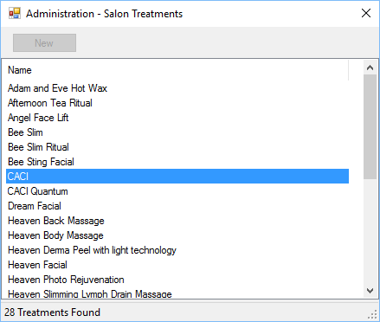

You can create a new one by clicking new, or double click an existing treatment to edit or view.

#### Treatments Edit

There are several options which can be used to change how a treatment is viewed on the website.

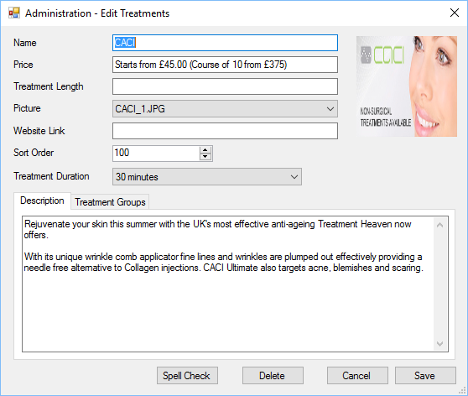

Name - Name of the treatment.

Price - Price of the treatment.

Treatment Length - Duration of the treatment.

Picture - Image associated with the treatment (please see Update All Images for more information).

Website Link - If the treatment has its own specific web page, the URL can entered.

Sort Order - The order of appearance on the website, lower numbers appear first, higher numbers later. Items with the same sort order will be further sorted alphabetically based on the name.

Treatment Duration - Duration of the treatment.

Description - Description of the treatment as seen on the website.

Treatment Groups - Select all groups (add a tick to the box) for all groups where the treatment should appear.

Spell Check - Spell check the name and description of the treatment.

Delete - Delete the treatment.

### Treatment Groups

Website Treatment Groups are shown on the website only.

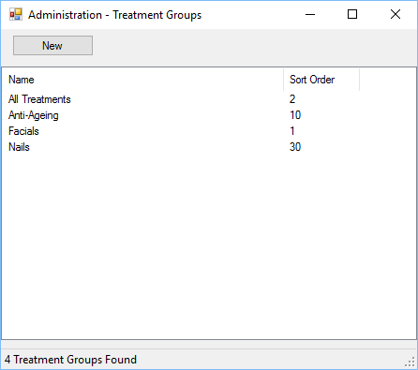

Double click a group to edit/view. Click new to create a new website treatment group.

### Treatment Group Edit

You can edit the treatment group settings within the POS.

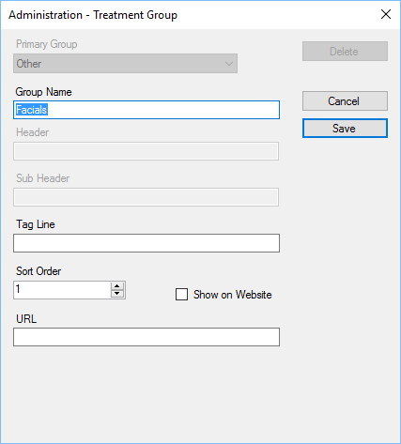

Group Name - Allows users to specify the name of the group as it will be seen on the website.

Tag Line - Used on the website only, the header displayed at the top of the page when the group is selected.

Sort Order - Specifies the sort order for the group, lower numbers appear before higher numbers. If groups have the same sort order then they will be sorted by name as well.

Show on Website - If ticked the group will be shown on the website.

### Distributors

Distributor details are exactly like Salons details, please see the Salons section for making changes.

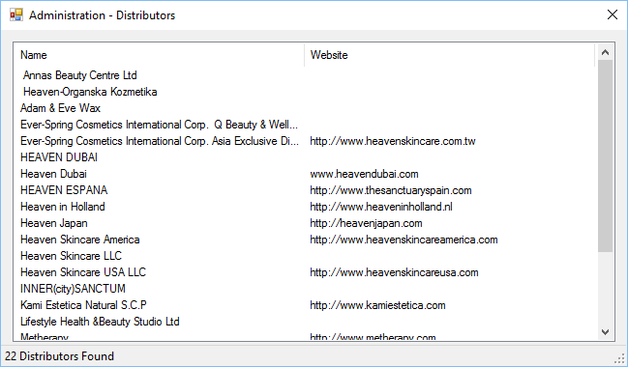

To edit distributor details double click the item in the list.

### Salon Owners

Salon owner is a specific Member Level which adds certain options above a normal user.

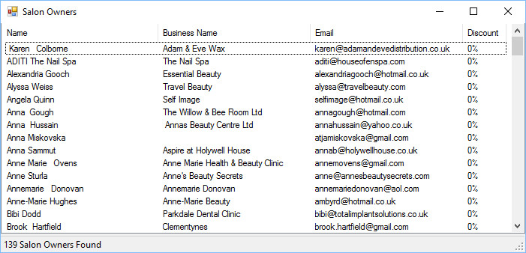

Find the salon owner within the system and double click to edit. To change a users Member Level see View Customer Details. Salon owners have two additional table when viewing the details, compared to normal Customers.

### Salon Owner Details

Salon owners, like distributors can be given a percentage discount on all orders in their basket when shopping online or when orders are created within the POS.

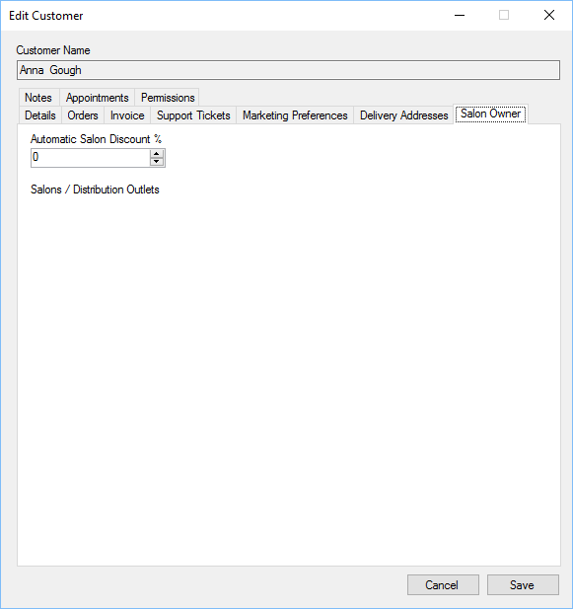

Specify the salon owner discount percent to be given on all orders within the POS.

### Salon Owner Permissions

Salon owners, like distributors need permission to perform certain tasks within the website, like editing their own salon details.

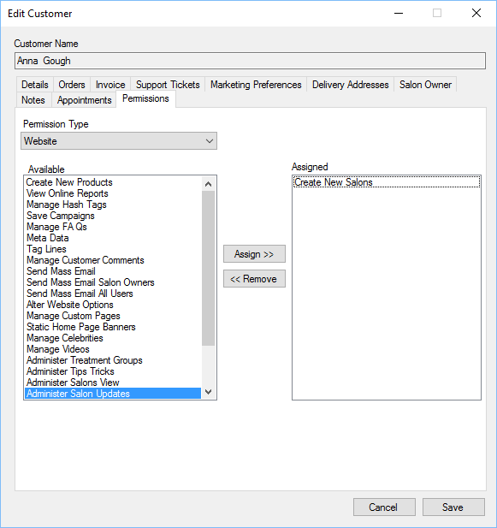

To assign a permission either double click the permission from the Available list, or highlight the required permission and click “Assign”.

To remove a permission for a staff member, either double click the assigned permission or highlight the assigned permission and click “Remove”.

See Staff, Permissions section for more details on types of permissions.

### Salons

You can display salon details for your own distributors or salon owners on your website.

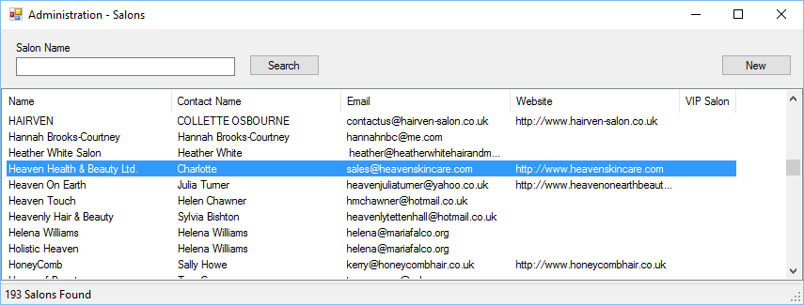

Click New to create a new salon, or double click an existing salon to open/edit.

### Salons Edit

The salon edit has 4 tabs that can be used to edit the settings to be displayed on the website.

#### Salon Edit – General

General settings contains contact details for the salon

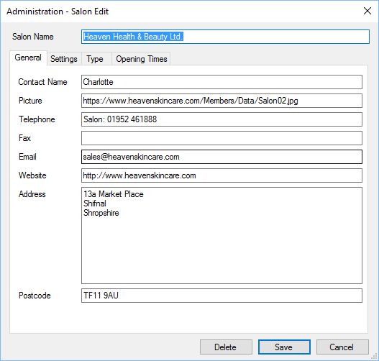

Contact Name - Name of primary contact within the salon.

Picture - This will be a link to a jpg or gif image which is 120 x 120 pixels.

Telephone - Telephone number for salon.

Fax - Fax number for salon.

Email - Email address for the salon.

Website - Homepage for the salon.

Address - Address of salon, without postcode.

Postcode - Postcode for salon, this will be used within the website to find nearest salon.

#### Salon Edit – Settings

Salon website settings.

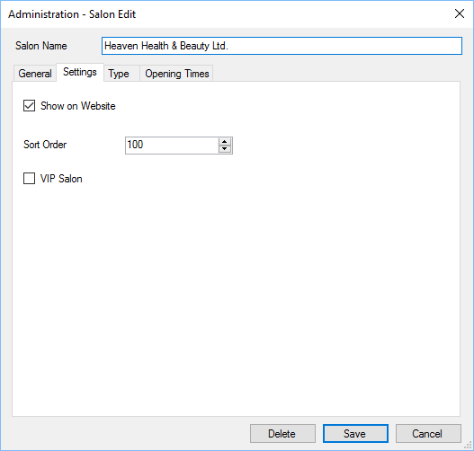

Show on Website - If ticked the salon will be shown on your website.

Sort Order - Sort order of salon on your website, a lower number will be shown firest, higher number last. If two salons share the same sort order then then a further sort on name will be used.

VIP Salon - Indicates the salon to be VIP, this will have a flag indication on the website.

#### Salon Edit – Type

Salon type settings.

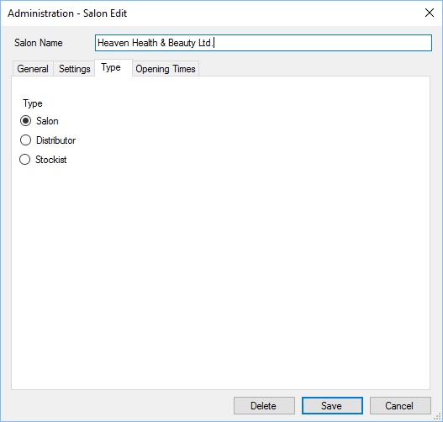

Salon - The details will be displayed on the salons page of your website.

Distributor - The details will be displayed on the distributor’s page within your website.

Stockist - The details will be displayed on the stockists’ page within your website.

#### Salon Edit – Opening Hours

Opening times settings. If set, the salon’s opening hours will be shown on your website.

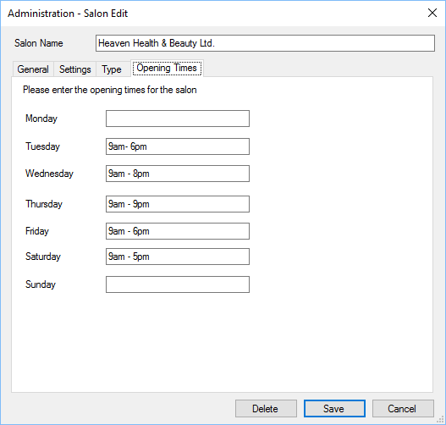

Specify the opening hours, in a uniform manner for each day the salon is open.

### Salon to Salon Owner

A solon can be linked to one or many people within the POS, on your website, any person linked to a salon can submit changes online for you to review in Salon Updates.

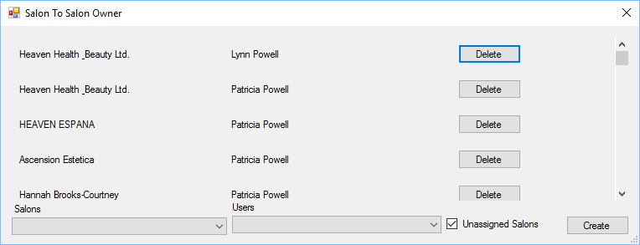

The top section shows the link between a salon and a user.

Salons - Salons within the system, if unassigned salons is ticked then only orphaned salons, or those not linked to any user will be shown.

Users - List of current users who are eligible to own salons.

Unassigned Salons - See Salons above.

Create - Once you have selected a salon, and a user click Create and it will link them together.

### Salon Updates

Users who are assigned to salons can update the salon details online on your website, themselves, this includes adding images. Each salon update will appear in the list and has to be approved prior to being updated on the website. This provides users with an opportunity to verify the details being given.

Double click the update to view the differences.

Once the differences have been approved or denied the update will be removed from the form.

### Salon Update Approval Process

When viewing changes to salon details submitted by users, the changed elements will appear in red.

Click either approve or disprove the changes.

### Missing Links

Missing links are pages that visitors tried to view but were not available on the website.

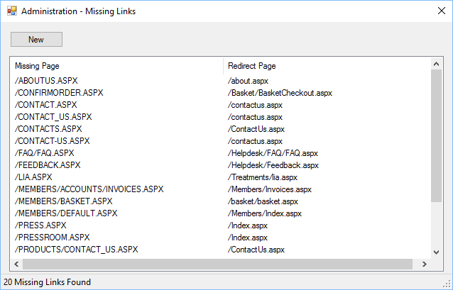

If you are notified of a missing link you can create an automatic redirect.

Click new to create a new missing link or double click an item to edit an existing missing link.

### Missing Link Edit

A missing link will automatically try and redirect a missing web page on your website to an existing page.

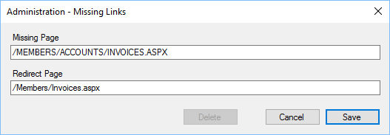

Missing Page - This is the page, without the URL which could not be found.

Redirect Page - This is the page where the user will be redirected to.

In the above example, a user tried to visit their invoices page, which was moved to a different area of the website.

You do not need to include the domain name part of the URL

### Celebrities

You can edit the celebrity details held on the website.

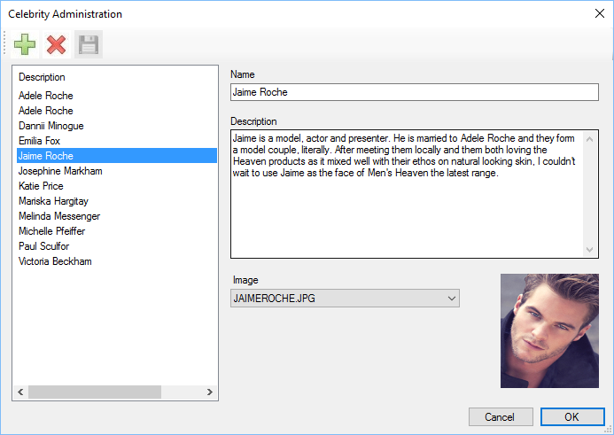

Create New - Creates a new Celebrity endorsement for the website.

Delete - Delete an existing celebrity endorsement from the website. Highlight the selected video and click delete.

Save - Once changes have been made to a celebrity endorsement click save to save the changes.

Name - Celebrity Name.

Description - Celebrity endorsement description.

Image - Select from predefined images.

### Tips and Tricks

Tips and tricks can be shown on the appropriate section of your website.

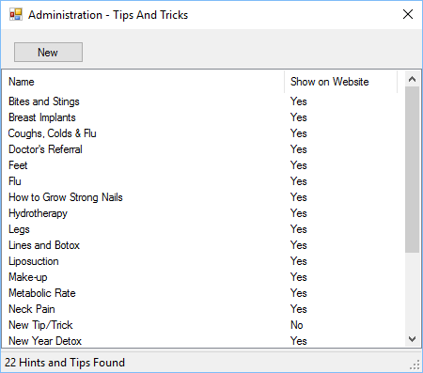

Click New to create a new tip and trick and double click the item to edit an existing tip and trick.

### Tips and Tricks Edit

You can edit the tips and tricks shown on a website.

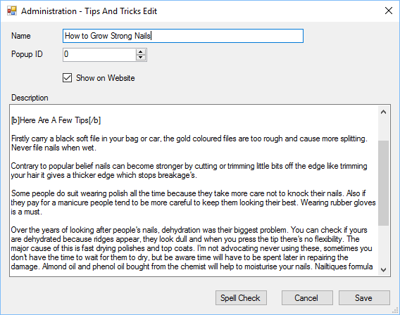

Name - Tips and trick name.

Popup ID - Reserved for future use.

Show On Website - If ticked the item will be displayed on the website.

Description - Tips and tricks description.

Spell Check - Performs a spell check of the Description and Name.

Save - Saves the Tip and Trick.

Cancel - Cancel’s saving of the Tip and Trick.

### Videos Administration

There is a section on the website that can show different videos from YouTube.

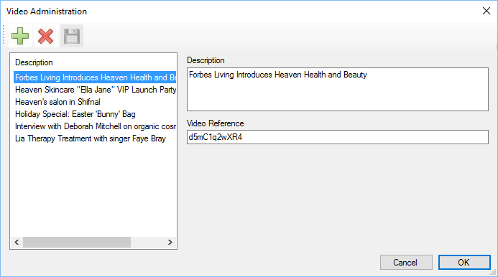

Create New - Creates a new video for the website.

Delete - Delete an existing video from the website. Highlight the selected video and click delete.

Save - Once changes have been made to a video click save to save the changes.

Description - Description of the video.

Video Reference - Unique YouTube reference.

When viewing videos on YouTube you can obtain the unique reference from the URL in your browser window. I.e. the following link refers to the Ella Jane VIP launch:

<https://www.youtube.com/watch?v=OcwfJIcQEjE>

The unique reference is the section after the v= in this case it is OcwfJIcQEjE

## Automatic Rule Updates[[12]](#footnote-9)

The auto update module allows administrators to perform automatic tasks at specific times, this includes:

* Show/hide product groups
* Increase/decrease prices

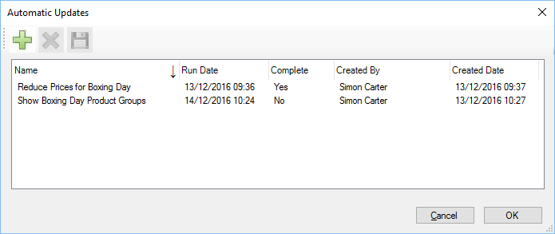

The automatic updates screen shows all automatic updates that have been scheduled or completed.

To create a new automatic update click the green plus button.

### Create Automatic Rule Wizard – Step 1

Select the type of automatic update.

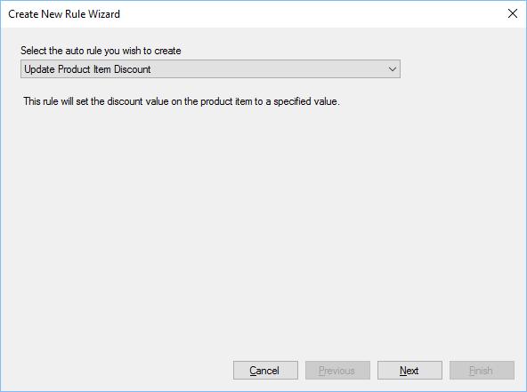

Select from the available list, the description will be shown below.

### Create Automatic Rule Wizard – Step 2

During step 2 you can select which items will be affected. The items listed will be dependent on the selected rule.

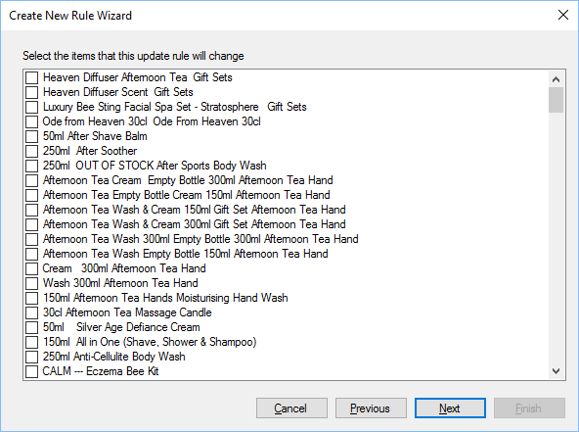

### Create Automatic Rule Wizard – Step 3

During step 3 you can set what the new values will be, the available options depend on the rule selected.

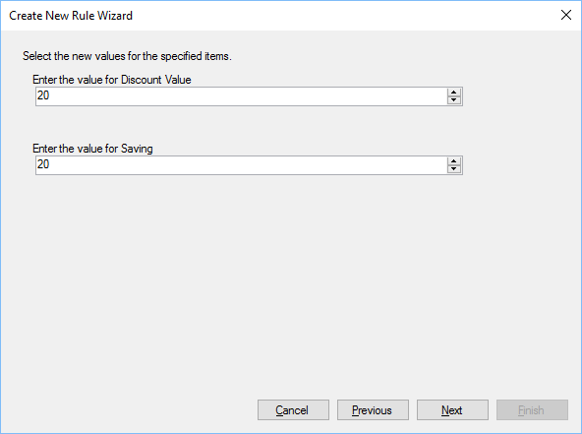

In this example the discount value is set to 20% and the Saving value is set to 20%, if set to zero then the discount would be removed.

### Create Automatic Rule Wizard – Step 4

This step shows what SQL will be executed when the automatic update is run

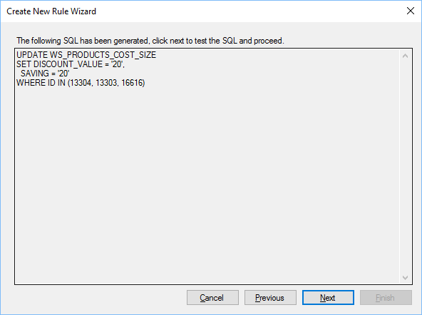

When next is clicked, a test will be made to ensure the SQL can be automatically run.

### Create Automatic Rule Wizard – Step 5

The final step allows administrators to select the date/time when the automatic update is run and a name.

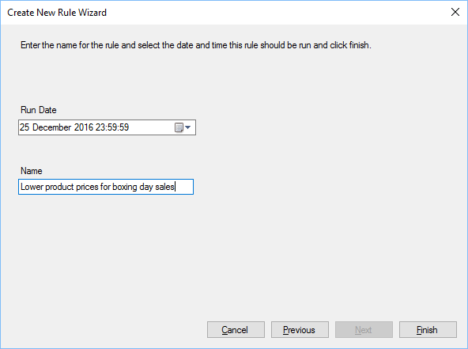

Run Date - The date/time that the rule will be run.

Name - The name of the rule, this should be something meaningful as you cannot edit an automatic update once created.

Click Finish to save the automatic update.

# Member Level

The member level for staff and customers affects what products they can use within the pos. There are several member level’s which are:

* StandardUser - Customer
* FormerStaffMember - Former Staff Member
* GoldUser - Gold Customer or VIP
* Reseller - Customer is also a reseller
* User4 - Undefined
* Distributor - Customer is also a distributor
* StaffMember - Member of staff
* User7 - Undefined
* AdminReadOnly - Administrator with read only priveleges.
* AdminUpdateDelete - Administrator with update/delete privileges.
* Admin - System Administrator.
* System - System use only

The member level primarily defines which products a user can see within the system, each product item and product group can have a member level set against it, this determines who can see the product/group.

For example, if you have a product that is only to be sold to distributors, then the member level for the product should be set to Distributor, you could also setup a Distributor product group for integration on the website, this will only be shown customers and staff who have a member level of Distributor or above.

Another example would be if you kept stock for sale in an outlet, which is not sold by other means (i.e. website), you can set the member level to Staff Member, this way when a member of staff uses the POS, they will be able to see the product.

If you have a case where a member of staff can see a product, and another member of staff cannot, then you need to check the member level for the product item.

# Replication

The POS includes a bespoke replication engine, which replicates data between a central server and each Server install.

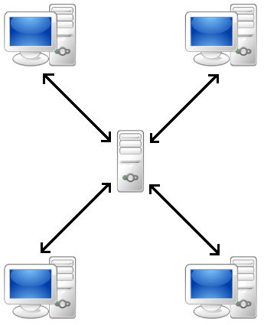

Data is replicated (synchronised) both ways about every 20 minutes using a standard install from each server installation.

If you have multiple server installs across different sites, there could be an instance where a user in one location creates an appointment, for a member of staff during a free period. This could take 30 minutes to appear on other computers, within the network.

# Parameters

There are a number of parameters which can be used to control how the POS works.

Parameters can be passed with the following switches:

-

/

If a value is required it can be passed using : as a separator, for instance to ignore checks you would pass the following parameter:

-ic:true

## Administration

Administration mode allows

## IgnoreRole

Ignore role parameter prevents the POS from assigning the currently logged on user as a database user. If this parameter is used then any system changes will be logged to the current database user not the user actually logged in.

## ic

Ignore Checks will not prompt the user about actions that should be completed prior to closing the POS. Valid values are true or false.

## MultiInstance

Multiple instance allows the POS to have multiple instances running on a single computer, if not set then only a single instance of the POS can be run.

# Troubleshooting

This section has provides help with general problems.

## Wrong Currency showing in Invoices/Stock control

#### Make sure you set the correct currency in the User settings

User settings can be accessed by all POS users.

User – General settings. If the currency is still wrong, check the

Countries settings, making sure the country has the correct currency selected.

## I cannot see a product but a co-worker can

If you have a case where one staff member can see a product within the POS or online, but another staff member can’t, then please see the section on Member Level.

# Foot Notes

1. Please note that the images and options shown in this manual may differ slightly depending on how your POS has been configured and which plugin modules you have loaded. [↑](#footnote-ref-1)
2. Please note, even if you login automatically it is still possible to lock the POS, to prevent unauthorised access. [↑](#footnote-ref-2)
3. See

   Products section to see how out of stock can be changed. [↑](#footnote-ref-3)
4. When named group types are selected the group name will be greyed out. When other group type is specified then the Header and Sub Header will be greyed out. [↑](#footnote-ref-4)
5. Integration with a website requires the system to be able to integrate with a public facing website. [↑](#endnote-ref-1)
6. Staff should only be given the permissions required to perform their role. [↑](#endnote-ref-2)
7. Only characters A to Z and 0 to 9 are allowed, spaces and other characters are not allowed in this ID. [↑](#footnote-ref-5)
8. The colour mentioned is the default colour, users can choose to change the colour to something more preferable in the stock settings section. [↑](#endnote-ref-3)
9. A coupon code can be used either on the website or within the Till. A coupon is not a voucher. [↑](#footnote-ref-6)
10. Please see company policy on whether a voucher can be partially redeemed. [↑](#footnote-ref-7)
11. Caution should be given when giving the permission to staff to administer vouchers as it could leave the company open to fraud from staff. [↑](#footnote-ref-8)
12. Please contact support if you require new rules to automatically update data. [↑](#footnote-ref-9)